COMSATS University, Islamabad Pakistan

**Assignment - 06**

**Final Project Report**

**For**

**Speech2Face**

**Submitted By:**

**Shahzaneer Ahmed CUI/SP21-BCS-087/ISB**

**Shayan Zameer CUI/ SP21-BCS-088/ISB**

**Supervisor  
Mr. Tehseen Riaz Abbasi**

Date of Submission: 31st December, 2022

Original Version 1.0

Bachelor of Science in Computer Science (2020-2025)

**The candidate confirms that the work submitted is their own and appropriate  
 credit has been given where reference has been made to the work of others**.



**COMSATS University, Islamabad Pakistan**

**Speech2Face**

**A project presented to**

**COMSATS University, Islamabad**

**In partial fulfillment**

**of the requirement for the degree of**

***Bachelors of Science in Computer Science (2021-2025)***

**By**

**Shahzaneer Ahmed CUI/SP21-BCS-087/ISB**

**Shayan Zameer CUI/ SP21-BCS-088/ISB**

**DECLARATION**

We hereby declare that this software, neither whole nor as a part has been copied out from any source. It is further declared that we have developed this software and accompanied report entirely on the basis of our personal efforts. If any part of this project is proved to be copied out from any source or found to be reproduction of some other. We will stand by the consequences. No Portion of the work presented has been submitted of any application for any other degree or qualification of this or any other university or institute of learning. This Project is unique in its nature and no practical software is present in the world at the moment which can perform tasks like it.

Shahzaneer Ahmed Shayan Zameer

--------------------------- ---------------------------

**Executive Summary**

Determining the facial features from speech of a person is considered impossible although if it could happen it would help the security agencies of the world to trace the faces of the criminals by the record of their voices.

Speech2face is a system which is developed by using machine learning and deep learning algorithms trained over a vast dataset consisting of the values of the facial and voice features of different ethnicities, regions, countries and genders. It generates image from the voice record. It can also fetch the voice from the videos and then generate image against it. The image formed can be modified in accordance with the investigational needs.

Speech2Face is a Research and Development system and thus it is subjected to be improved with the passage of time as its application is increased.

**Acknowledgement**

All praise is to Almighty Allah who bestowed upon us a minute portion of His boundless knowledge by virtue of which we were able to accomplish this challenging task.

We are greatly indebted to our project supervisor “Mr. Tehseen Riaz Abbasi”. Without their personal supervision, advice and valuable guidance, completion of this project would have been doubtful. We are deeply indebted to them for their encouragement and continual help during this work.

And we are also thankful to our parents and family who have been a constant source of encouragement for us and brought us the values of honesty & hard work.

Shahzaneer Ahmed Shayan Zameer

--------------------------- ---------------------------

**Abbreviations**

|  |  |
| --- | --- |
| **API** | Application Programming Interface |
| **FAQ** | Frequently Asked Questions |
| **FR** | Functional Requirements |
| **M** | Module |
| **NFR** | Non-Functional Requirements |
| **QA** | Quality Assurance |
| **S2F Software** | Speech2Face System |
| **SDS** | Software Design Specification |
| **SRS** | Software Require Specification |
| **STP** | Software Test Plan |
| **TC** | Test Case |
| **UC** | Use Case |
| **UI** | User Interface |
| **URL** | Uniform Resource Locator |

**Table of Contents**

1. Introduction 14

1.1 Project Major Category 14

1.2 Abstract 14

1.3 Vision Statement 14

1.4 Related System Analysis/Literature Review 15

Sound Classification: 15

Speech2Face: 15

Face.net: 15

1.5 Advantages/Benefits of Proposed System 17

1.6 Project Scope 17

1.7 Modules 18

Module 1: Profile Management 18

Module 2: Place Voice Record 18

Module 3: Sound to Face Vector Model 19

Module 4: Face-Vector to Face-Image Model 19

Module 5: Image View Customization 19

Module 6: Features Enhancer 19

Module 7: Insight Panel 20

Module 8: Feedback Panel 20

Module 9: Help and Support 20

1.8 System Limitations/Constraints 20

1.9 Tools and Technologies 21

1.10 Relevance to Course Material 24

1.11 Design and Process Methodology for this Project 24

1.11.1 Process Methodology 24

1.11.2 Design Methodology 24

2. Problem Definition 25

2.1 Problem Statement 25

2.2 Problem Solution for the Proposed System 25

2.3 Deliverables and Development Requirements 25

3. Requirement Analysis 28

**3.1** **Requirement Elicitation Techniques** 28

Questionnaire and Surveys: 28

Group Discussion: 28

Studying Related Systems: 28

Observation: 28

**3.2** **Use Cases Diagram(s)** 29

**3.3** **Detailed Use Case (Tabular- Module Wise)** 32

**3.3.1** **List of Use Cases** 32

3.4 Functional Requirements 84

**3.5** **Non-Functional Requirements** 134

**3.5.1** **Reliability** 134

**3.5.2** **Usability** 135

**3.5.3** **Performance** 135

**3.5.4** **Security** 135

4. Architecture and Design 136

4.1. System Architecture 136

4.2. Design Methodology 136

4.3. Data Representation 137

4.3.1. ERD 137

4.4. Process Flow 137

4.5. Design Models 146

4.5.1. Class Diagram 146

4.5.2. Sequence Diagrams 147

Following are some of the Class diagram of the application “Speech2Face System”: 147

5. Implementation 155

5.1. Algorithm 155

• Sign up and Login 155

• Adding Voice Record 155

• Voice to Vector Modeling 155

• Vector to Image Modeling 156

• Image View Customization 156

• Features Enhancer 157

• Insight Panel 157

5.2. User Interface 159

6. Testing and Evaluation 178

7. Conclusion and Future Work 224

7.1. Conclusion 224

7.2. Future Work 224

7.3. Lessons Learnt 224

7.4. Work Division 226

8. References 230

Related System: 230

https://www.github.com/topics/sound-classification. 230

https://speech2face.github.io/ 230

Google Facenet 230

YouTube Resources: 230

https://www.youtube.com/watch?v=aKYlSIs3UDY&t=334s 230

9. Appendix 230

9.1. Figma UI 230

https://www.figma.com/file/2cnbvpco1PohBbW6qkxKSk/Speech2Face?node-id=231%3A832&t=ElN4Nwrc7zcLQNko-0 230

https://www.figma.com/file/2cnbvpco1PohBbW6qkxKSk/Speech2Face?node-id=304%3A781&t=ElN4Nwrc7zcLQNko-0 230

9.2. Figma Prototypes 230

https://www.figma.com/proto/2cnbvpco1PohBbW6qkxKSk/Speech2Face?node-id=295%3A527&scaling=scale-down&page-id=231%3A832&starting-point-node-id=295%3A527 230

https://www.figma.com/proto/2cnbvpco1PohBbW6qkxKSk/Speech2Face?node-id=104%3A7&scaling=scale-down&page-id=0%3A1&starting-point-node-id=104%3A7 230

9.3. Github Repositories 231

https://github.com/ShayanZameer 231

https://github.com/shahzaneer/Speech2Face 231

9.4. YouTube Link 231

https://www.youtube.com/channel/UCNXbD47Sy6nJumfAAME0V9A 231

9.5. Guidelines 231

10. Plagiarism Report 232

**Table of Figures**

*Figure 1: Context Diagram of Speech2Face System*

*Figure 2: Use Case Diagrams for System*

*Figure 3: Architecture Diagram*

*Figure 4: Entity Relation Diagram of peech2Face System*

*Figure 5: Activity Diagram of Module1*

*Figure 6: Activity Diagram of Module 2*

*Figure 7: Activity Diagram of Module3and 4*

*Figure 8: Activity Diagram of Module 5*

*Figure 9: Activity Diagram of Module 6*

*Figure 10: Activity Diagram of Module 7*

*Figure 11: Activity Diagram of Module 8*

*Figure 12: Activity Diagram of Module 9*

*Figure 13: Class Diagram of Speech2Face System*

*Figure 14: Sequence Diagram of Module 1*

*Figure 15: Activity Diagram of Module2*

*Figure 16: Sequence Diagram of Module 3 and 4*

*Figure 17: Sequence Diagram of Module 5*

*Figure 18: Sequence Diagram of Module 6*

*Figure 19: Sequence Diagram of Module 7*

*Figure 20: Sequence Diagram of Module 8*

*Figure 21: Sequence Diagram of Module 9*

*Figure 22: User Interface (Mockups)*

# Introduction

Recognizing the facial features of a person based on their audio notes by a human being who don’t actually know the person make no sense in real life. There is no such way to do something like this. Every prediction will be a wild guess with zero or no reliability at all. But with the advent in the Technology, Artificial Intelligence has made it possible to do so. The Machine Learning and Deep Learning Models can be trained on data of all type of people with some mathematical perspectives of voice that use clustering algorithms and categorize the people in different domains. By doing so, they generate predicted images.

The images will not be 100% real. But they can give a lot of insights of the data which can help us identify the person.

# Project Major Category

**B-**Web Application/Web Application based Information System

**C-**Problem Solving and Artificial Intelligence

**E-**Smartphone Application

**H-**Image Processing

# Abstract

Speech2face is a web and mobile application-based software that is mainly built to recognize the face general structure, ethnicity and gender with the audio waves. Currently there is no full fledge software in the world that helps in this regard although there are deep learning libraries on which much work is done in the past. It was nearly impossible to predict the appearance of some person with his/her voice. But Artificial Intelligence has made it. It will automate the attendance system and reinvigorate the authentication system. Moreover, it will prove itself as an asset to the security and intelligence agencies by recognizing criminals faces with the voice notes and eventually help them resolving complex cases. Speech2face can also be used as a general-purpose software for recognizing the individuals in old audios and images where their appearance is not clear.

# Vision Statement

For users (generic, intelligence agencies) who want to authenticate their user systems and find a visual representation (facial view) of voices depending upon different factors, the Speech2face is an internet-based and smartphone-enabled application that will help in authenticating the users and finding real-time insights about voices unlike the data analyzed models which are not in practical usage form, the users who will use our speech2face system will be able to transform the audios into images and gain generic information about the person whose voice is under observation.

# Related System Analysis/Literature Review

Following are some existing apps related to our project:

### Sound Classification:

Audio Classification is the practice of examining audio recordings. The project classifies the sound into different categories e.g., environmental sound, the voice of speech, music sound, etc. Several AI and Data Science applications including chatbots, automatic voice translators, text to speech software can be created through this technology.

### Speech2Face:

Speech2Face is all about guessing a person's Face using voice. In this project, we are trying to reconstruct the facial image of a person from a short audio recording of that person speaking.

### Face.net:

Face.net is a project developed by three researchers at Google. Face.net basically takes a face and turns it into a vector of 128 values. The project is designed to produce an embedding from a face of a person.

The ***Table 1***provides weakness of these apps and proposed solution that would be done in this project.

*Table 1: Related System Analysis with Speech2Face System.*

|  |  |  |
| --- | --- | --- |
| **Application Name** | **Weakness** | **Proposed Project Solution** |
| Sound Classification | There are too many sounds so There is a possibility that the system can’t get sound and displays results according to their need. | The project deals with speech recognition and converts facial images. The risk is low as compared to related projects. |
| Facenet | There are a number of areas that are still left to be explored and how different ages and races play a role in face recognition. | . |
| Speech2Face | No Mobile application, only available as a website. | The application will be available on the web as well as a mobile application. |

# Advantages/Benefits of Proposed System

Following are the advantages of our application:

Privacy of a person is there because the resemblance is apparently not 100% right.

This application helps the investigation team to get an idea of what the criminals look like by using their voices.

We evaluate and numerically quantify how and in what matter reconstruction from audio resembles the true face of images of the speaker.

# Project Scope

**Speech2Face** will be a Research and development-based Product with the main functionality to convert the voice into vector form and the vector form to image form and thus assisting in providing insights about the details of the person whose voice is under observation. It will be developed using different technologies and Deep Learning and machine learning techniques will be used. The Image generated can be modified in accordance with the users’ perspective

**General user**: They can retrieve their images from their voice notes.

**Security Agencies**: It Can help them identify the criminals and speed up the process of resolving complex cases.

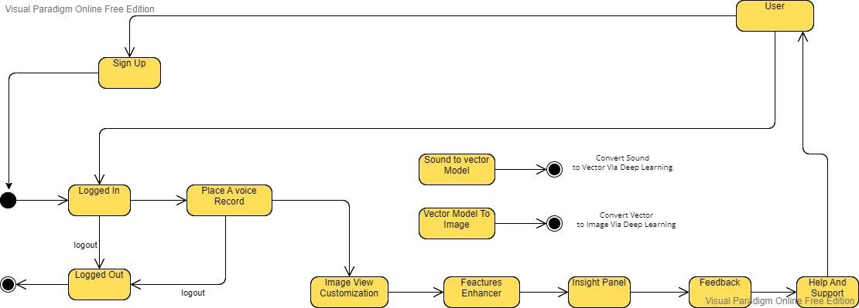

*Figure 1: Context Diagram of Speech2Face System*

# Modules

The major modules for the RPC System are listed below:

### Module 1: Profile Management

**MF-1.1 Sign Up MF-1.2 Login**

**MF-1.3 Sign in Via Phone MF-1.4 Sign in as a Guest MF-1.5 Sign in Via Voice**

**MF-1.6 Update Profile Information MF-1.7 Delete Profile**

**MF-1.8 Logout**

## Module 2: Place Voice Record

**MF-2.1 Record Voice**

**MF-2.2 Upload Existing Voice**

**MF-2.3 Upload Existing Video to fetch Voice MF-2.4 Update Voice**

**MF-2.5 Update Video MF-2.6 Delete Voice MF-2.7 Delete Video**

## Module 3: Sound to Face Vector Model

**MF-3.1 Sound to vector Modeling via Deep Learning** **MF-3.2 Generate Vector Model**

## Module 4: Face-Vector to Face-Image Model

**MF-4.1 Vector to Image Modeling via Deep Learning MF-4.2 Generate Image Model**

## Module 5: Image View Customization

**MF-5.1 Brightness Control**

**MF-5.2 Saturation Management MF-5.3 Skin Color Management MF-5.4 Filters**

## Module 6: Features Enhancer

**MF-6.1 Face Shape Enhancement MF-6.2 Nose Enhancement**

**MF-6.3 Eyebrow Enhancement MF-6.4 Beard Maker**

**MF-6.5 Eye Enhancement**

## Module 7: Insight Panel

**MF-7.1 View Report**

**MF-7.2 Download Report MF-7.3 Share on Socials**

## Module 8: Feedback Panel

**MF-8.1 Rate Result**

**MF-8.2 Feedback in terms of words MF-8.3 System Lagging Checks**

## Module 9: Help and Support

**MF-9.1 Chat with AI Bot**

**MF-9.2 Contact Support Team**

**MF-9.3 Change Bots-Language**

**MF-9.4 View Bot’s Query History**

# System Limitations/Constraints

Following are the limitations of our proposed system:

* The system cannot predict the image 100% right.
  + The system is unable to guess some voices if it consists of the type on which the data is not trained. It is the limitation of AI.
  + The System can be accessed over the internet only.

# Tools and Technologies

The tools and technologies that we will be using are provided in the ***Table 2*** below. The main IDE tool to develop the code will be **Microsoft Visual Studio Code 2022** on which different Technologies like **Flutter, HTML-CSS** and **Java Script** will be implemented. **Figma** will be used for mockup creation. **Microsoft Word** and **PowerPoint** will be used for documentation and presentation. **Firebase** Firestore will be used as the backend database.

**Table 2: Tools and Technologies for the Speech2face.**

|  |  |  |  |
| --- | --- | --- | --- |
| **Tools** | **Tools** | **Version** | **Rationale** |
| Visual Studio Code | 2022 | IDE |
| MS Word | 2021 | Documentation |
| MS Power Point | 2021 | Presentation |
| Figma | 2022 | Mockups Creation |
| Flutter | 3.3 | SDK |

|  |  |  |  |
| --- | --- | --- | --- |
| **Technologies** | Git | 4.3 | VCS |
| Netlify |  | Deployment |
| **Technology** | **Version** | **Rationale** |
| Dart | 3.5 | Client-side Scripting |
| Firebase | 5 | Ready Made Backend |
| Html | 5 | Web Structuring |
| CSS | 3 | Web Design |
| Tailwind CSS | 3.0 | Web Design |
| Bootstrap | 5 | Built-in Web Components |
| JavaScript | ECMA Script 2017 | Event Based Programming language |
| Python | 3.8 | ML/DL Modeling |

# Relevance to Course Material

* From coding perspective, we used some of the core courses and concepts of BCS i.e., Object Oriented Programming, and Data Structures and Algorithms.
* From database perspective, we implemented our knowledge about non-relational databases that we learnt in Database System-I course.
* From overall presentation and reports perspective, courses like Information and Communication Technology (ICT) and Reporting Writing Skills (RWS) helped us through.
* We also utilized our knowledge of Software Engineering Concepts we gained studying this course throughout the semester.

# Design and Process Methodology for this Project

# Process Methodology

The software process model which we will be following for this project is **Iterative Process Model.** Our application has finite number of functionalities and most of the requirements are not surely known as the project is not very common in market and it is research and development based. Therefore, the most suitable process model we could select is iterative process model so that we may go back to the requirement or design phase when the need arrives.

# Design Methodology

The design methodology we will be using is **Object Oriented Programming Approach** because it increases the reusability of the code, reduces the complexity of the code, and it would be easier for the team members to work together without any confusion as it is the most followed programming paradigm in the market.

# 

# Problem Definition

This chapter highlights the problem faced by people on a daily basis during the Usage of Speech2Face Application. Alongside, the effective solution and our projects’ requirements and deliverables are also discussed.

## Problem Statement

There are many loop holes in the user authentications used in the security systems including banks, critical profile accounts and many more places where authenticity should be the first and foremost priority. Every other person who has the credentials of the account of that specific user can log into the accounts specified merely for the former. Secondly In most of the criminal scenes it is observed that the faces are not recognized and hence the criminals are not capture by the security forces. There is always a hindrance in the recognizing of the culprits involved in the crime scene. Mostly the voice can be seen but the faces are under the veil and thus cannot be seen directly. Market has no such software that provides such facilities at the same place as utilities.

## Problem Solution for the Proposed System

Many Application users and Agencies have requested systems that are helpful, efficient, and reliable in user authentication. People have asked to ensure the dependability and security of critical accounts. Speech2face will provide an acceptable solution to these concerns. Security and intelligence agencies face many complications in identifying criminals as in most cases their faces are not revealed by the camera. They cannot give their visual representation to the security forces to capture them and mark them wanted. Speech2face will help us in this regard. Moreover, the old audio and video notes can be used to find insights about the person’s basic information.

## Deliverables and Development Requirements

Deliverables and development requirements are as follows:

* Project Scope document to define the scope of the system,
* Project Status reports to gather the status of the ongoing project.
* The main goal of the project was to build a web application and mobile phone application for users to coordinate with each other and maintain the data of their properties.
* Time sheet report for the demonstration of work of every team member.
* SRS document (System Requirement Specification)
* SDS document (System Design Specification)
* STP document (Software Test Plan)
* User Manuals for user guidance.
* Final financial report document.

# Requirement Analysis

Thorough explanation of all the requirements of our project are discussed. System functionalities and quality attributes are discussed in detail as well. This part of the document is very essential for the success of the project.

* 1. **Requirement Elicitation Techniques**

Following requirements gathering techniques were implemented.

### Questionnaire and Surveys:

* + - A set of Questions were given to the public for their thoughts on application. Requirements for our system were extracted from these Questionnaires. Data was gathered for Improvement and best features that were to be included.

### Group Discussion:

* + - Group discussions with public and group partner were held for gathering the information necessary for development of this application.

### Studying Related Systems:

* + - Various related system was studied to improve the requirements and cope up with the problems of the users. Research was complete and adequate to add value to the users.

### Observation:

* + - Different types of people were observed in different cases to make the system more reliable to the user and help solve their main problems through the system.

* 1. **Use Cases Diagram(s)**

The Use case diagrams of System, are given below:

*Figure 2: Use Case Diagram for User*

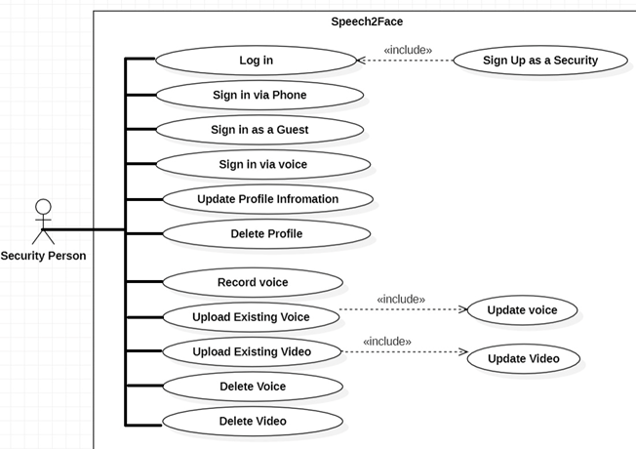

*Figure 3: Use Case Diagram for User*

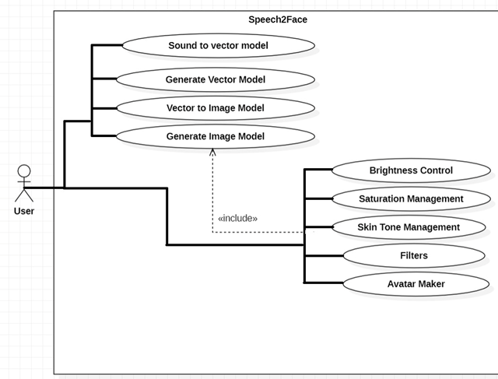

*Figure 4: Use Case Diagram for User*

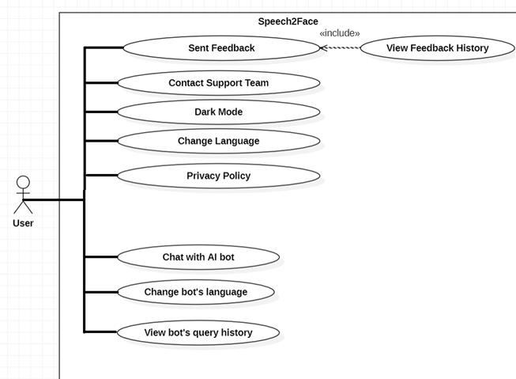

*Figure 5: Use Case Diagram for Security Person*

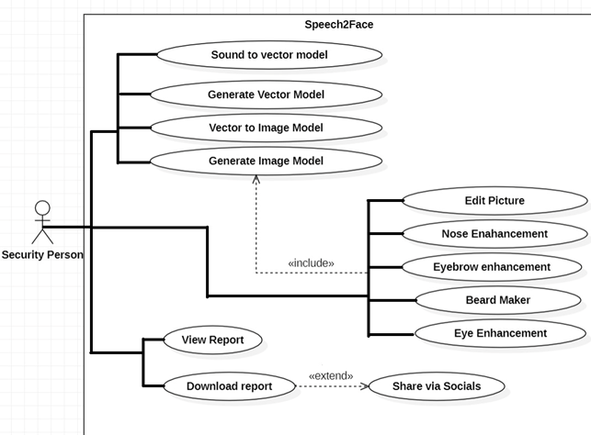

* 1. **Detailed Use Case (Tabular- Module Wise)** 
     1. **List of Use Cases**

List of use cases per module is given below:

* ***Module 1: Profile Management***

*Table 2: List of Use Cases (Module 1: Profile Management)*

|  |  |
| --- | --- |
| **UC-ID** | **Use Case Name** |
| **UC-1.1** | Sign up |
| **UC-1.2** | Log in |
| **UC-1.3** | Sign in Via Phone |
| **UC-1.4** | Sign in Via Voice |
| **UC-1.5** | Update Profile |
| **UC-1.6** | Logout |

* ***Module 2: Place A Voice Record***

*Table 3: List of Use Cases (Module 2: User Interaction Chat Box)*

|  |  |
| --- | --- |
| **UC-ID** | **Use Case Name** |
| **UC-2.1** | Record Voice |
| **UC-2.2** | Upload Existing Voice |
| **UC-2.3** | Upload Existing Video to Fetch Voice |
| **UC-2.4** | Update Voice |
| **UC-2.5** | Update Video |
| **UC-2.6** | Delete Voice |
| **UC-2.7** | Delete Video |

* ***Module 3: Sound To Face Vector Model***

*Table 4: List of Use Cases (Module 3:Sound to Face vector Model)*

|  |  |
| --- | --- |
| **UC-ID** | **Use Case Name** |
| **UC-3.1** | Sound to Vector Modeling Via Deep Learning |
| **UC-3.2** | Generate Vector Model |

* ***Module 4: Vector to Image Model***

*Table 5: List of Use Cases (Module 4: Vector to Image Model)*

|  |  |
| --- | --- |
| **UC-ID** | **Use Case Name** |
| **UC-4.1** | Sound to Vector Modeling Via Deep Learning |
| **UC-4.2** | Generate Image Model |

* ***Module 5: Image View Customization***

*Table 6: List of Use Cases (Module 5: Tenant Management Portal)*

|  |  |
| --- | --- |
| **UC-ID** | **Use Case Name** |
| **UC-5.1** | Brightness Control |
| **UC-5.2** | Saturation Management |
| **UC-5.3** | Skin Tone Management |
| **UC-5.4** | Filters |
| **UC-5.5** | Avatar Maker |

* ***Module 6: Features Enhancer***

*Table 7: List of Use Cases (Module 6: Features Enhancer)*

|  |  |
| --- | --- |
| **UC-ID** | **Use Case Name** |
| **UC-6.1** | Edit Picture |
| **UC-6.2** | Nose Enhancement |
| **UC-6.3** | Eyebrow Enhancement |
| **UC-6.4** | Beard Maker |
| **UC-6.5** | Eye Enhancement |

* ***Module 7: Insight Panel***

*Table 8: List of Use Cases (Module 7: Insight panel)*

|  |  |
| --- | --- |
| **UC-ID** | **Use Case Name** |
| **UC-7.1** | View Report |
| **UC-7.2** | Download Report |
| **UC-7.3** | Share Via Socials |

* ***Module 8: Setting and Configuration***

*Table 9: List of Use Cases (Module 8: Setting And Configuration*

|  |  |
| --- | --- |
| **UC-ID** | **Use Case Name** |
| **UC-8.1** | Sent Feedback |
| **UC-8.2** | View Feedback History |
| **UC-8.3** | Dark Mode |
| **UC-8.4** | Change Language |
| **UC-8.5** | Privacy Policy |

* ***Module 9: Help and Support***

*Table 12: List of Use Cases (Module 8: Help and Support)*

|  |  |
| --- | --- |
| **UC-ID** | **Use Case Name** |
| **UC-9.1** | Chat with AI Bot |
| **UC-9.2** | Contact with Support Team |
| **UC-9.3** | Change Bots’ Language |

* + 1. **Tabular Form of Use Cases:**

Following are the Use Cases in detailed Tabular Form:

* ***Module 1: Profile Management***

The tabular use cases of the module profile management are provided below:

* **Sign Up**

The tabular use cases are given below:

*Table 13: Tabular Use Case UC-1.1*

|  |  |
| --- | --- |
| **Use Case ID:** | UC-1.1 |
| **Use Case Name:** | Sign Up |
| **Actors:** | User / Security agencies authority |
| **Description:** | User will create their account in order to use the application. |
| **Priority:** | High |
| **Precondition:** | User should have an authentic and valid email address and contact number. |
| **Trigger:** | User will click on the Sign-up button from main screen. |
| **Include:** | None. |
| **Normal Flow:** | 1. The user will enter authentic credentials (email, name, Voice) and password in the sign-up window. 2. Then user will click on the sign-up button. 3. OTP will be generated and sent to the user’s contact or email. 4. On correct input of OTP, successful sign-up message will be displayed to the user. |
| **Alternative Flows:** | None. |
| **Exceptions:** | * In step 4 of normal flow, if the user enters an invalid email address, and password:  1. An appropriate error message will be displayed 2. Asking the user to enter the data and credentials again 3. Then user will provide correct data.   Use Case resumes from step 5 of normal flow   * In step 7, if the user enters incorrect OTP:  1. An appropriate error message will be displayed. 2. User will be used to enter OTP again. 3. If fails to enter within 30 seconds, OTP will expire. 4. User will have to request another OTP and correctly enter it for successful sign-up. |
| **Post condition:** | After successful entry of credentials, new user account will be formed and control will move to home screen from where the user can log in or sign up. |
| **Business Rules:** | User should have a verified email address |
| **Notes & Issues:** | None. |
| **Assumptions:** | 1. User will have a stable internet connection. 2. User will be able to enter data correctly. |

* **Log In**

The tabular use cases are given below:

*Table 14: Tabular Use Case UC-1.2*

|  |  |
| --- | --- |
| **Use Case ID:** | UC-1.2 |
| **Use Case Name:** | Log In |
| **Actors:** | User/ Security Agency Authority |
| **Description:** | User will log in to their account in order to use the application. |
| **Priority:** | High |
| **Precondition:** | User must have signed up for an account. |
| **Trigger:** | User will click on the Log-in button from main screen. |
| **Include:** | UC-1.1 |
| **Normal Flow:** | 1. The user will enter an authentic email and password used at the time of account creation in the login window. 2. Then user will click on the log in button. |
| **Alternative Flows:** | None. |
| **Exceptions:** | In step 1 of normal flow, if the user enters an invalid email address and password with which no account was formed:   1. An appropriate error message will be displayed 2. Asking the user to enter the credentials again 3. Then user will provide correct data.   Use Case resumes from step 2 of normal flow |
| **Post condition:** | After logging in, the user will reach to the main menu of the application from where they can see the main screen |
| **Business Rules:** | User should log in with correct email and password combination. |
| **Notes & Issues:** | None. |
| **Assumptions:** | 1. User will have a stable internet connection. 2. User will be able to enter data correctly. |

* **Sign in Via Phone**

*Table 15: Tabular Use Case UC-1.3*

|  |  |
| --- | --- |
| **Use Case ID:** | UC-1.3 |
| **Use Case Name:** | Sign in Via Phone |
| **Actors:** | User/ Security Agency Authority |
| **Description:** | User will log in to their account in order to use the application. |
| **Priority:** | Medium |
| **Precondition:** | User must have signed up for an account. |
| **Trigger:** | User will click on the Log-in button from main screen. |
| **Include:** | UC-1.1 |
| **Normal Flow:** | * + - 1. Click the button Sign in via Phone. |
| **Alternative Flows:** | None. |
| **Exceptions:** | None |
| **Post condition:** | After logging in, the user will reach to the main menu of the application from where they can choose their role between renter and proprietor. |
| **Business Rules:** | None |
| **Notes & Issues:** | None. |
| **Assumptions:** | 1. User will have a stable internet connection. 2. User will be able to enter data correctly. |

* **Sign in Via Voice**

*Table 16: Tabular Use Case UC-1.4*

|  |  |
| --- | --- |
| **Use Case ID:** | UC-1.4 |
| **Use Case Name:** | Sign in via Voice |
| **Actors:** | User |
| **Description:** | User will log in to their account in order to use the application. |
| **Priority:** | Medium |
| **Precondition:** | User must have signed up for an account. |
| **Trigger:** | User will click on the Log-in button from main screen. |
| **Include:** | UC-1.1 |
| **Normal Flow:** | 1.Click sign in via voice  2.Now the roller waiting symbol will appear for 30 secs and user should record the voice to get whole out of it. |
| **Alternative Flows:** | None. |
| **Exceptions:** | In step 1 of normal flow, if the user enters an invalid email address and voice with which no account was formed:   1. An appropriate error message will be displayed 2. Asking the user to enter the credentials again 3. Then user will provide correct data.   Use Case resumes from step 2 of normal flow |
| **Post condition:** | After logging in, the user will reach to the main menu of the application from where they can see the main screen. |
| **Business Rules:** | User should log in with correct email and Voice combination. |
| **Notes & Issues:** | None. |
| **Assumptions:** | 1. User will have a stable internet connection. 2. User will be able to enter data correctly. |

* **Update Profile**

*Table 17: Tabular Use Case UC-1.5*

|  |  |
| --- | --- |
| **Use Case ID:** | UC-1.5 |
| **Use Case Name:** | Update Profile |
| **Actors:** | User |
| **Description:** | User can update info of their account. |
| **Priority:** | High |
| **Precondition:** | User must be logged in an account. |
| **Trigger:** | User will click on the edit profile button from side pane. |
| **Include:** | UC-1.2 |
| **Normal Flow:** | 1. The user can change/edit any detail of the given module including email , name,password, and voice record (for login) |
| **Alternative Flows:** | None. |
| **Exceptions:** | While logging out, if internet connection is lost the logging out process will be cancelled and user will be redirected to the main menu instead of the home screen. Use case resumes from step 1. |
| **Post condition:** | After successfully logging out, the user will be redirected to home screen from where they can sign up or log in again. |
| **Business Rules:** | User should have stable internet connection |
| **Notes & Issues:** | None. |
| **Assumptions:** | 1. User will have a stable internet connection. 2. User will be able to find and select the option from the menu correctly. |

* **Logout**

*Table 18: Tabular Use Case UC-1.6*

|  |  |
| --- | --- |
| **Use Case ID:** | UC-1.6 |
| **Use Case Name:** | Log out |
| **Actors:** | User |
| **Description:** | User can log out from their account. |
| **Priority:** | High |
| **Precondition:** | User must be logged in an account. |
| **Trigger:** | User will click on the Log-out button from side pane. |
| **Include:** | UC-1.2 |
| **Normal Flow:** | 1. After using the application, the user wants to switch off their account. 2. From the main account settings, the user will click on the log out button. |
| **Alternative Flows:** | None. |
| **Exceptions:** | While logging out, if internet connection is lost the logging out process will be cancelled and user will be redirected to the main menu instead of the home screen. Use case resumes from step 1. |
| **Post condition:** | After successfully logging out, the user will be redirected to home screen from where they can sign up or log in again. |
| **Business Rules:** | User should have stable internet connection |
| **Notes & Issues:** | None. |
| **Assumptions:** | 1. User will have a stable internet connection. 2. User will be able to find and select the option from the menu correctly. |

* ***Module 2: Place Voice Record***

The tabular use cases of the module named Place voice record are given below:

* **Record Voice**

*Table 19: Tabular Use Case UC-2.1*

|  |  |
| --- | --- |
| **Use Case ID:** | UC-2.1 |
| **Use Case Name:** | Record Voice |
| **Actors:** | User |
| **Description:** | The goal is to enable the users to record the voice which is then used for conversion of image of that person. |
| **Priority** | High |
| **Preconditions:** | * User must be logged into the application. |

|  |  |
| --- | --- |
| **Trigger** | The user will click convert button. |
| **Include** | UC-1.2 |
| **Normal Flow:** | * The user will open the web or mobile application * The user will sign into his/her account * After the home screen appears, move to the Add a voice option, then record voice. |
| **Alternative Flows:** | None |
| **Exceptions:** | * Microphone must be present in system to record a voice. |
| **Post condition:** | None |
| **Business Rules:** | None |
| **Notes and Issues** | None |
| **Assumptions:** | * The user must understand the English language. * The user must be able to find the correct menu. |

* **Upload Existing Voice**

*Table 20: Tabular Use Case UC-2.2*

|  |  |
| --- | --- |
| **Use Case ID:** | UC-2.2 |
| **Use Case Name:** | Upload Existing Voice |
| **Actors:** | Primary Actor: User  Secondary Actor: Security User |
| **Description:** | The goal is to enable the users to upload existing voice which is recorded previously by person. |
| **Priority** | High |
| **Preconditions:** | * Users must be logged into the application. |

|  |  |
| --- | --- |
| **Trigger** | The users will click convert button. |
| **Include** | UC-1.2 |
| **Normal Flow:** | * The users will open the web or mobile application * The users will sign into his/her account * After the home screen appears, move to the upload existing voice option, and then upload voice. |
| **Alternative Flows:** | * When user click upload existing option then two options appear: * Upload voice from Music folder or Upload voice from saved voices. |
| **Exceptions:** | None |
| **Post condition:** | None |
| **Business Rules:** | None |
| **Notes and Issues** | None |
| **Assumptions:** | * The user must understand the English language. * The user must be able to find the correct menu. |

* **Upload Existing Video to Fetch Voice**

*Table 21: Tabular Use Case UC-2.3*

|  |  |  |
| --- | --- | --- |
| **Use Case ID:** | UC-2.3 | |
| **Use Case Name:** | Upload Existing Video to Fetch Voice | |
| **Actors:** | Primary Actor: User  Secondary Actor: Security User | |
| **Description:** | The goal is to enable the users to upload existing video and voice is being extracted by video which is then converted to image. | |
| **Priority** | High | |
| **Preconditions:** | * User must be logged into the application. | |
| **Trigger** | The user will click convert button. |
| **Include** | UC-1.2 |
| **Normal Flow:** | * The user will open the web or mobile application * The user will sign into his/her account * After the home screen appears, move to the upload existing video option, and then upload video. |
| **Alternative Flows:** | * When user click upload existing option then two options appear: * Upload video from gallery or Upload video from saved videos. |
| **Exceptions:** | None |
| **Post condition:** | None |
| **Business Rules:** | None |
| **Notes and Issues** | None |
| **Assumptions:** | * The user must understand the English language. * User must have a stable internet connection. * The user must be able to find the correct menu. |

* **Update Voice**

*Table 22: Tabular Use Case UC-2.4*

|  |  |
| --- | --- |
| **Use Case ID:** | UC-2.4 |
| **Use Case Name:** | Update Voice |
| **Actors:** | Primary Actor: User  Secondary Actor: Security User |
| **Description:** | The goal is to enable the users to update voice which is recorded previously by person. |
| **Priority** | High |
| **Preconditions:** | * User must be logged into the application. * User must record voice at least one time. |

|  |  |
| --- | --- |
| **Trigger** | The user will click convert button. |
| **Include** | UC-2.1 |
| **Normal Flow:** | * The user will open the web or mobile application * The user will sign into his/her account * When user record voice then he/she has option to update voice by clicking update voice option. |
| **Alternative Flows:** | None |
| **Exceptions:** | None |
| **Post condition:** | * The user will again allow to record voice or upload voice. |
| **Business Rules:** | None |
| **Notes and Issues** | None |
| **Assumptions:** | * The user must understand the English language. * The user must be able to find the correct menu. * User must have a stable internet connection. * Microphone must be present in application. |

* **Update Video**

*Table 23: Tabular Use Case UC-2.5*

|  |  |
| --- | --- |
| **Use Case ID:** | UC-2.5 |
| **Use Case Name:** | Update Video |
| **Actors:** | Primary Actor: User  Secondary Actor: Security Person |
| **Description:** | The goal is to enable the users to provide facility to update video, which is previously uploaded by his/her. |
| **Priority** | High |
| **Preconditions:** | * User must be logged into the application. * User must upload video at least one time. |
| **Trigger** | The user will click convert button. |
| **Include** | UC-2.3 |
| **Normal Flow:** | * The user will open the web or mobile application * The user will sign into his/her account * When user upload video he/she has option to update video by clicking update video option. |
| **Alternative Flows:** | * When user click update video option then two options appear: * Upload video from gallery or Upload video from saved videos. |
| **Exceptions:** | None |
| **Post condition:** | * The user will again allow to upload video. |
| **Business Rules:** | None |
| **Notes and Issues** | None |
| **Assumptions:** | * The user must understand the English language. * User must have a stable internet connection. * The user must be able to find the correct menu. |

* **Delete Voice**

*Table 24: Tabular Use Case UC-2.6*

|  |  |
| --- | --- |
| **Use Case ID:** | UC-2.6 |
| **Use Case Name:** | Delete Voice |
| **Actors:** | Primary Actor: User  Secondary Actor: Security Person |
| **Description:** | The goal is to enable the users to provide facility to delete saved voices. |
| **Priority** | High |
| **Preconditions:** | * User must be logged into the application. * User must have at least one saved voice. |
| **Trigger** | None. | |
| **Include** | UC-1.2 | |
| **Normal Flow:** | * The user will open the web or mobile application * The user will sign into his/her account * User will select saved voices option. * Then, User will delete voice which he/she wants. | |
| **Alternative Flows:** | None | |
| **Exceptions:** | None | |
| **Post condition:** | None | |
| **Business Rules:** | None | |
| **Notes and Issues** | None | |
| **Assumptions:** | * The user must understand the English language. * User must have a stable internet connection. * The user must be able to find the correct menu. | |

* **Delete Video**

*Table 25: Tabular Use Case UC-2.7*

|  |  |
| --- | --- |
| **Use Case ID:** | UC-2.7 |
| **Use Case Name:** | Delete Video |
| **Actors:** | Primary Actor: User  Secondary Actor: Security Person |
| **Description:** | The goal is to enable the users to provide facility to delete saved videos. |
| **Priority** | High |
| **Preconditions:** | * Users must be logged into the application. * Users must have at least one saved video. |
| **Trigger** | None. | |
| **Include** | UC-1.2 | |
| **Normal Flow:** | * The user will open the web or mobile application * The user will sign into his/her account * User will select saved videos option. * Then, User will delete video which he/she wants. | |
| **Alternative Flows:** | None | |
| **Exceptions:** | None | |
| **Post condition:** | None | |
| **Business Rules:** | None | |
| **Notes and Issues** | None | |
| **Assumptions:** | * The users must understand the English language. * Users must have a stable internet connection. * The users must be able to find the correct menu. | |

* ***Module 3: Sound to Face Vector Model***

The tabular use cases of Sound to Face Vector Model are provided below:

* **Sound to Vector Modeling via Deep Learning**

*Table 26: Tabular Use Case UC-3.1*

|  |  |
| --- | --- |
| **Use Case ID:** | UC-3.1 |
| **Use Case Name:** | Sound to Vector Modeling via Deep Learning |
| **Actors:** | User and System |
| **Description:** | User the initiate the Deep Learning Module of converting the sound to vector model. |
| **Priority:** | Medium |
| **Preconditions:** | User must be logged in to their account. |
| **Trigger:** | The user will click on the “vector form” button. |
| **Include:** | UC-1.2 |
| **Normal Flow:** | 1. The DL library will start working on the voice and the user will have to wait for a minute or so. |
| **Alternative Flows:** | None. |
| **Exceptions:** | If the internet connection fails, the application will reload the loading process till it has been loaded. |
| **Post condition:** | None. |
| **Business Rules:** | User should have stable internet connection. |
| **Notes & Issues:** | None. |
| **Assumptions:** | 1. User will have a stable internet connection. 2. User will be able to find and select the option from the menu correctly. |

* **Generate Vector Model**

*Table 27: Tabular Use Case UC-3.2*

|  |  |
| --- | --- |
| **Use Case ID:** | UC-3.2 |
| **Use Case Name:** | Generate Vector Model |
| **Actors:** | User |
| **Description:** | User can generate and view their vector pictures. |
| **Priority:** | Medium |
| **Preconditions:** | User must be logged in to their account. |
| **Trigger:** | The user will click on the display picture icon from the side pane. |
| **Include:** | UC-1.2 |
| **Normal Flow:** | 1. Three options will be provided. Whether view picture, upload picture from device or take a new picture. The user will select view picture. 2. The display picture will be opened. |
| **Alternative Flows:** | None. |
| **Exceptions:** | If the internet connection fails, the application will reload the display picture till it has been loaded. |
| **Post condition:** | View frame of profile picture will be opened. |
| **Business Rules:** | User should have stable internet connection. |
| **Notes & Issues:** | None. |
| **Assumptions:** | 1. User will have a stable internet connection. 2. User will be able to find and select the option from the menu correctly. |

* ***Module 4: Face Vector to Face Image Model***

The tabular use cases of Face Vector to Face Image Model are provided below:

* **Vector to Image Modeling via Deep Learning**

*Table 28: Tabular Use Case UC-4.1*

|  |  |
| --- | --- |
| **Use Case ID:** | UC-4.1 |
| **Use Case Name:** | Vector to image Modeling via Deep Learning |
| **Actors:** | User |
| **Description:** | The goal is to enable the users to see how vector is converted to image using Machine learning. |
| **Priority** | High |
| **Preconditions:** | * Users must be logged into the application. * User must have stable internet connection. |

|  |  |
| --- | --- |
| **Trigger** | Convert image button plays role of trigger here. |
| **Include** | UC-1.2, UC-3.1 |
| **Normal Flow:** | * The user will open the web or mobile application * The user will sign into his/her account * When voice is converted to vector then * User enter convert image button to convert vector to image. |

* ***Module 5: Image View Customization***

The tabular use cases of tenant management portal are provided in the following:

* **Brightness Control**

*Table 29: Tabular Use Case UC-5.1*

|  |  |
| --- | --- |
| **Use Case ID:** | UC-5.1 |
| **Use Case Name:** | Brightness Control |
| **Actors:** | User |
| **Description:** | User can control the brightness of image. |
| **Priority:** | Medium |
| **Preconditions:** | Image Should be formed beforehand via DL model. |
| **Trigger:** | The user will click on the brightness control tab and then the brightness screen will appear. |
| **Include:** | UC-4.2 |
| **Normal Flow:** | 1. The slider will be present to control the level of brightness.  2. There are two main ways to control via shadows and via brightness. |
| **Alternative Flows:** | None. |
| **Exceptions:** | None |
| **Post condition:** | The brightness of the image is customized. |
| **Business Rules:** | None |
| **Notes & Issues:** | None. |
| **Assumptions:** | 1. User will have a stable internet connection. 2. User will be able to find and select the option from the menu correctly. |

* **Saturation Management**

*Table 30: Tabular Use Case UC-5.2*

|  |  |
| --- | --- |
| **Use Case ID:** | UC-5.2 |
| **Use Case Name:** | Saturation Management |
| **Actors:** | User |
| **Description:** | The saturation of the image can be managed in this module. |
| **Priority:** | Medium |
| **Preconditions:** | Image should be formed via the DL Model |
| **Trigger:** | The user will click on the saturation module and then the screen with the image will appear. |
| **Include:** | 4.2 |
| **Normal Flow:** | 1.The user will click on the three different categories provided by the module including hew, darkness and contrast and manage them by scrolling the slider. |
| **Alternative Flows:** | None. |
| **Exceptions:** | If the internet connection fails, the application will reload the display picture till it has been loaded. |
| **Post condition:** | The image with enhanced saturation will be available for the record. |
| **Business Rules:** | User should have stable internet connection. |
| **Notes & Issues:** | None. |
| **Assumptions:** | 1. User will have a stable internet connection. 2. User will be able to find and select the option from the menu correctly. |

* **Skin Tone Management**

*Table 31: Tabular Use Case UC-5.3*

|  |  |
| --- | --- |
| **Use Case ID:** | UC-5.3 |
| **Use Case Name:** | Skin Tone Management |
| **Actors:** | User |
| **Description:** | User can modify the skin tone produced by the ML model according to his/her desire. |
| **Priority:** | Medium |
| **Preconditions:** | The Image should be already formed by the Image formation module. |
| **Trigger:** | The user will click on the skin tone enhancement button. |
| **Include:** | UC-4.2 |
| **Normal Flow:** | 1. The user will select the category of skin tones from given 5 options depending upon the preferred race  2.They can also change the intensity of color from mild to dark with the slider |
| **Alternative Flows:** | None. |
| **Exceptions:** | None. |
| **Post condition:** | The image with the preffered skin tone will be available for proceedings. |
| **Business Rules:** | User should have stable internet connection. |
| **Notes & Issues:** | None. |
| **Assumptions:** | 1.User will have a stable internet connection.  2.User will be able to find and select the option from the menu correctly. |

* **Filters**

*Table 32: Tabular Use Case UC-5.4*

|  |  |
| --- | --- |
| **Use Case ID:** | UC-5.4 |
| **Use Case Name:** | Filters |
| **Actors:** | User |
| **Description:** | Users can apply filter to the images formed |
| **Priority:** | Medium |
| **Preconditions:** | The image should be formed beforehand. |
| **Trigger:** | The user will click on the Filters button |
| **Include:** | UC-4.2 |
| **Normal Flow:** | 1.The user can select the filters and select the one they like the most  2.Then they have to click the tick Icon to confirm the filter. |
| **Alternative Flows:** | None. |
| **Exceptions:** | If the internet connection fails, the application will reload the display picture till it has been loaded. |
| **Post condition:** | The image with filter will be available for the proceedings. |
| **Business Rules:** | User should have stable internet connection. |
| **Notes & Issues:** | None. |
| **Assumptions:** | 1.User will have a stable internet connection.  2.User will be able to find and select the option from the menu correctly. |

* **Avatar Maker**

*Table 33: Tabular Use Case UC-5.5*

|  |  |
| --- | --- |
| **Use Case ID:** | UC-5.5 |
| **Use Case Name:** | Avatar Maker |
| **Actors:** | User |
| **Description:** | User can make their avatar and customize it. |
| **Priority:** | Medium |
| **Preconditions:** | The image should be formed before hand. |
| **Trigger:** | The user will click on the Create Avatar button. |
| **Include:** | UC-4.2 |
| **Normal Flow:** | 1. The avatar will be made from the image generated.  2.It can be Further customized. |
| **Alternative Flows:** | None. |
| **Exceptions:** | None. |
| **Post condition:** | None. |
| **Business Rules:** | User should have stable internet connection. |
| **Notes & Issues:** | None. |
| **Assumptions:** | 1. User will have a stable internet connection. 2. User will be able to find and select the option from the menu correctly. |

* ***Module 6: Features Enhancer***

The tabular use cases of Features enhancer are provided in the following:

* **Face Shape Enhancement**

*Table 34: Tabular Use Case UC-6.1*

|  |  |
| --- | --- |
| **Use Case ID:** | UC-6.1 |
| **Use Case Name:** | Edit Picture |
| **Actors:** | Security Person |
| **Description:** | The goal is to enable the person to edit the face of person after generation of image model. |
| **Priority** | High |
| **Preconditions:** | * person must be logged into the application. |
|  | * The person must use place a voice option. * conversion of voice to image model is compulsory. |
| **Trigger** | None |
| **Include** | UC-4.2 |
| **Normal Flow:** | * The person will open the web or mobile application * The person will sign into his/her account * After the home screen appears, move to the Add a voice, then select conversion to image button. * After generation of image click edit button and select face enhancement option and enhance according to your need. |
| **Alternative Flows:** | None |
| **Exceptions:** | * If the user is not connected to the internet, then: * Conversion of image is not possible. * Face enhancement is also not possible. |
| **Post condition:** | None |
| **Business Rules:** | Person should have a stable internet connection. |
| **Notes and Issues** | None |
| **Assumptions:** | * Person must have a stable internet connection. * The Person must understand the English language. * The Person must be able to find the correct menu. |

* **Nose Enhancement**

*Table 35: Tabular Use Case UC-6.2*

|  |  |
| --- | --- |
| **Use Case ID:** | UC-6.2 |
| **Use Case Name:** | Nose Enhancement |
| **Actors:** | Security Person |
| **Description:** | The goal is to enable the person to enhance the Nose of person after generation of image model. |
| **Priority** | High |
| **Preconditions:** | * person must be logged into the application. |
|  | * The person must use place a voice option. * conversion of voice to image model is compulsory. |
| **Trigger** | None |
| **Include** | UC-4.2 |
| **Normal Flow:** | * The person will open the web or mobile application * The person will sign into his/her account * After the home screen appears, move to the Add a voice, then select conversion to image button. * After generation of image click edit button and select nose enhancement option and enhance according to your need. |
| **Alternative Flows:** | None |
| **Exceptions:** | * If the person is not connected to the internet, then: * Conversion of image is not possible. * Nose enhancement is also not possible. |
| **Post condition:** | None |
| **Business Rules:** | User should have a stable internet connection. |
| **Notes and Issues** | None |
| **Assumptions:** | * person must have a stable internet connection. * The person must understand the English language. * The person must be able to find the correct menu. |

* **Eyebrow Enhancement**

*Table 36: Tabular Use Case UC-6.3*

|  |  |
| --- | --- |
| **Use Case ID:** | UC-6.3 |
| **Use Case Name:** | Eyebrow Enhancement |
| **Actors:** | Security Person |
| **Description:** | The goal is to enable the person to enhance the Eyebrow of person after generation of image model. |
| **Priority** | High |
| **Preconditions:** | * person must be logged into the application. |

|  |  |
| --- | --- |
|  | * The Person must use place a voice option. * conversion of voice to image model is compulsory. |
| **Trigger** | None |
| **Include** | UC-4.2 |
| **Normal Flow:** | * The person will open the web or mobile application * The person will sign into his/her account * After the home screen appears, move to the Add a voice, then select conversion to image button. * After generation of image click edit button and select Eyebrow enhancement option and enhance according to your need. |
| **Alternative Flows:** | None |
| **Exceptions:** | * If the person is not connected to the internet, then: * Conversion of image is not possible. * Eyebrow enhancement is also not possible. |
| **Post condition:** | None |
| **Business Rules:** | User should have a stable internet connection. |
| **Notes and Issues** | None |
| **Assumptions:** | * person must have a stable internet connection. * The person must understand the English language. * The person must be able to find the correct menu. |

* **Beard Maker**

*Table 37: Tabular Use Case UC-6.4*

|  |  |
| --- | --- |
| **Use Case ID:** | UC-6.4 |
| **Use Case Name:** | Beard Maker |
| **Actors:** | Security Person |
| **Description:** | The goal is to enable the person to make the beard of person after generation of image model. |
| **Priority** | High |
| **Preconditions:** | * Person must be logged into the application. |

|  |  |
| --- | --- |
|  | * The person must use place a voice option. * conversion of voice to image model is compulsory. |
| **Trigger** | None |
| **Include** | UC-4.2 |
| **Normal Flow:** | * The person will open the web or mobile application * The person will sign into his/her account * After the home screen appears, move to the Add a voice, then select conversion to image button. * After generation of image click edit button and select beard option and make according to your need. |
| **Alternative Flows:** | None |
| **Exceptions:** | * If the perosn is not connected to the internet, then: * Conversion of image is not possible. * Making of beard is also not possible. |
| **Post condition:** | None |
| **Business Rules:** | person should have a stable internet connection. |
| **Notes and Issues** | None |
| **Assumptions:** | * User must have a stable internet connection. * The user must understand the English language. * The user must be able to find the correct menu. |

* ***Module 7: Insight Panel***

The tabular use cases of property management portal are provided in the following:

* **View Report**

*Table 38: Tabular Use Case UC-7.1*

|  |  |
| --- | --- |
| **Use Case ID:** | UC-7.1 |
| **Use Case Name:** | Insight Panel |
| **Actors:** | User |
| **Description:** | User can view the report of their image generated. |
| **Priority:** | Medium |
| **Preconditions:** | The user must be logged in and should have generated some image via sound. |
| **Trigger:** | The user will click on the view report button. |
| **Include:** | UC-1.2 and UC-4.2 |
| **Normal Flow:** | 1.The user can view the report and generate it with different details. |
| **Alternative Flows:** | If internet is not present, the user will be prompt to check the connection and try again |
| **Exceptions:** | None. |
| **Post condition:** | The report will be generated. |
| **Business Rules:** | User should have stable internet connection. |
| **Notes & Issues:** | None. |
| **Assumptions:** | 1.User will have a stable internet connection.  2.User will be able to find and select the option from the menu correctly. |

* **Download Report**

*Table 39: Tabular Use Case UC-7.2*

|  |  |
| --- | --- |
| **Use Case ID:** | UC-7.2 |
| **Use Case Name:** | Download Report |
| **Actors:** | User |
| **Description:** | User can download the report generated. |
| **Priority:** | Medium |
| **Preconditions:** | User must have generated the image. |
| **Trigger:** | The user will click on the display picture icon from the side pane. |
| **Include:** | UC-7.1 |
| **Normal Flow:** | 1.The user can download via PDF or export the JPG image format. |
| **Alternative Flows:** | None. |
| **Exceptions:** | If the internet connection fails, the application will not download instead it will show some error. |
| **Post condition:** | None. |
| **Business Rules:** | User should have stable internet connection. |

|  |  |
| --- | --- |
| **Notes & Issues:** | None. |
| **Assumptions:** | 1. User will have a stable internet connection. 2. User will be able to find and select the option from the menu correctly. |

* **Share Via Socials**

*Table 40: Tabular Use Case UC-7.3*

|  |  |
| --- | --- |
| **Use Case ID:** | UC-7.3 |
| **Use Case Name:** | Share Via Socials |
| **Actors:** | Users |
| **Description:** | Users will be able to share reports on their social handles. |
| **Priority:** | Medium |
| **Preconditions:** | User must be logged in to their account. |
| **Trigger:** | The user will click on the social button, |
| **Include:** | UC-4.2 |
| **Normal Flow:** | 1.The user can share their reports or imagers generated on social media platforms. |
| **Alternative Flows:** | None. |
| **Exceptions:** | If the internet connection fails, the application will not be able to share rather it will prompt that there is no internet connection. |
| **Post condition:** | The image will be shared on socials. |
| **Business Rules:** | User should have stable internet connection. |
| **Notes & Issues:** | None. |
| **Assumptions:** | 1. User will have a stable internet connection. 2. User will be able to find and select the option from the menu correctly. |

* ***Module 8: Settings and Configuration***

The tabular use cases of Setting and Configuration are provided in the following:

* **Send Feedback**

*Table 41: Tabular Use Case UC-8.1*

|  |  |
| --- | --- |
| **Use Case ID:** | UC-8.1 |
| **Use Case Name:** | Send Feedback |
| **Actors:** | User |
| **Description:** | The goal is to enable the users to send feedback to the management team about the app. |
| **Priority** | High |
| **Preconditions:** | 1. User must be logged into the application. |
|  | 2. The user must select the feedback option available in the interface of the app. |
| **Trigger** | When the user wants to send the feedback. |
| **Include** | None. |
| **Normal Flow:** | * The user will open the web or mobile application * The user will sign into his/her account * After the home screen appears, move to the feedback section, then select the feedback option to add description. * The user can also rate the app while sending feedback. |
| **Alternative Flows:** | None |
| **Exceptions:** | * If the user is not connected to the internet, then: * The feedback will be failed to be sent. * The feedback might reload if the internet facility comes back. * The feedback is blank. * No rating star is selected. |
| **Post condition:** | The feedback would be sent to the management team which will help them make their application better and get notified about any bugs |
| **Business Rules:** | User should have a stable internet connection. |
| **Notes and Issues** | None |
| **Assumptions:** | * User must have a stable internet connection. * The user must understand the English language. * The user must be able to find the correct menu. |

* **View Feedback History**

*Table 42: Tabular Use Case UC-8.2*

|  |  |
| --- | --- |
| **Use Case ID:** | UC-8.2 |
| **Use Case Name:** | View Feedback History |
| **Actors:** | User |
| **Description:** | The user can view the history of the feedbacks provided. |
| **Priority** | Low |
| **Preconditions:** | 1. User must be logged into the application. 2. The user must go to the help and support option to view the feedback history. |
| **Trigger** | When the user clicks the view history button. |
| **Include** | None |
| **Normal Flow:** | None |
| **Alternative Flows:** | None |
| **Exceptions:** | The user must be connected to the internet otherwise the page will fail to load and  move to the previous menu. |
| **Post condition:** | The user will be able to view the history of the feedbacks given by the user. |
| **Business Rules:** | None |
| **Notes and Issues** | None. |
| **Assumptions:** | 1. The user must understand the English language. 2. The user must be able to find the correct menu. |

* **Dark Mode**

*Table 43: Tabular Use Case UC-8.3*

|  |  |
| --- | --- |
| **Use Case ID:** | UC-8.3 |
| **Use Case Name:** | Dark Mode |
| **Actors:** | User |
| **Description:** | The user can switch the mode of application. |
| **Priority** | Medium |
| **Preconditions:** | User must be logged into the application with active internet connection |
| **Trigger** | When the user clicks the view history button. |
| **Include** | UC-1.2 |
| **Normal Flow:** | User will click on Dark mode button and click on the check to on it and then the system will apply dark mode to application |
| **Alternative Flows:** | None |
| **Exceptions:** | The user must be connected to the internet. |
| **Post condition:** | Dark mode will apply to the application. |
| **Business Rules:** | None |
| **Notes and Issues** | None. |
| **Assumptions:** | 1. The user must understand the English language. 2. The user must be able to find the correct menu. |

* **Change Language**

*Table 44: Tabular Use Case UC-8.4*

|  |  |
| --- | --- |
| **Use Case ID:** | UC-8.4 |
| **Use Case Name:** | Change Language |
| **Actors:** | User |
| **Description:** | The user can change language of application according to his or her need. |
| **Priority** | Medium |
| **Preconditions:** | User must be logged into the application with active internet connection |
| **Trigger** | When the user clicks the language button. |
| **Include** | UC-1.2 |
| **Normal Flow:** | User will click on Change Language button and then the system will apply that language to the application which user clicks |
| **Alternative Flows:** | None |
| **Exceptions:** | The user must be connected to the internet. |
| **Post condition:** | Chosen language will apply to the application. |
| **Business Rules:** | None |
| **Notes and Issues** | None. |
| **Assumptions:** | 1. The user must understand the English language. 2. The user must be able to find the correct menu. |

* **Privacy Policy**

*Table 45: Tabular Use Case UC-8.5*

|  |  |
| --- | --- |
| **Use Case ID:** | UC-8.5 |
| **Use Case Name:** | Privacy Policy |
| **Actors:** | User |
| **Description:** | The user can read the privacy policies about the application. |
| **Priority** | Low |
| **Preconditions:** | User must be logged into the application with active internet connection |
| **Trigger** | None |
| **Include** | UC-1.2 |
| **Normal Flow:** | User will click on Privacy Policy button and then the system will show the user the privacy policy of the application. |
| **Alternative Flows:** | None |
| **Exceptions:** | The user must be connected to the internet. |
| **Post condition:** | None |
| **Business Rules:** | None |
| **Notes and Issues** | None. |
| **Assumptions:** | 1. The user must understand the English language. 2. The user must be able to find the correct menu. |

* ***Module 9: Help and Support***
* **Chat With AI Bot**

*Table 46: Tabular Use Case UC-9.1*

|  |  |
| --- | --- |
| **Use Case ID:** | UC-9.1 |
| **Use Case Name:** | Chat With AI Bot |
| **Actors:** | Users |
| **Description:** | The goal is to enable the users to chat with bot to get the automated answers of the AI Bot. |
| **Priority** | High |
| **Preconditions:** | 1. User must be logged into the application. 2. The user must select the FAQ option tab. |
| **Trigger** | When the user clicks the Bot at the lower section of the interface. |
| **Include** | None |
| **Normal Flow:** | 1. The user will open the web or mobile application 2. The user will sign into his/her account 3. After the home screen appears, move to the FAQ section. 4. The AI implemented bot will answer user’s queries. |
| **Alternative Flows:** | If the user is not connected to the internet, then he/she cannot chat with bot. |
| **Exceptions:** | None |
| **Post condition:** | The user will be able to chat with the bot. |
| **Business Rules:** | None |
| **Notes and Issues** | The bot might not answer the query if it is not fed into automated answers. |
| **Assumptions:** | 1. User must have a stable internet connection. 2. The user must understand the English language. 3. The user’s query exists in the answers fed into the bot. |

* **Contact Support team**

*Table 47: Tabular Use Case UC-9.2*

|  |  |
| --- | --- |
| **Use Case ID:** | UC-9.2 |
| **Use Case Name:** | Contact Support Team |
| **Actors:** | User |
| **Description:** | User can contact the support team |
| **Priority:** | Medium |
| **Preconditions:** | User must be logged in to their account. |
| **Trigger:** | The user will click on contact support team option. |
| **Include:** | UC-1.2 |
| **Normal Flow:** | 1. The user will open the web or mobile application 2. The user will sign into his/her account 3. After the home screen appears, move to the FAQ section. 4. Then select Contact us option. |
| **Alternative Flows:** | None. |
| **Exceptions:** | None. |
| **Post condition:** | User can propose his/her problem to the support team and get it sorted out in 24 hours. |
| **Business Rules:** | User should have stable internet connection. |
| **Notes & Issues:** | None. |
| **Assumptions:** | 1.User will have a stable internet connection.  2.User will be able to find and select the option from the menu correctly. |

* 1. **Change Bot’s Language**

*Table 48: Tabular Use Case UC-9.3*

|  |  |
| --- | --- |
| **Use Case ID:** | UC-9.3 |

|  |  |
| --- | --- |
| **Use Case Name:** | Bot Language |
| **Actors:** | User |
| **Description:** | The goal is to enable the user to change the language |
| **Priority** | Low |
| **Preconditions:** | * + - 1. User must be logged into the application.       2. The user must go to the setting option to change the language. |
| **Trigger** | When the user clicks the change language button. |
| **Include** | None |
| **Normal Flow:** | 1. The user will open the web or mobile application 2. The user will sign into his/her account 3. After the home screen appears, move to the settings menu, then select the language option to select. |
| **Alternative Flows:** | None |
| **Exceptions:** | If the user is not connected to the internet, then bot’s language will not change. |
| **Post condition:** | The feedback would be sent to the management team which will help them make their application better and get notified about any bugs |
| **Business Rules:** | None |
| **Notes and Issues** | None |
| **Assumptions:** | 1. The user must understand the English language. 2. The user must be able to find the correct menu. |

* **View Bot’s Query History**

*Table 49: Tabular Use Case UC-9.4*

|  |  |
| --- | --- |
| **Use Case ID:** | UC-9.4 |
| **Use Case Name:** | Bot’s Query |
| **Actors:** | User |
| **Description:** | User can see the Query History |
| **Priority:** | Low |
| **Preconditions:** | User must be logged in to their account and he should have some past queries. |
| **Trigger:** | The user will click on the view queires, |
| **Include:** | UC-1.2 |
| **Normal Flow:** | 1. User must be logged into the application. 2. The user must go to the help and support option to view the history. |
| **Alternative Flows:** | None. |
| **Exceptions:** | None. |

|  |  |
| --- | --- |
| **Post condition:** | The bot Query’s history will be projected. |
| **Business Rules:** | User should have stable internet connection. |
| **Notes & Issues:** | None. |
| **Assumptions:** | The user must understand the English language.  The user must be able to find the correct menu. |

* 1. **Functional Requirements**

The Functional Requirements of the system are listed below:

* ***Module 1 (Profile Management):***
* **Sign-Up**

*Table 50: Description of FR-1.1.1*

|  |  |
| --- | --- |
| **Identifier** | FR-1.1.1 |
| **Title** | Get first Name |
| **Requirement** | Users first name is needed |
| **Source** | Shahzaneer (Developer 1) |
| **Rationale** | The purpose is to get the user registered for their account. |
| **Business Rule** | N/A |
| **Dependencies** | N/A |
| **Priority** | High |

*Table 51: Description of FR-1.1.2*

|  |  |
| --- | --- |
| **Identifier** | FR-1.1.2 |
| **Title** | Get second Name |
| **Requirement** | Users second name is needed |
| **Source** | Shahzaneer (Developer 1) |
| **Rationale** | The purpose is to get the user registered for their account. |
| **Business Rule** | N/A |
| **Dependencies** | N/A |
| **Priority** | High |

*Table 52: Description of FR-1.1.3*

|  |  |
| --- | --- |
| **Identifier** | FR-1.1.3 |
| **Title** | Get email address |
| **Requirement** | Users email adresss is required |
| **Source** | Shahzaneer (Developer 1) |
| **Rationale** | The purpose is to get the user registered for their account. |
| **Business Rule** | N/A |
| **Dependencies** | N/A |
| **Priority** | High |

*Table 53: Description of FR-1.1.4*

|  |  |
| --- | --- |
| **Identifier** | FR-1.1.4 |
| **Title** | Get Voice Record |
| **Requirement** | Voice Record is necessary for Sign up. |
| **Source** | Shahzaneer (Developer 1) |
| **Rationale** | The purpose is to get the user registered for their account. |
| **Business Rule** | N/A |
| **Dependencies** | N/A |
| **Priority** | High |

*Table 54: Description of FR-1.1.5*

|  |  |
| --- | --- |
| **Identifier** | FR-1.1.5 |
| **Title** | Get Password |
| **Requirement** | User password is needed |
| **Source** | Shahzaneer (Developer 1) |
| **Rationale** | The purpose is to get the user registered for their account. |
| **Business Rule** | N/A |
| **Dependencies** | N/A |
| **Priority** | High |

*Table 55: Description of FR-1.1.6*

|  |  |
| --- | --- |
| **Identifier** | FR-1.1.6 |
| **Title** | Get confirm Password |
| **Requirement** | User confirm password is needed |
| **Source** | Shahzaneer (Developer 1) |
| **Rationale** | The purpose is to get the user registered for their account. |
| **Business Rule** | N/A |
| **Dependencies** | N/A |
| **Priority** | High |

* **Login**

*Table 56: Description of FR-1.2.1*

|  |  |
| --- | --- |
| **Identifier** | FR-1.2.1 |
| **Title** | Get email |
| **Requirement** | User email is need for login |
| **Source** | Shahzaneer (Developer 1) |
| **Rationale** | The purpose is to get the user login |
| **Business Rule** | N/A |
| **Dependencies** | N/A |
| **Priority** | High |

*Table 57: Description of FR-1.2.2*

|  |  |
| --- | --- |
| **Identifier** | FR-1.2.2 |
| **Title** | Get password |
| **Requirement** | Users password is needed for login |
| **Source** | Shahzaneer (Developer 1) |
| **Rationale** | The purpose is to get the user login |
| **Business Rule** | N/A |
| **Dependencies** | N/A |
| **Priority** | High |

* **Sign in Via Phone**

*Table 58: Description of FR-1.3.1*

|  |  |
| --- | --- |
| **Identifier** | FR-1.3.1 |
| **Title** | Get email |
| **Requirement** | Users email is required for login |
| **Source** | Shahzaneer (Developer 1) |
| **Rationale** | The purpose is to get the user login |
| **Business Rule** | N/A |
| **Dependencies** | N/A |
| **Priority** | High |

*Table 59: Description of FR-1.3.2*

|  |  |
| --- | --- |
| **Identifier** | FR-1.3.2 |
| **Title** | Get voice for login |
| **Requirement** | Users voice for login is needed |
| **Source** | Shahzaneer (Developer 1) |
| **Rationale** | The purpose is to get the user login into the system |
| **Business Rule** | N/A |
| **Dependencies** | N/A |
| **Priority** | High |

* **Update Profile**

*Table 60: Description of FR-1.4.1*

|  |  |
| --- | --- |
| **Identifier** | FR-1.4.1 |
| **Title** | Get new first name |
| **Requirement** | Users first name to be updated |
| **Source** | Shahzaneer (Developer 1) |
| **Rationale** | The purpose is to update the first name |
| **Business Rule** | N/A |
| **Dependencies** | N/A |
| **Priority** | High |

*Table 61: Description of FR-1.4.2*

|  |  |
| --- | --- |
| **Identifier** | FR-1.4.2 |
| **Title** | Get new second name |
| **Requirement** | Users second name is needed |
| **Source** | Shahzaneer (Developer 1) |
| **Rationale** | The purpose is to update the second name |
| **Business Rule** | N/A |
| **Dependencies** | N/A |
| **Priority** | High |

*Table 62: Description of FR-1.4.3*

|  |  |
| --- | --- |
| **Identifier** | FR-1.4.3 |
| **Title** | Get new email |
| **Requirement** | Users email is to be updated |
| **Source** | Shahzaneer (Developer 1) |
| **Rationale** | The purpose is to get the email updated against that user |
| **Business Rule** | N/A |
| **Dependencies** | N/A |
| **Priority** | High |

*Table 63: Description of FR-1.4.4*

|  |  |
| --- | --- |
| **Identifier** | FR-1.4.4 |
| **Title** | Delete the profile |
| **Requirement** | To delete the current user |
| **Source** | Shahzaneer (Developer 1) |
| **Rationale** | The purpose is to delete the current user |
| **Business Rule** | N/A |
| **Dependencies** | N/A |
| **Priority** | High |

*Table 64: Description of FR-1.4.5*

|  |  |
| --- | --- |
| **Identifier** | FR-1.4.5 |
| **Title** | Get new password |
| **Requirement** | User’s new password is needed for login |
| **Source** | Shahzaneer (Developer 1) |
| **Rationale** | The purpose is to update the user password |
| **Business Rule** | N/A |
| **Dependencies** | N/A |
| **Priority** | High |

*Table 65: Description of FR-1.4.6*

|  |  |
| --- | --- |
| **Identifier** | FR-1.4.6 |
| **Title** | Get first Name |
| **Requirement** | Users first name is needed |
| **Source** | Shahzaneer (Developer 1) |
| **Rationale** | The purpose is to get the user registered for their account. |
| **Business Rule** | N/A |
| **Dependencies** | N/A |
| **Priority** | High |

* **Logout**

*Table 66: Description of FR-1.5.1*

|  |  |
| --- | --- |
| **Identifier** | FR-15.1 |
| **Title** | Logout |
| **Requirement** | To logout the user |
| **Source** | Shahzaneer (Developer 1) |
| **Rationale** | The purpose is to get the user logged out. |
| **Business Rule** | N/A |
| **Dependencies** | N/A |
| **Priority** | High |

* ***Module 2 (Place Voice Record):***
* **Record Voice**

***Table 67: Description of FR-2.1.1***

|  |  |
| --- | --- |
| **Identifier** | FR-2.1.1 |
| **Title** | Add voice |
| **Requirement** | The user will record voice which is then converted to image later. |
| **Source** | Shayan Zameer |
| **Rationale** | Voice to be record. |
| **Business Rule** | N/A |
| **Dependencies** | UC-1.2 |
| **Priority** | High |

***Table 68: Description of FR-2.1.2***

|  |  |
| --- | --- |
| **Identifier** | FR-2.1.2 |
| **Title** | Play voice |
| **Requirement** | The user will play voice which is previously record. |
| **Source** | Shayan Zameer |
| **Rationale** | Voice to be played. |
| **Business Rule** | N/A |
| **Dependencies** | UC-1.2 |
| **Priority** | High |

***Table 69: Description of FR-2.1.3***

|  |  |
| --- | --- |
| **Identifier** | FR-2.1.3 |
| **Title** | Pause voice |
| **Requirement** | The user will have option to pause a voice. |
| **Source** | Shayan Zameer |
| **Rationale** | Voice to be paused. |
| **Business Rule** | N/A |
| **Dependencies** | UC-1.2 |
| **Priority** | High |

* **Upload Existing Voice**

***Table 70: Description of FR-2.2.1***

|  |  |
| --- | --- |
| **Identifier** | FR-2.2.1 |
| **Title** | Selection of folder |
| **Requirement** | The user will select the folder from where voice to be uploaded. |
| **Source** | Shayan Zameer |
| **Rationale** | Selection of folder. |
| **Business Rule** | N/A |
| **Dependencies** | UC-1.2 |
| **Priority** | High |

***Table 71: Description of FR-2.2.2***

|  |  |
| --- | --- |
| **Identifier** | FR-2.2.2 |
| **Title** | Upload Voice |
| **Requirement** | The user will Upload voice to application. |
| **Source** | Shayan Zameer |
| **Rationale** | Upload voice. |
| **Business Rule** | N/A |
| **Dependencies** | UC-1.2 |
| **Priority** | High |

***Table 72: Description of FR-2.2.3***

|  |  |
| --- | --- |
| **Identifier** | FR-2.2.3 |
| **Title** | Check Saved Voices |
| **Requirement** | The user will have option to check saved voices folder where he/ she wants to upload voice. |
| **Source** | Shayan Zameer |
| **Rationale** | Saved voices checking. |
| **Business Rule** | N/A |
| **Dependencies** | UC-1.2 |
| **Priority** | High |

* **Upload Existing Video**

***Table 73: Description of FR-2.3.1***

|  |  |
| --- | --- |
| **Identifier** | FR-2.3.1 |
| **Title** | Upload Existing Video |
| **Requirement** | The user will upload video from where voice is extracted and then converted to image later. |
| **Source** | Shayan Zameer |
| **Rationale** | Upload video. |
| **Business Rule** | N/A |
| **Dependencies** | UC-1.2 |
| **Priority** | High |

***Table 74: Description of FR-2.3.2***

|  |  |
| --- | --- |
| **Identifier** | FR-2.3.2 |
| **Title** | Pause video |
| **Requirement** | The user will have option to pause a video. |
| **Source** | Shayan Zameer |
| **Rationale** | Video to be paused. |
| **Business Rule** | N/A |
| **Dependencies** | UC-1.2 |
| **Priority** | Medium |

***Table 75: Description of FR-2.3.3***

|  |  |
| --- | --- |
| **Identifier** | FR-2.3.3 |
| **Title** | Play video |
| **Requirement** | The user will have option to play a video. |
| **Source** | Shayan Zameer |
| **Rationale** | Video to be played. |
| **Business Rule** | N/A |
| **Dependencies** | UC-1.2 |
| **Priority** | High |

***Table 76: Description of FR-2.3.4***

|  |  |
| --- | --- |
| **Identifier** | FR-2.3.3 |
| **Title** | Check Saved Videos |
| **Requirement** | The user will have option to check saved videos where he/ she wants to upload video. |
| **Source** | Shayan Zameer |
| **Rationale** | Saved videos checking. |
| **Business Rule** | N/A |
| **Dependencies** | UC-1.2 |
| **Priority** | High |

* **Update Video**

***Table 77: Description of FR-2.4.1***

|  |  |
| --- | --- |
| **Identifier** | FR-2.3.1 |
| **Title** | Update Video |
| **Requirement** | The user will update video which is previously uploaded. |
| **Source** | Shayan Zameer |
| **Rationale** | Video to be updated. |
| **Business Rule** | N/A |
| **Dependencies** | UC-1.2, FR-2.3.1 |
| **Priority** | High |

* **Update Voice**

***Table 78: Description of FR-2.5.1***

|  |  |
| --- | --- |
| **Identifier** | FR-2.5.1 |
| **Title** | Update Voice |
| **Requirement** | The user will update voice which is previously uploaded. |
| **Source** | Shayan Zameer |
| **Rationale** | Voice to be updated. |
| **Business Rule** | N/A |
| **Dependencies** | UC-1.2, FR-2.2.1 |
| **Priority** | High |

* **Delete Voice**

***Table 79: Description of FR-2.6.1***

|  |  |
| --- | --- |
| **Title** | Delete Voice |
| **Requirement** | The user will delete voices from saved voices folder. |
| **Source** | Shayan Zameer |
| **Rationale** | Voice to be deleted. |
| **Business Rule** | N/A |
| **Dependencies** | UC-1.2 |
| **Priority** | High |

* **Delete Video**

***Table 80: Description of FR-2.7.1***

|  |  |
| --- | --- |
| **Title** | Delete Video |
| **Requirement** | The user will delete videos from saved videos folder. |
| **Source** | Shayan Zameer |
| **Rationale** | Videos to be deleted. |
| **Business Rule** | N/A |
| **Dependencies** | UC-1.2 |
| **Priority** | High |

* ***Module 3 (Sound to Face Vector Model):***
* **Sound to vector modeling**

*Table 81: Description of FR-3.1.1*

|  |  |
| --- | --- |
| **Identifier** | FR-3.1.1 |
| **Title** | Convert into Vector |
| **Requirement** | DL Module to be initiated for this purpose. |
| **Source** | Shahzaneer (Developer 1) |
| **Rationale** | The purpose is to initiate the ML/DL Libraries. |
| **Business Rule** | N/A |
| **Dependencies** | N/A |
| **Priority** | High |

* **Generate Vector Model:**

*Table 82: Description of FR-3.2.1*

|  |  |
| --- | --- |
| **Identifier** | FR-3.2.1 |
| **Title** | Show Vector Formed |
| **Requirement** | It will show the vector that is formed |
| **Source** | Shahzaneer (Developer 1) |
| **Rationale** | The purpose is to get the vector formed. |
| **Business Rule** | N/A |
| **Dependencies** | N/A |
| **Priority** | High |

* ***Module 4(Face Vector to Image Model):***
* **Face Vector to Image Model:**

***Table83: Description of FR-4.1.1***

|  |  |
| --- | --- |
| **Title** | Vector to image |
| **Requirement** | The vector is converted to image using Machine learning and AI. |
| **Source** | Shayan Zameer |
| **Rationale** | Conversion of vector to image. |
| **Business Rule** | N/A |
| **Dependencies** | UC-1.2 |
| **Priority** | High |

* **Generate Image Model:**

***Table 84: Description of FR-4.1.2***

|  |  |
| --- | --- |
| **Title** | Generate Image |
| **Requirement** | When vector is converted to image by using Machine learning and AI the image is generated. |
| **Source** | Shayan Zameer |
| **Rationale** | Generation of image. |
| **Business Rule** | N/A |
| **Dependencies** | UC-1.2 |
| **Priority** | High |

* ***Module 5(Image View Customization):***
* **Brightness Control**

*Table 85: Description of FR-5.1.1*

|  |  |
| --- | --- |
| **Identifier** | FR-5.1.1 |
| **Title** | Brightness Scroller |
| **Requirement** | It is used for changing the brightness level. |
| **Source** | Shahzaneer (Developer 1) |
| **Rationale** | The purpose is to customize the brightness of the image formed. |
| **Business Rule** | N/A |
| **Dependencies** | FR-4.2.1 |
| **Priority** | Medium |

* *Table 86: Description of FR-5.1.2*

|  |  |
| --- | --- |
| **Identifier** | FR-5.1.2 |
| **Title** | Shadow Controller |
| **Requirement** | To change the shadow intensity. |
| **Source** | Shahzaneer (Developer 1) |
| **Rationale** | The purpose is to enhance the shadow by leveling it. |
| **Business Rule** | N/A |
| **Dependencies** | FR-4.2.1 |
| **Priority** | Medium |

* **Saturation Management**

*Table 87: Description of FR-5.2.1*

|  |  |
| --- | --- |
| **Identifier** | FR-5.2.1 |
| **Title** | Hue Control |
| **Requirement** | To change the Hue level of the image formed. |
| **Source** | Shahzaneer (Developer 1) |
| **Rationale** | The purpose is to enhance the hue coloring of the image |
| **Business Rule** | N/A |
| **Dependencies** | FR-4.2.1 |
| **Priority** | Medium |

*Table 88: Description of FR-5.2.2*

|  |  |
| --- | --- |
| **Identifier** | FR-5.2.2 |
| **Title** | Contrast Control |
| **Requirement** | To manage the contrast of image |
| **Source** | Shahzaneer (Developer 1) |
| **Rationale** | The purpose is to enhance the contrast of the system |
| **Business Rule** | N/A |
| **Dependencies** | FR-4.2.1 |
| **Priority** | High |

*Table 89: Description of FR-5.2.3*

|  |  |
| --- | --- |
| **Identifier** | FR-5.2.3 |
| **Title** | Darkness Control |
| **Requirement** | To manage the darkness level |
| **Source** | Shahzaneer (Developer 1) |
| **Rationale** | The purpose is to specifiy the darkness aspect in the image. |
| **Business Rule** | N/A |
| **Dependencies** | FR-4.2.1 |
| **Priority** | Medium |

* **Skin Tone Management:**

*Table 90: Description of FR-5.3.1*

|  |  |
| --- | --- |
| **Identifier** | FR-5.3.1 |
| **Title** | Skin Cateogory |
| **Requirement** | To Decide what Skin Category is needed to modify the image. |
| **Source** | Shahzaneer (Developer 1) |
| **Rationale** | The purpose is to decide one skin category. |
| **Business Rule** | N/A |
| **Dependencies** | FR-4.2.1 |
| **Priority** | Medium |

*Table 91: Description of FR-5.3.2*

|  |  |
| --- | --- |
| **Identifier** | FR-5.3.2 |
| **Title** | Tone Management Slider |
| **Requirement** | To manage the tone for the selected Skin category. |
| **Source** | Shahzaneer (Developer 1) |
| **Rationale** | The purpose is to manage the tone from mild to dark for the selected category |
| **Business Rule** | N/A |
| **Dependencies** | FR-5.3.1 |
| **Priority** | Medium |

* **Filters**

*Table 92: Description of FR-5.4.1*

|  |  |
| --- | --- |
| **Identifier** | FR-5.4.1 |
| **Title** | Filter Slider |
| **Requirement** | To apply different filters to the image formed. |
| **Source** | Shahzaneer (Developer 1) |
| **Rationale** | The purpose is to beautify the image formed. |
| **Business Rule** | N/A |
| **Dependencies** | FR-4.2.1 |
| **Priority** | Medium |

* **Avatar Maker**
* *Table 93: Description of FR-5.5.1*

|  |  |
| --- | --- |
| **Identifier** | FR-5.5.1 |
| **Title** | Get Avatar |
| **Requirement** | To get the avatar. |
| **Source** | Shahzaneer (Developer 1) |
| **Rationale** | The purpose is to get the avatar of the image formed. |
| **Business Rule** | N/A |
| **Dependencies** | FR-4.2.1 |
| **Priority** | Medium |

* *Table 94: Description of FR-5.5.2*

|  |  |
| --- | --- |
| **Identifier** | FR-5.5.2 |
| **Title** | Customize avatar |
| **Requirement** | To Customize the avatar to a limited extend |
| **Source** | Shahzaneer (Developer 1) |
| **Rationale** | The purpose is to enhance the avatar made. |
| **Business Rule** | N/A |
| **Dependencies** | FR-4.2.1 |
| **Priority** | Medium |

* ***Module 6 (Features Enhancement)***
* **Face Enhancement**

***Table 95: Description of FR-6.1.1***

|  |  |
| --- | --- |
| **Identifier** | FR-6.1.1 |
| **Title** | Adjust Brightness |
| **Requirement** | The Security person will adjust brightness according to his/her need |
| **Source** | Shayan Zameer |
| **Rationale** | Brightness to be adjusted. |
| **Business Rule** | N/A |
| **Dependencies** | UC-1.2, UC 4.2 |
| **Priority** | High |

***Table 96: Description of FR-6.1.2***

|  |  |
| --- | --- |
| **Identifier** | FR-6.1.2 |
| **Title** | Adjust Saturation |
| **Requirement** | The Security person will adjust Saturation according to his/her need |
| **Source** | Shayan Zameer |
| **Rationale** | Saturation to be adjusted. |
| **Business Rule** | N/A |
| **Dependencies** | UC-1.2, UC 4.2 |
| **Priority** | High |

***Table 97: Description of FR-6.1.3***

|  |  |
| --- | --- |
| **Identifier** | FR-6.1.3 |
| **Title** | Applying Filter |
| **Requirement** | The Security person will have authority to apply filter |
| **Source** | Shayan Zameer |
| **Rationale** | Filter to be applied. |
| **Business Rule** | N/A |
| **Dependencies** | UC-1.2, UC 4.2 |
| **Priority** | High |

***Table 98: Description of FR-6.1.3***

|  |  |
| --- | --- |
| **Identifier** | FR-6.1.4 |
| **Title** | Crop Picture |
| **Requirement** | The Security person will have authority to crop picture. |
| **Source** | Shayan Zameer |
| **Rationale** | Picture to be cropped. |
| **Business Rule** | N/A |
| **Dependencies** | UC-1.2, UC 4.2 |
| **Priority** | Medium |

***Table 99: Description of FR-6.1.5***

|  |  |
| --- | --- |
| **Identifier** | FR-6.1.5 |
| **Title** | Applying Lightning Effects |
| **Requirement** | The Security person will have authority to apply some effects on picture. |
| **Source** | Shayan Zameer |
| **Rationale** | Lightning affects to be applied on picture. |
| **Business Rule** | N/A |
| **Dependencies** | UC-1.2, UC 4.2 |
| **Priority** | Medium |

***Table 100: Description of FR-6.1.6***

|  |  |
| --- | --- |
| **Identifier** | FR-6.1.6 |
| **Title** | Selection of tool for enhancement |
| **Requirement** | The Security person will select the tools for editing such as liquify tool , dodge and run tool or any other tool etc. |
| **Source** | Shayan Zameer |
| **Rationale** | Selection of tool for Enhancement |
| **Business Rule** | N/A |
| **Dependencies** | UC-1.2, UC 4.2 |
| **Priority** | High |

* **Nose Enhancement**

***Table 101: Description of FR-6.2.1***

|  |  |
| --- | --- |
| **Identifier** | FR-6.2.1 |
| **Title** | Adjust Nose Length |
| **Requirement** | The Security person will have authority to adjust length of nose in picture. |
| **Source** | Shayan Zameer |
| **Rationale** | Adjustment of length of nose. |
| **Business Rule** | N/A |
| **Dependencies** | UC-1.2, UC 4.2 |
| **Priority** | High |

***Table 102: Description of FR-6.2.2***

|  |  |
| --- | --- |
| **Identifier** | FR-6.2.1 |
| **Title** | Adjust Nose Width |
| **Requirement** | The Security person will have authority to adjust width of nose in picture. |
| **Source** | Shayan Zameer |
| **Rationale** | Adjustment of width of nose. |
| **Business Rule** | N/A |
| **Dependencies** | UC-1.2, UC 4.2 |
| **Priority** | High |

***Table 103: Description of FR-6.2.3***

|  |  |
| --- | --- |
| **Identifier** | FR-6.2.3 |
| **Title** | Add New Layer |
| **Requirement** | The Security person will have authority to add new layer to nose. |
| **Source** | Shayan Zameer |
| **Rationale** | Addition of new layer to nose. |
| **Business Rule** | N/A |
| **Dependencies** | UC-1.2, UC 4.2 |
| **Priority** | Low |

* **Eyebrow Enhancement**

***Table 104: Description of FR-6.3.1***

|  |  |
| --- | --- |
| **Identifier** | FR-6.3.1 |
| **Title** | Change Eyebrow Colour |
| **Requirement** | The Security person will have authority to change eyebrow colour. |
| **Source** | Shayan Zameer |
| **Rationale** | Colour changing of eyebrow. |
| **Business Rule** | N/A |
| **Dependencies** | UC-1.2, UC 4.2 |
| **Priority** | Medium |

***Table 105: Description of FR-6.3.2***

|  |  |
| --- | --- |
| **Identifier** | FR-6.3.2 |
| **Title** | Add some hairs |
| **Requirement** | The Security person will have authority to add hairs to eyebrow. |
| **Source** | Shayan Zameer |
| **Rationale** | Adding hairs to eyebrows. |
| **Business Rule** | N/A |
| **Dependencies** | UC-1.2, UC 4.2 |
| **Priority** | Medium |

***Table 106: Description of FR-6.3.3***

|  |  |
| --- | --- |
| **Identifier** | FR-6.3.3 |
| **Title** | Selection of Brush |
| **Requirement** | The Security person will select the brush for the enhancement of eyebrows. |
| **Source** | Shayan Zameer |
| **Rationale** | Selection of brush. |
| **Business Rule** | N/A |
| **Dependencies** | UC-1.2, UC 4.2 |
| **Priority** | High |

***Table 107: Description of FR-6.3.4***

|  |  |
| --- | --- |
| **Identifier** | FR-6.3.4 |
| **Title** | Adjust Size of Brush |
| **Requirement** | The Security person will have to adjust the size of brush for the enhancement of eyebrows. |
| **Source** | Shayan Zameer |
| **Rationale** | Adjustment of size of brush. |
| **Business Rule** | N/A |
| **Dependencies** | UC-1.2, UC 4.2, FR-6.3.3 |
| **Priority** | High |

* **Beard Maker**

***Table 108: Description of FR-6.4.1***

|  |  |
| --- | --- |
| **Identifier** | FR-6.4.1 |
| **Title** | Selection of Brush tool |
| **Requirement** | The Security person will have to select the brush tool for beard making. |
| **Source** | Shayan Zameer |
| **Rationale** | Selection of brush tool. |
| **Business Rule** | N/A |
| **Dependencies** | UC-1.2, UC 4.2 |
| **Priority** | High |

***Table 109: Description of FR-6.4.2***

|  |  |
| --- | --- |
| **Identifier** | FR-6.4.2 |
| **Title** | Selection of Existing Template of beard |
| **Requirement** | The Security person will have option to select beard that are already existing. |
| **Source** | Shayan Zameer |
| **Rationale** | Selecting existing template of beard. |
| **Business Rule** | N/A |
| **Dependencies** | UC-1.2, UC 4.2 |
| **Priority** | High |

***Table 110: Description of FR-6.4.3***

|  |  |
| --- | --- |
| **Identifier** | FR-6.4.3 |
| **Title** | Change beard color |
| **Requirement** | The Security person will have option to change the color of beard. |
| **Source** | Shayan Zameer |
| **Rationale** | Changing beard color. |
| **Business Rule** | N/A |
| **Dependencies** | UC-1.2, UC 4.2 |
| **Priority** | High |

* **Eye Enhancement**

***Table 111: Description of FR-6.5.1***

|  |  |
| --- | --- |
| **Identifier** | FR-6.4.3 |
| **Title** | Add Lens |
| **Requirement** | The Security person will have option to add lens to the eye. |
| **Source** | Shayan Zameer |
| **Rationale** | Adding lenses. |
| **Business Rule** | N/A |
| **Dependencies** | UC-1.2, UC 4.2 |
| **Priority** | Medium |

***Table 112: Description of FR-6.5.2***

|  |  |
| --- | --- |
| **Identifier** | FR-6.5.2 |
| **Title** | Adjust Eyelashes |
| **Requirement** | The Security person will have option to adjust the eyelashes. |
| **Source** | Shayan Zameer |
| **Rationale** | Adjusting eyelashes. |
| **Business Rule** | N/A |
| **Dependencies** | UC-1.2, UC 4.2 |
| **Priority** | Medium |

***Table 113: Description of FR-6.5.3***

|  |  |
| --- | --- |
| **Identifier** | FR-6.5.3 |
| **Title** | Adjust Eye Width |
| **Requirement** | The Security person will have option to adjust the width of eye. |
| **Source** | Shayan Zameer |
| **Rationale** | Adjusting eye width. |
| **Business Rule** | N/A |
| **Dependencies** | UC-1.2, UC 4.2 |
| **Priority** | Medium |

* ***Module 7(Insight Panel)***
* **View Report**

*Table 114: Description of FR-7.1.1*

|  |  |
| --- | --- |
| **Identifier** | FR-7.1.1 |
| **Title** | Generate Complete Report |
| **Requirement** | To show up all the details of the image formed. |
| **Source** | Shahzaneer (Developer 1) |
| **Rationale** | The purpose is to give the insights of the result |
| **Business Rule** | N/A |
| **Dependencies** | FR-4.2.1 |
| **Priority** | High |

*Table 115: Description of FR-7.1.2*

|  |  |
| --- | --- |
| **Identifier** | FR-7.1.2 |
| **Title** | Generate image only |
| **Requirement** | To generate image only |
| **Source** | Shahzaneer (Developer 1) |
| **Rationale** | The purpose is to generate the image for insights. |
| **Business Rule** | N/A |
| **Dependencies** | N/A |
| **Priority** | Medium |

* **Download Report**

*Table 116: Description of FR-7.2.1*

|  |  |
| --- | --- |
| **Identifier** | FR-7.2.1 |
| **Title** | Get PDF |
| **Requirement** | To get the PDF format copy. |
| **Source** | Shahzaneer (Developer 1) |
| **Rationale** | The purpose is to get the insights in a specific format of PDF. |
| **Business Rule** | N/A |
| **Dependencies** | FR-4.2.1 |
| **Priority** | Medium |

*Table 117: Description of FR-7.2.2*

|  |  |
| --- | --- |
| **Identifier** | FR-7.2.2 |
| **Title** | Get JPG |
| **Requirement** | To get the JPG format copy. |
| **Source** | Shahzaneer (Developer 1) |
| **Rationale** | The purpose is to get the insights in a specific format of JPG |
| **Business Rule** | N/A |
| **Dependencies** | FR-4.2.1 |
| **Priority** | Medium |

* **Share via Socials**

*Table 118: Description of FR-7.3.1*

|  |  |
| --- | --- |
| **Identifier** | FR-7.3.1 |
| **Title** | Share via Facebook |
| **Requirement** | To share the insight report on Fb |
| **Source** | Shahzaneer (Developer 1) |
| **Rationale** | The purpose is to share the insights on social media for marketing |
| **Business Rule** | N/A |
| **Dependencies** | FR-4.2.1 |
| **Priority** | Low |

*Table 119: Description of FR-7.3.2*

|  |  |
| --- | --- |
| **Identifier** | FR-7.3.2 |
| **Title** | Share via Linkedin |
| **Requirement** | To share the insight report on LinkedIn |
| **Source** | Shahzaneer (Developer 1) |
| **Rationale** | The purpose is to share the insights on social media for marketing |
| **Business Rule** | N/A |
| **Dependencies** | N/A |
| **Priority** | Low |

*Table 120: Description of FR-7.3.3*

|  |  |
| --- | --- |
| **Identifier** | FR-7.3.3 |
| **Title** | Share Via Twitter |
| **Requirement** | To share the insight report on Twitter |
| **Source** | Shahzaneer (Developer 1) |
| **Rationale** | The purpose is to share the insights on social media for marketing |
| **Business Rule** | N/A |
| **Dependencies** | N/A |
| **Priority** | Low |

*Table 121: Description of FR-7.3.4*

|  |  |
| --- | --- |
| **Identifier** | FR-7.3.4 |
| **Title** | Share Via Instagram |
| **Requirement** | To share the insight report on Instagram |
| **Source** | Shahzaneer (Developer 1) |
| **Rationale** | The purpose is to share the insights on social media for marketing |
| **Business Rule** | N/A |
| **Dependencies** | N/A |
| **Priority** | Low |

* ***Module 8(Setting and Configuration)***
* **Sent Feedback**

***Table 122: Description of FR-8.1.1***

|  |  |
| --- | --- |
| **Identifier** | FR-8.1.1 |
| **Title** | Write Feedback |
| **Requirement** | The user will be able to write feedback in the text box provided |
| **Source** | Shayan Zameer |
| **Rationale** | To send feedback to the support team about the app |
| **Business Rule** | N/A |
| **Dependencies** | UC-1.2 |
| **Priority** | Medium |

***Table 123: Description of FR-8.1.2***

|  |  |
| --- | --- |
| **Identifier** | FR-8.1.2 |
| **Title** | Give Rating |
| **Requirement** | The user will be able to give rating out of 10. |
| **Source** | Shayan Zameer |
| **Rationale** | To send feedback |
| **Business Rule** | N/A |
| **Dependencies** | UC-1.2 |
| **Priority** | Medium |

* **View Feedback History**

***Table 124: Description of FR-8.3.1***

|  |  |
| --- | --- |
| **Identifier** | FR-8.3.1 |
| **Title** | View Feedback History |
| **Requirement** | The user will be able to view the feedback history. |
| **Source** | Shayan Zameer |
| **Rationale** | To view feedback history. |
| **Business Rule** | N/A |
| **Dependencies** | UC-1.2 |
| **Priority** | Medium |

* **Dark Mode**

***Table 125: Description of FR-8.4.1***

|  |  |
| --- | --- |
| **Identifier** | FR-8.4.1 |
| **Title** | Dark Mode |
| **Requirement** | The user will be able to convert the mode of application into dark colour. |
| **Source** | Shayan Zameer |
| **Rationale** | To change the mode of application. |
| **Business Rule** | N/A |
| **Dependencies** | UC-1.2 |
| **Priority** | Medium |

* **Select Language**

***Table 126: Description of FR-8.5.1***

|  |  |
| --- | --- |
| **Identifier** | FR-8.5.1 |
| **Title** | Select Language |
| **Requirement** | The user can select the any language including Urdu and English. |
| **Source** | Shayan Zameer |
| **Rationale** | To Select a Language |
| **Business Rule** | N/A |
| **Dependencies** | UC-1.2 |
| **Priority** | Medium |

* **Privacy Policy**

***Table 127: Description of FR-8.6.1***

|  |  |
| --- | --- |
| **Identifier** | FR-8.6.1 |
| **Title** | Privacy Policy |
| **Requirement** | The user can read the privacy policy of system. |
| **Source** | Shayan Zameer |
| **Rationale** | To read a privacy policy. |
| **Business Rule** | N/A |
| **Dependencies** | UC-1.2 |
| **Priority** | Medium |

* ***Module 9(Help and Support):***
* **Chat with AI Bot**

*Table 128: Description of FR-9.1.1*

|  |  |
| --- | --- |
| **Identifier** | FR-9.1.1 |
| **Title** | Display Auto Generated msg |
| **Requirement** | To show the chat bot’s msgs |
| **Source** | Shahzaneer (Developer 1) |
| **Rationale** | The purpose is to help user with the understandings of the app. |
| **Business Rule** | N/A |
| **Dependencies** | N/A |
| **Priority** | High |

*Table 129: Description of FR-9.1.2*

|  |  |
| --- | --- |
| **Identifier** | FR-9.1.2 |
| **Title** | Display Reply |
| **Requirement** | To show the reply against the message |
| **Source** | Shahzaneer (Developer 1) |
| **Rationale** | The purpose is to help the user with the understandings of the app. |
| **Business Rule** | N/A |
| **Dependencies** | N/A |
| **Priority** | High |

*Table 130: Description of FR-9.1.3*

|  |  |
| --- | --- |
| **Identifier** | FR-9.1.3 |
| **Title** | Write questions |
| **Requirement** | To make the user enable for writing question |
| **Source** | Shahzaneer (Developer 1) |
| **Rationale** | The purpose is to provide some pre-exisiting questions |
| **Business Rule** | N/A |
| **Dependencies** | N/A |
| **Priority** | High |

*Table 131: Description of FR-9.1.4*

|  |  |
| --- | --- |
| **Identifier** | FR-9.1.4 |
| **Title** | Enter Question |
| **Requirement** | To provide interface for users to enter their queries. |
| **Source** | Shahzaneer (Developer 1) |
| **Rationale** | The purpose is to provide the user ability to interact with chat bot. |
| **Business Rule** | N/A |
| **Dependencies** | N/A |
| **Priority** | High |

* **Contact Support Team**

*Table 132: Description of FR-9.2.1*

|  |  |
| --- | --- |
| **Identifier** | FR-9.2.1 |
| **Title** | Select support team member |
| **Requirement** | To provide user with facility of selecting the desired member from support team. |
| **Source** | Shahzaneer (Developer 1) |
| **Rationale** | The purpose is to help the user in order to report the bugs. |
| **Business Rule** | N/A |
| **Dependencies** | N/A |
| **Priority** | Medium |

* **Change Bot’s Language**
* *Table 133: Description of FR-9.3.1*

|  |  |
| --- | --- |
| **Identifier** | FR-9.3.1 |
| **Title** | Change bots language |
| **Requirement** | To allow the user to change language |
| **Source** | Shahzaneer (Developer 1) |
| **Rationale** | The purpose is to help the user toggle between Urdu and English. |
| **Business Rule** | N/A |
| **Dependencies** | N/A |
| **Priority** | Low |

* **View Bot’s Query History**

*Table 134: Description of FR-9.4.1*

|  |  |
| --- | --- |
| **Identifier** | FR-9.4.1 |
| **Title** | See Query History |
| **Requirement** | To provide user an interface to look into history |
| **Source** | Shahzaneer (Developer 1) |
| **Rationale** | The purpose is to help ther user back track their queries. |
| **Business Rule** | N/A |
| **Dependencies** | N/A |
| **Priority** | Low |

* 1. **Non-Functional Requirements**

The non-functional requirements which would affect the quality of the system are described below:

* + 1. **Reliability**
* **MTBF (Mean Time between Failures):**

The estimated mean time between failures will be 24 **hours ÷ 4 Errors**. So the estimated MTBF value is **6**.

* **Consequences of the Software Failure:**

The software can fail in multiple ways:

* + Interface Bug (i.e., Buttons not working correctly)
  + Payment Reminder Bug (i.e., Payment reminder did not received on time)
  + Late Chat Reply Notification Bug.
  + App not responding bug.

The users can report the bug by contacting the management of the Software and each bug will be fixed as soon as possible to maintain the rating of the Application.

Even if the software fails due to an error, the user will not lose his/her data. Every detail of the user’s data will be recovered because the backup system of software will always update the backup file after every change the user made in his/her profile. So in case the system fails, the backup program will execute automatically to recover all the data.

* **Protection from Failure:**

At the testing phase of the Software development, the software would be thoroughly checked before going on to the next phase. So, there would be a **10%** chance that an error could be faced by any user.

* **Strategy of Error Detection:**

The feedback feature of the system will allow the user to report bugs which will get the management notified about the errors and it would be fixed within **42 hours**.

* **Strategy for Correction:**

As the design methodology that will be used is Object Oriented, so even if the error shows up, it will be easier to detect the line of code where the bug is present. So, the average time to fix an error would be **3-4 hours**.

* + 1. **Usability**

**Use-1:** A new user of the software will take only **10-15 minutes** to understand the use of the system. Although AI Chat bot is also available in case of any difficulty in usage.

**Use-2:** The software will be easy to use as the system will be using the phenomenon of shared preferences i.e., no need to logiin again if the user is already logged in.

**Use-3:** The lost data can can recovered in less than 15 minutes through the backup system.

* + 1. **Performance**
* **Response Time**

The system will have a minimum response time of **1.5 second** and maximum response time of **5 seconds**. After reaching 5 seconds limit, user will receive a prompt message and previous activity will be restored.

* **Throughput**

The application will work on minimum Internet speed of **4 mbps**.

* **Memory Utilization**

The average memory required by the application will be **50 MBs**.

* **Degradation Modes**

If the system crashes, it will work towards restoring the previous app activity. If it is not achieved within **5 seconds**, the app will restart.

* + 1. **Security**

The system will ensure the security of data and information of users. The online payment process will be secured from any fraud. Proper authentication of users will be simultaneously performed as they try to access their accounts, taking less than **1 minute**.

# Architecture and Design

This chapter thoroughly discusses about the system architecture and design of our Renter-Proprietor Coordination System.

# System Architecture

The System has a **Model View Controller (MVC) architecture.** The system will have static pages or menus which will be viewed by the user. All the independent pages of the View will be connected to the Controller of the system which will manage the sequences of instructions added by the user. The Model of the system is the database which will be used to store data. The model will update anything on the view based on the queries. The Controller will take the query to the model in order to fetch data.

*Figure 3: System Architecture Diagram*

# Design Methodology

The design methodology we will be using is **Object Oriented Approach** because it increases the reusability of the code, and it would be easier for the team members to work together without any confusion. Therefore, we are using Flutter, HTML, CSS languages which follows object-oriented approach. Also, it is easier to describe the code using UML diagrams. So, OOP is the best approach which fits our framework.

# Data Representation

# ERD

The Entity-Relationship Diagram of Speech2Face System is given below:

*Figure 4: Entity Relation Diagram of Speech2FaceSystem*

# Process Flow

Following are some of the activity diagrams of the application **“Speech2Face System”:**

**Module 1: Profile Management**

*Figure 5: Activity Diagram for Module 1*

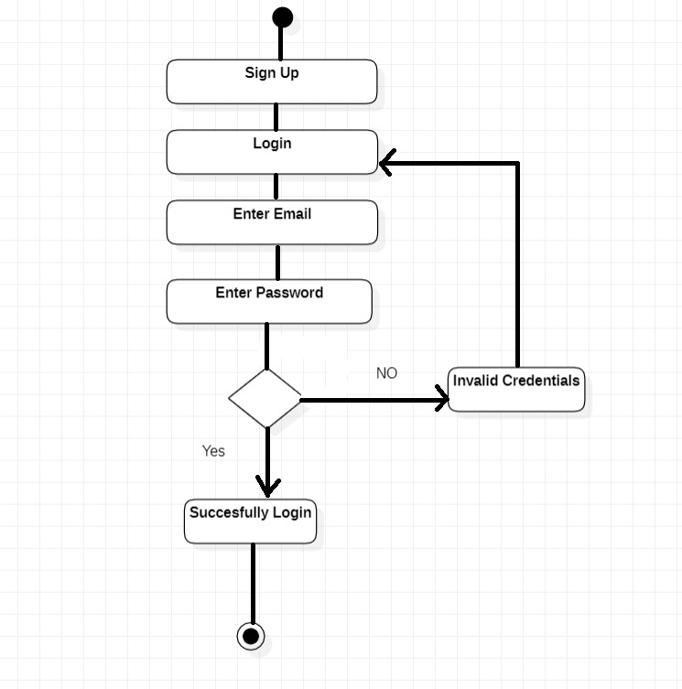

**Module 2: Place Voice Record**

*Figure 6: Activity Diagram for Module 2*

**Module 3 and 4: Vector and Image Generation Via Voice**

*Figure 7: Activity Diagram for Module 3 and 4*

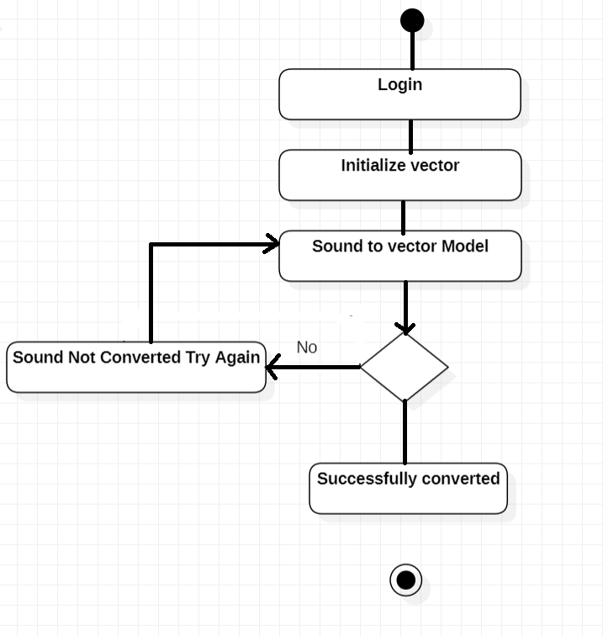

**Module 5: Image View Customization**

*Figure 8: Activity Diagram for Module 5*

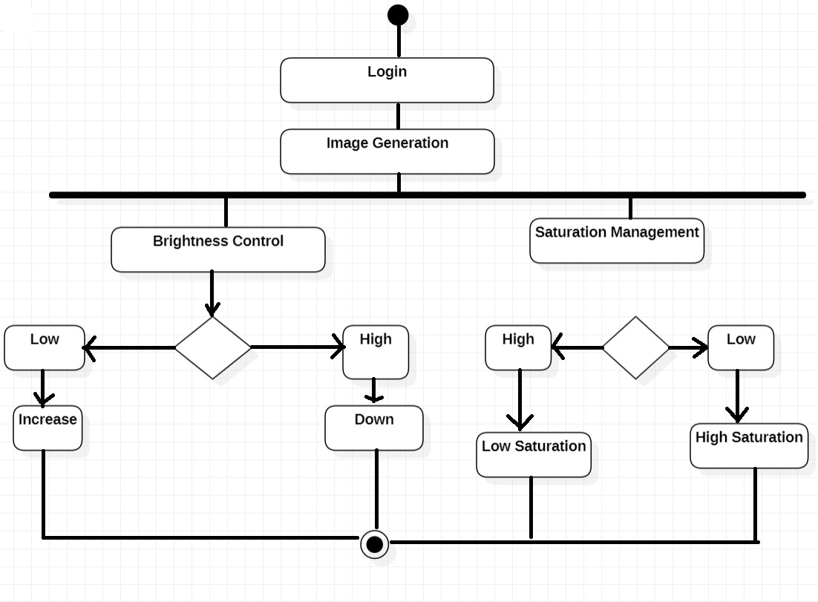

**Module 6: Features Enhancer**

*Figure 9: Activity Diagram for Module 6*

**Module 7: Insight Module**

*Figure 10: Activity Diagram for Module 7*

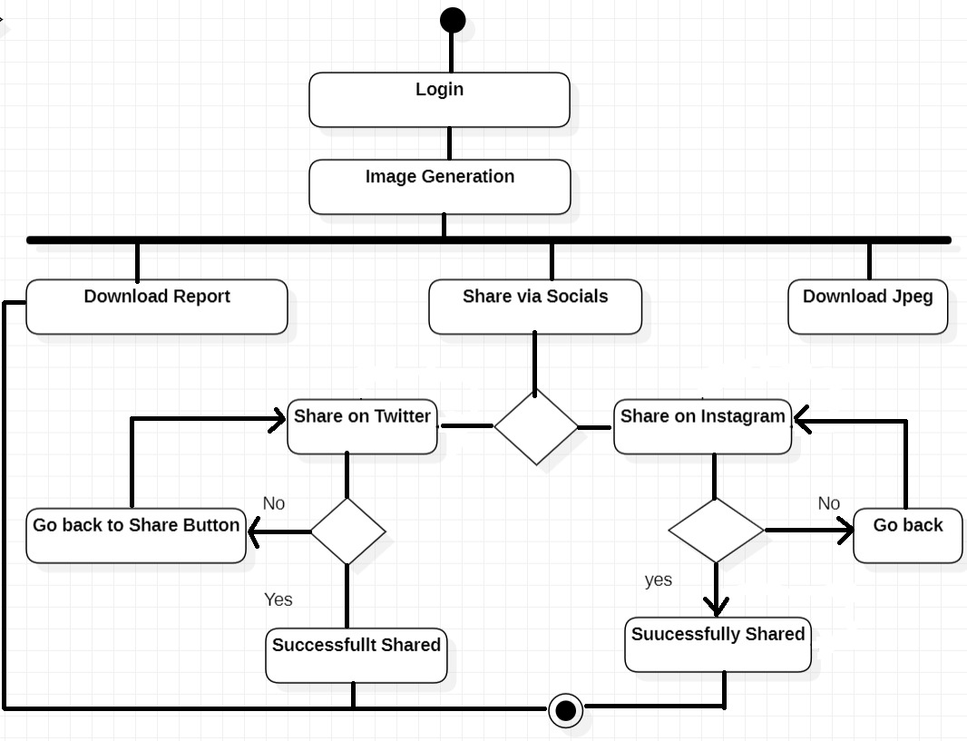

**Module 8: Feedback Panel**

*Figure 11: Activity Diagram for Module 8*

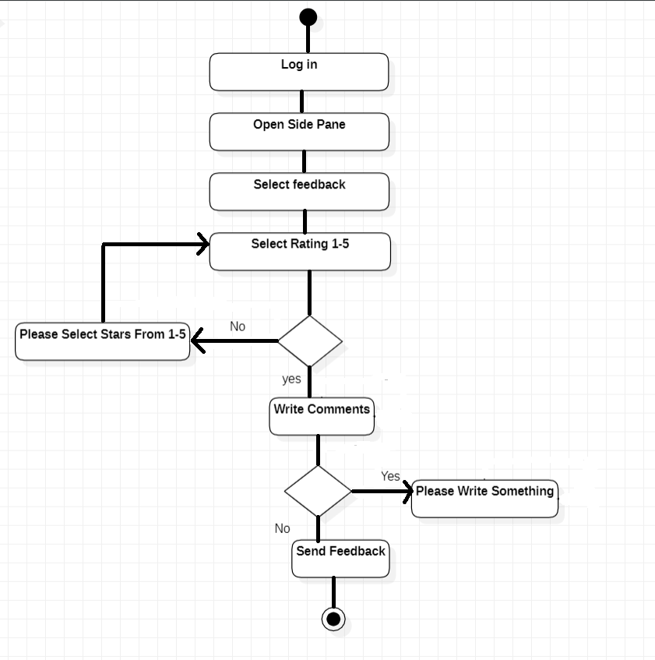

**Module 9: Help and Support**

*Figure 12: Activity Diagram for Module 9*

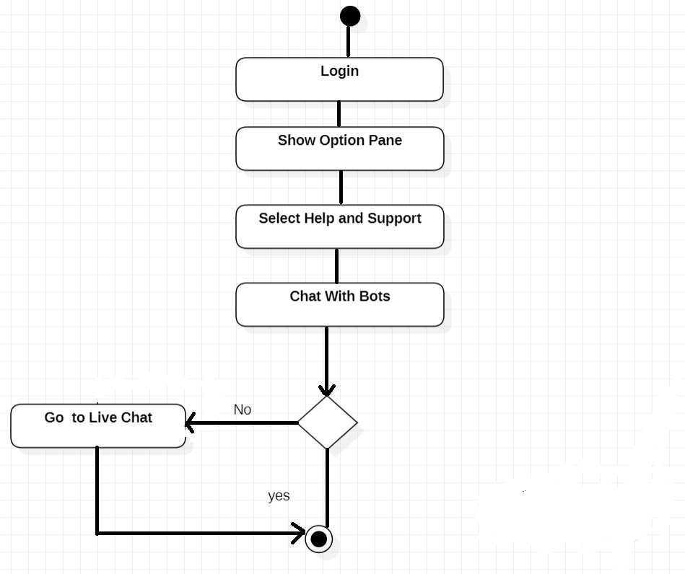

# Design Models

# Class Diagram

Following are some of the Class diagram of the application **“Speech2Face System”:**

*Figure 13: Class Diagram for Speech2Face System*

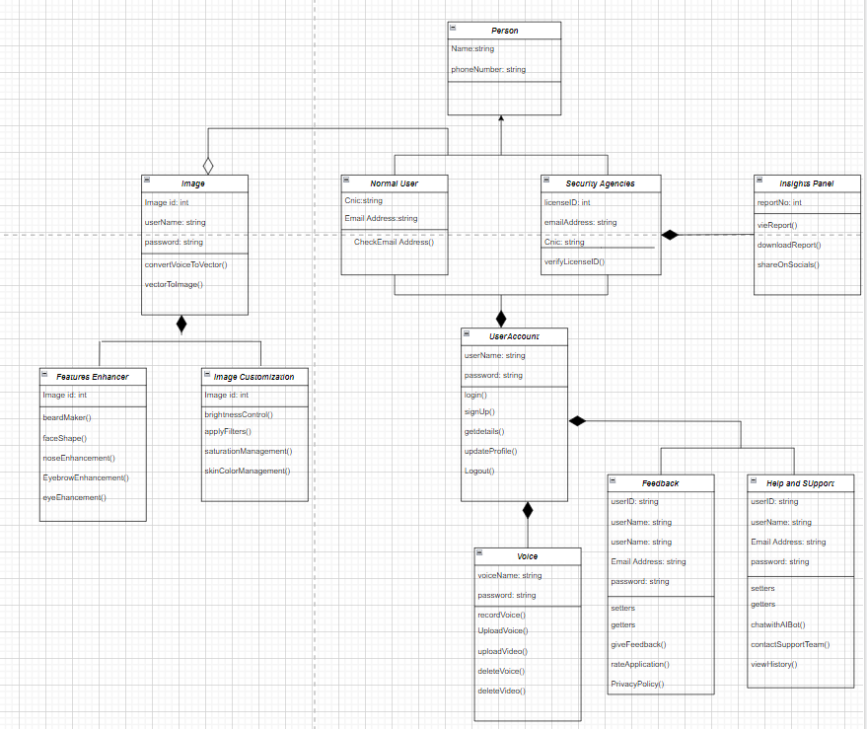

# Sequence Diagrams

# Following are some of the Class diagram of the application “Speech2Face System”:

**Module 1: Profile Management**

*Figure 14: Sequence Diagram for Module 1*

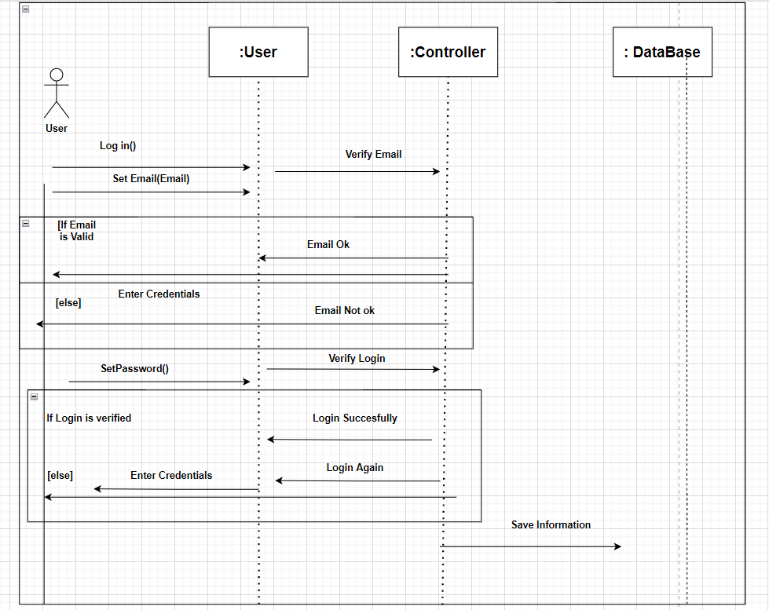

**Module 2: Place Voice Record**

*Figure 15: Sequence Diagram for Module 2*

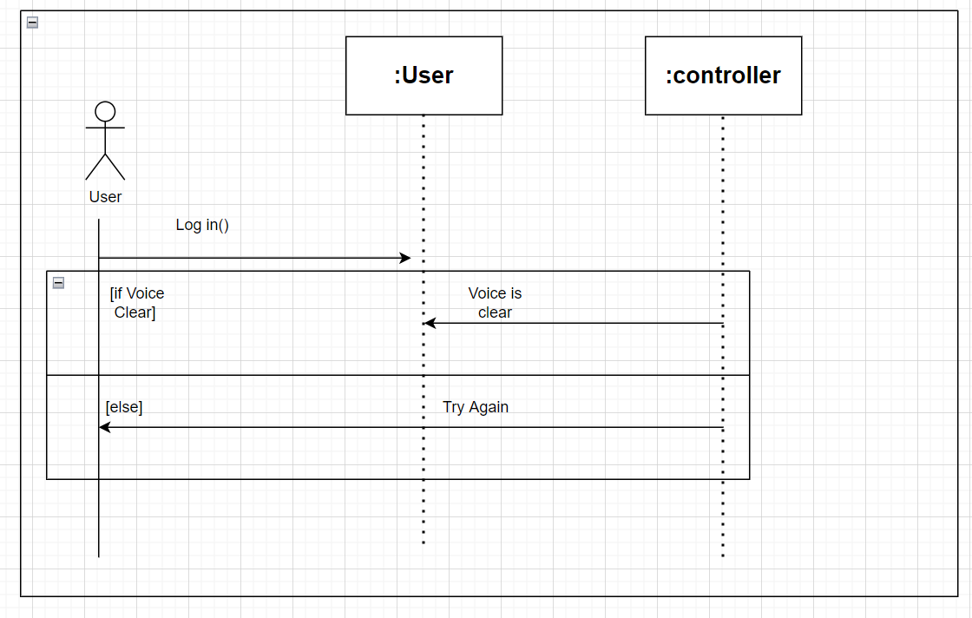

**Module 3 and 4: Vector and Image Generation Via Voice**

*Figure 16: Sequence Diagram for Module 3 and 4*

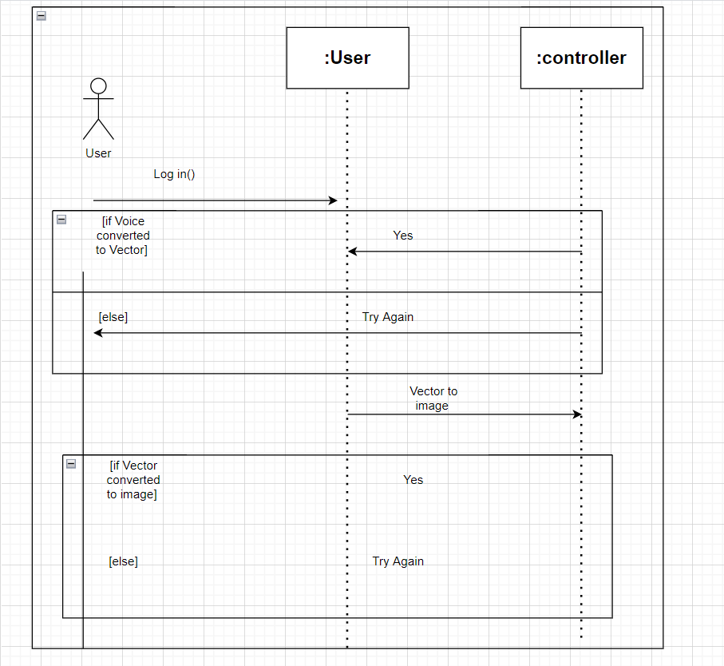

**Module 5: Image View Customization**

*Figure 17: Sequence Diagram for Module 5*

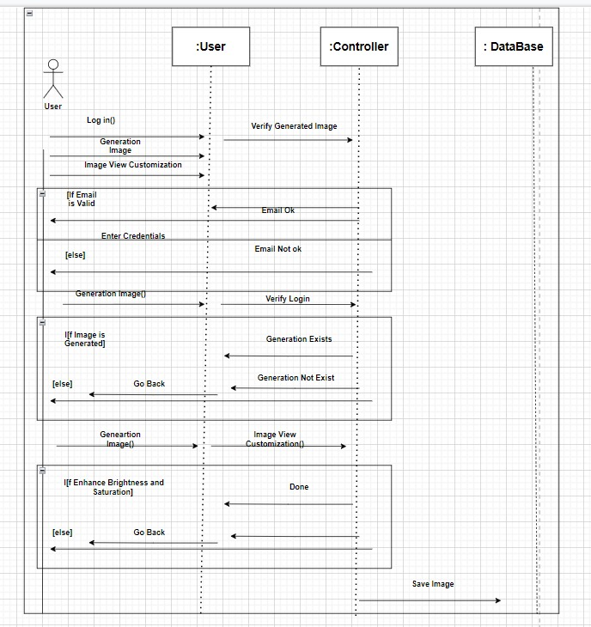

**Module 6: Features Enhancer**

*Figure 18: Sequence Diagram for Module 6*

**Module 7: Insight Module**

*Figure 19: Sequence Diagram for Module 7*

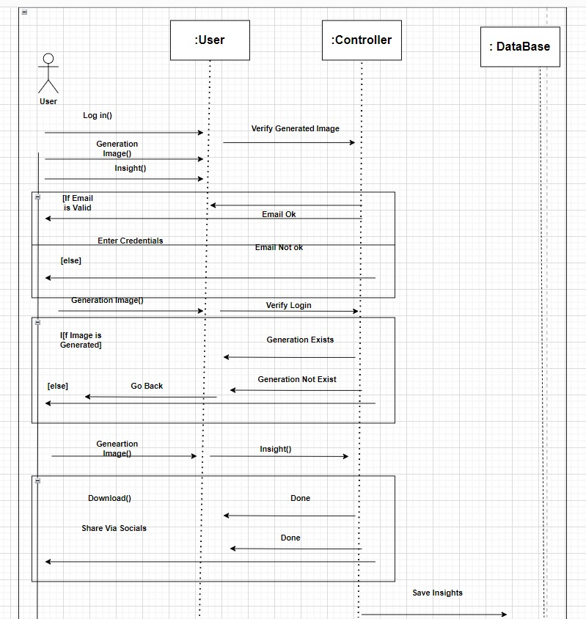

**Module 8: Feedback Panel**

*Figure 20: Sequence Diagram for Module 8*

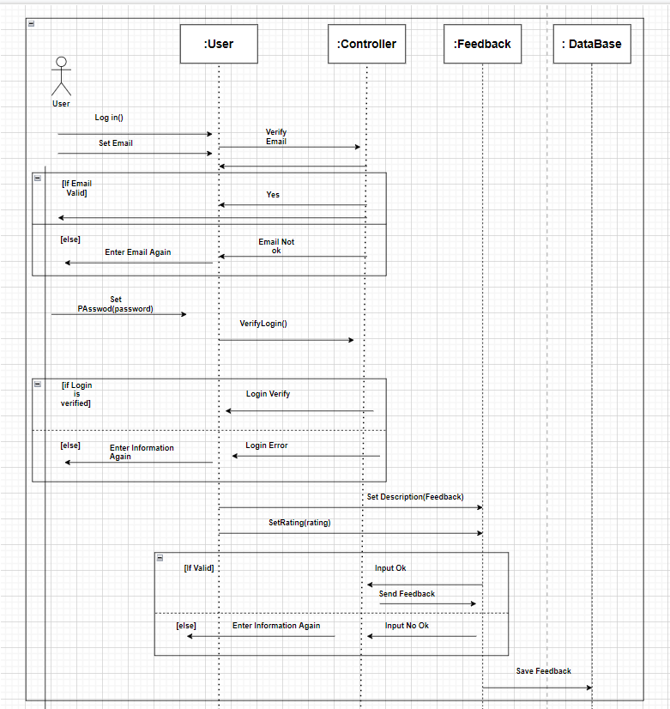

**Module 9: Help and Support**

*Figure 21: Sequence Diagram for Module 9*

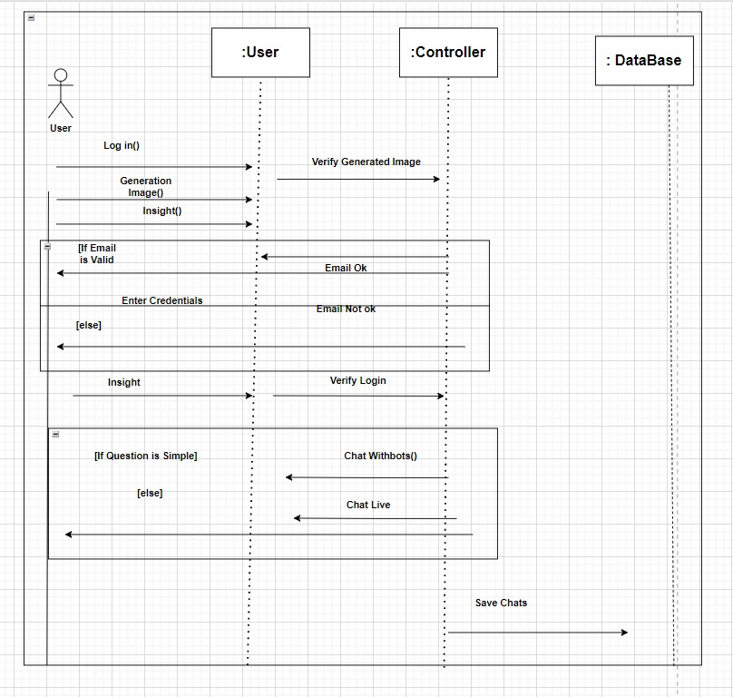

# Implementation

This chapter thoroughly discusses the implementation procedures used in the RPC System. Our project is divided into 9 modules.

# Algorithm

## Sign up and Login

DO

INPUT email

IF(verifyEmail NOT EQUAL true)

DISPLAY “Invalid Email”

WHILE (verifyEmail EQUAL false)

INPUT password

IF(account NOT found)

DISPLAY “Invalid login credentials! Please try again!”

ELSE

DISPLAY “Successfully logged in!”

## Adding Voice Record

IF(Login)

Do

INPUT VOICE RECORD

INPUT USER_ID

IF(VOICE NOT DELETED)

DISPLAY “VOICE SAVED”

## Voice to Vector Modeling

IF (Login && voiceSaved)

InitialzeVectorModeling

WHILE(!Modeling successful)

Initialize Again

ELSE

Generate Vector

DISPLAY ”Generate and Save Vector Image”

## Vector to Image Modeling

IF (Login && VectorIsSaved)

InitialzeImageModeling

WHILE(!Modeling successful)

Initialize Again

ELSE

GENERATE Image

DISPLAY “Image Saved”

## Image View Customization

IF (Login && ImageSaved)

ShowCutomizeButton

IF(CustomizedButtonClicked)

ShowCustomizeScreen

WHILE(Brightness || saturation || hue)

setController;

MODIFY Image

DISPLAY Image

## Features Enhancer

IF(login && ImageGenerated)

ShowFeaturesEnhancer

SELECT NOSE , EYE, HAIR , SKIN COLOR

WHILE (NOSE || EYE || HAIR || SKIN is Modifying)

setController;

MODIFY Image

DISPLAY Image

## Insight Panel

IF(login && ImageGenerated)

ShowInsightsPanel

SELECT (Download via JPG || DOCX || Share via socials)

ExecuteSelectedCommand();

**Following are the API used by Speech2face -System:**

|  |  |  |
| --- | --- | --- |
| **Name of API** | **Description** | **Purpose** |
| Dialog-flow API | Dialog-flow API is an AI powered chatbot for user support. It turns FAQ content into a helper bot. | Eliminates the need for a human to be available 24/7 to resolve redundant and common queries. |
| Face net API by Google | Google’s face net is a powerful dataset governed by Deep learning modules. | Google is working on speech2face functionality, and it has maintained great data sets so we will use it to transform voice into image |
| Firebase (Auth,Firestore) | Firebase is the ready-made backend. Auth is used for the authentication-purpose whereas Firestore serves as the noSQL based Database. | It eliminates the need of custom backend which costs the user high and is time consuming for making one. |
| Google Ads API | The Google Ads API lets advertisers manage large Google Ads accounts and lets developers make applications that use these ads | A way to provides user free services but the development team still gets revenue out of it. |

# User Interface

* **Mobile User Interface**

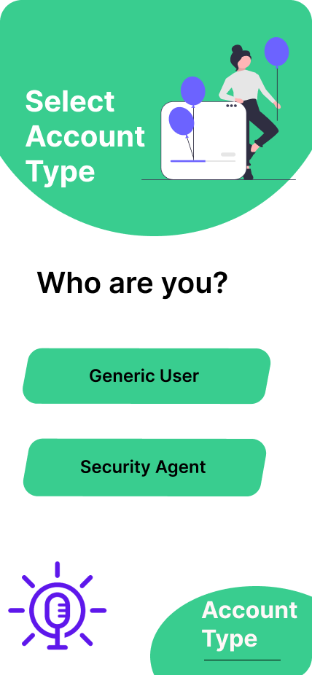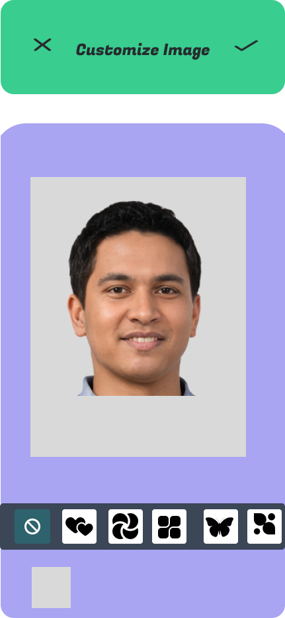

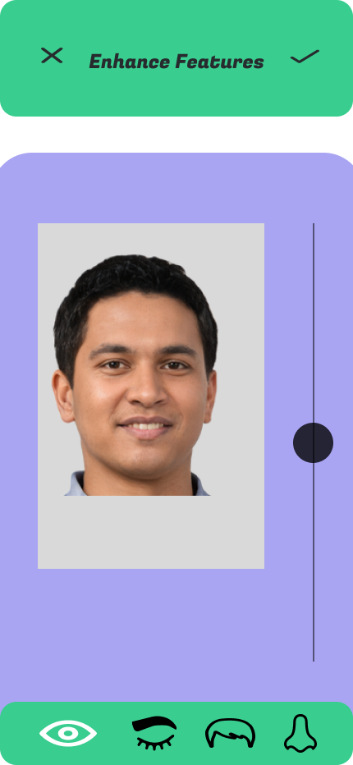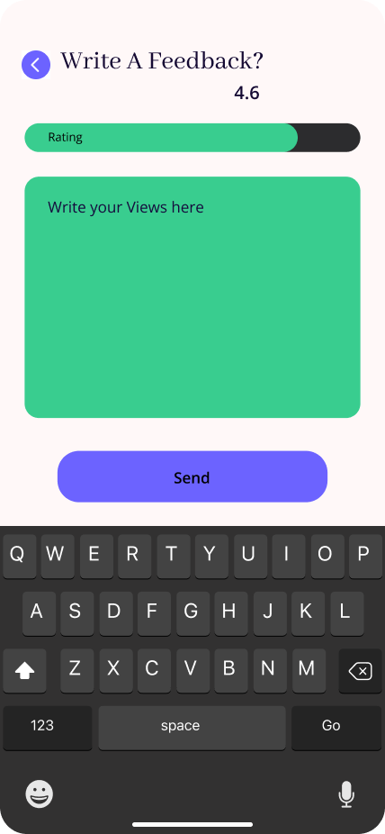

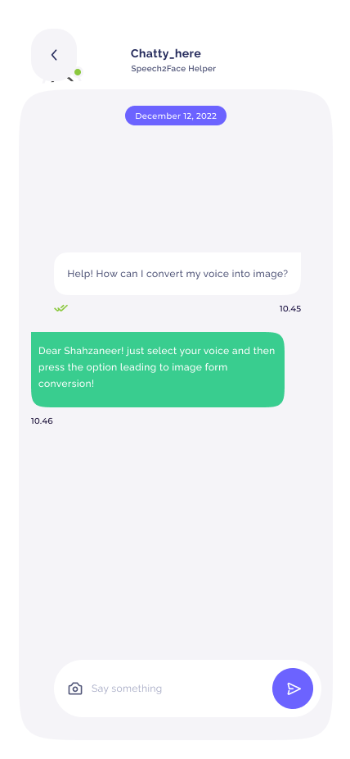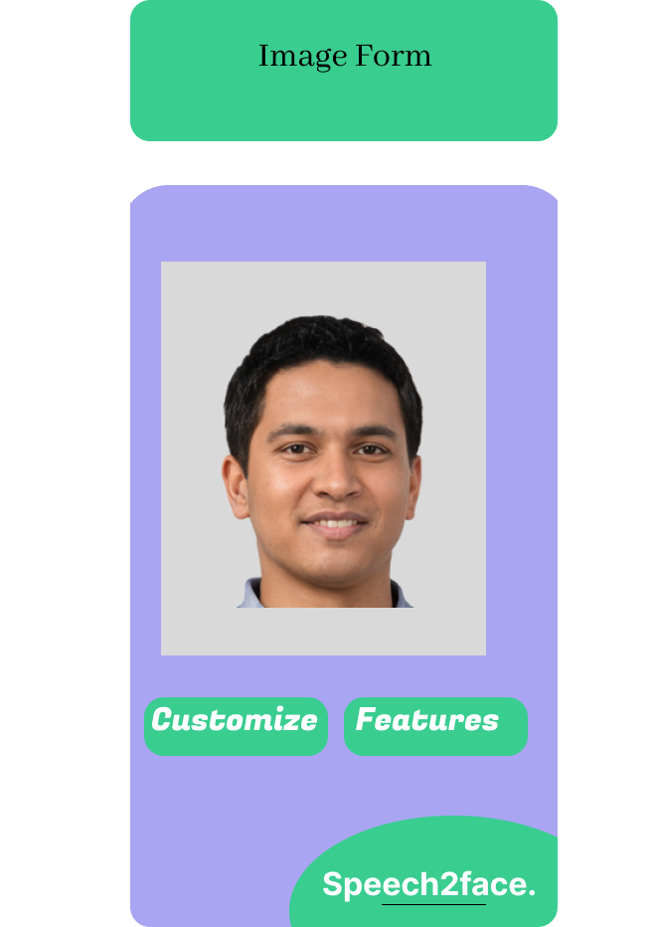

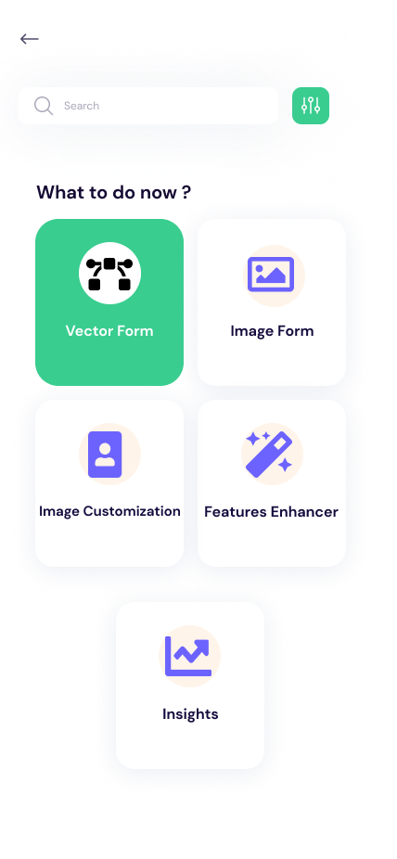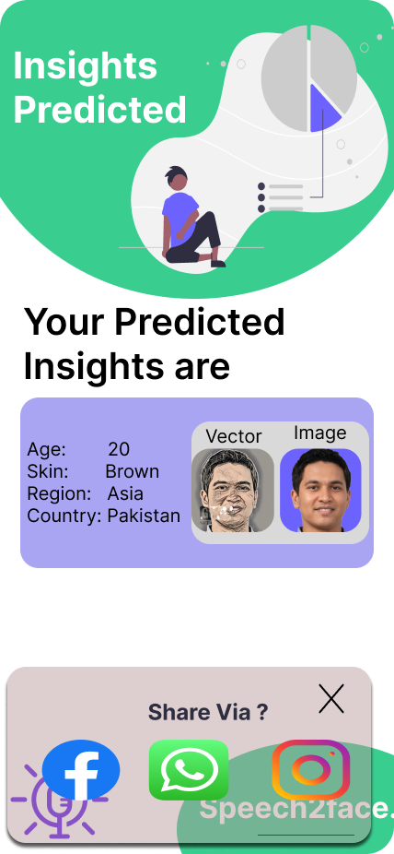

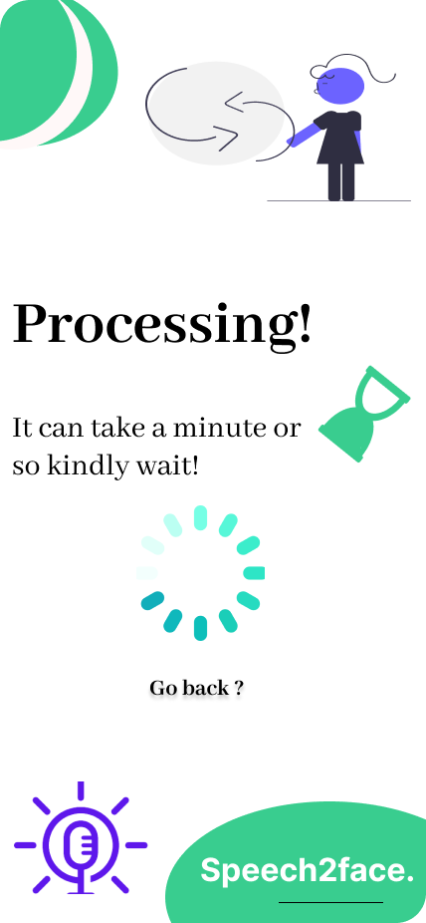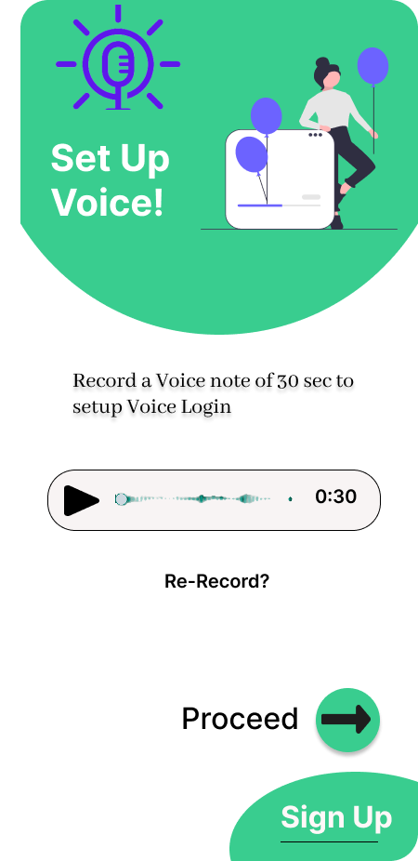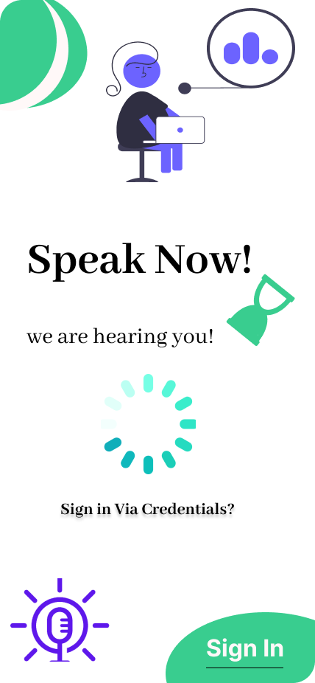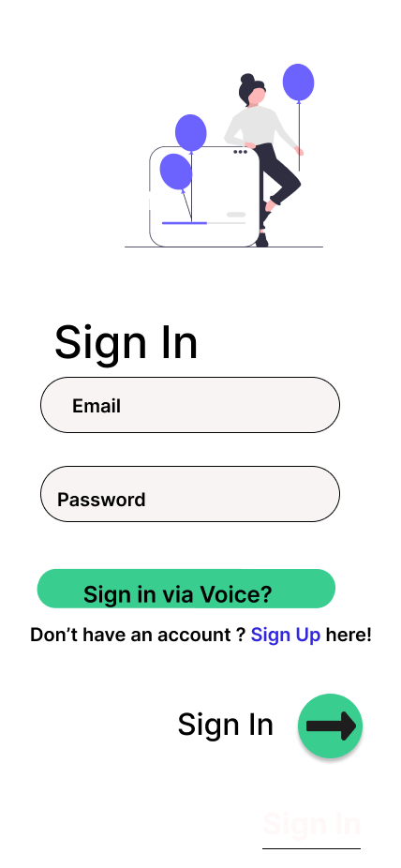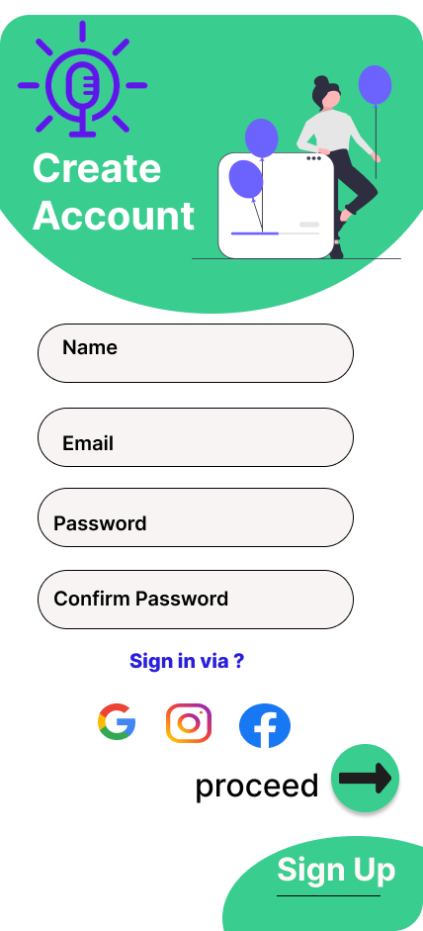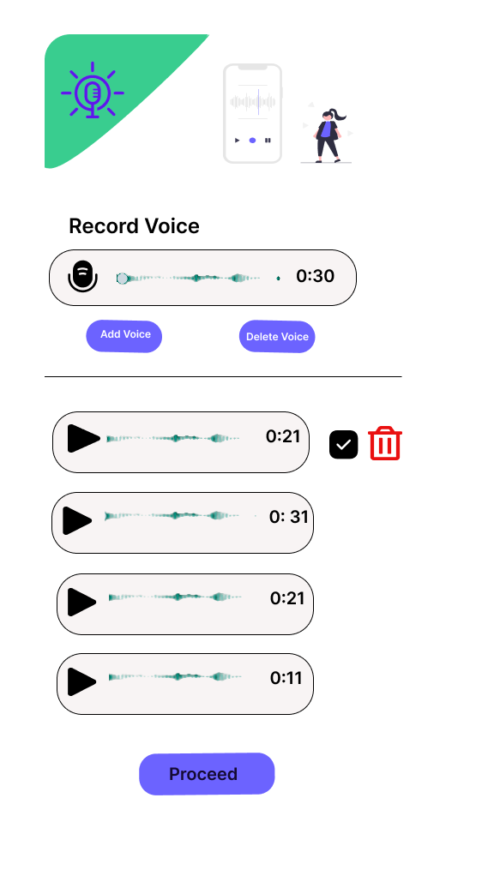

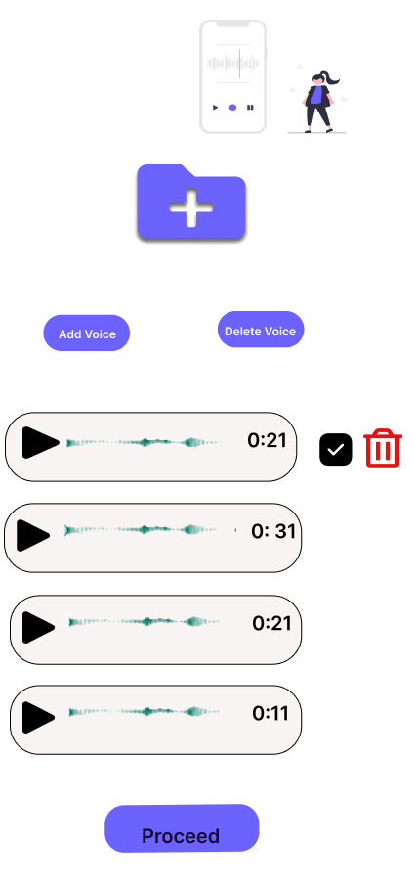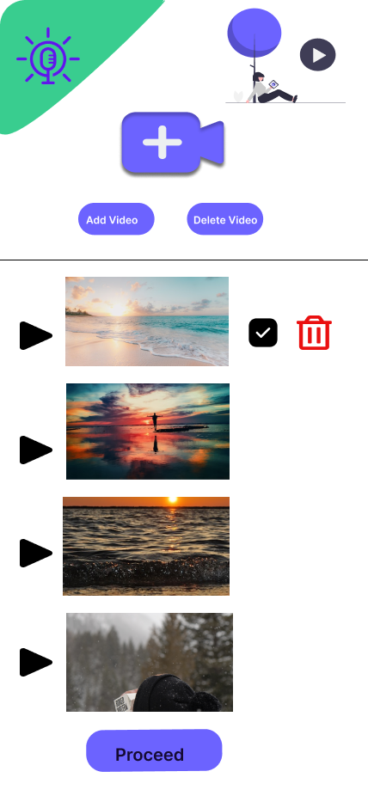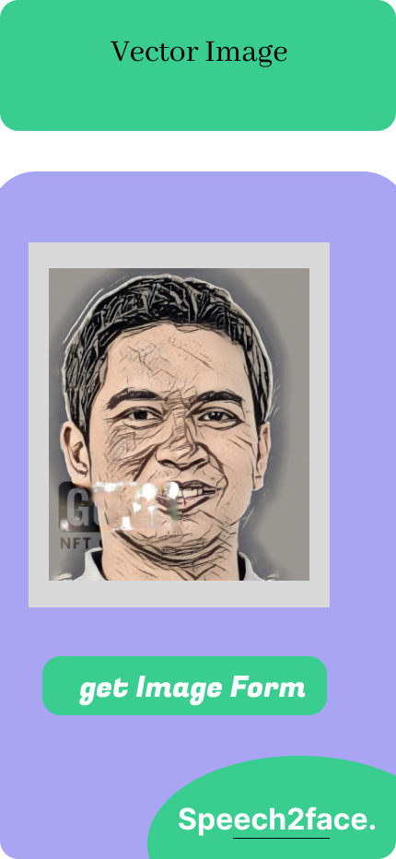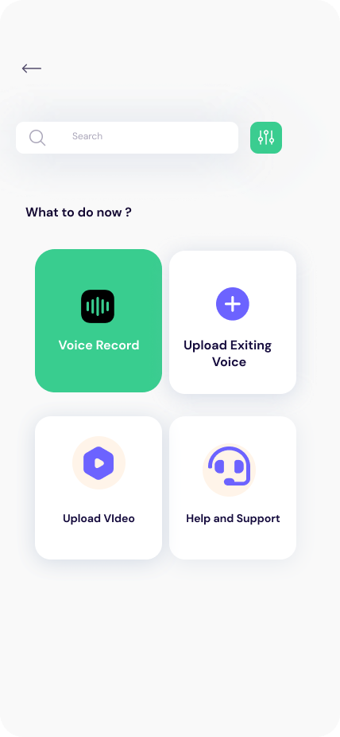

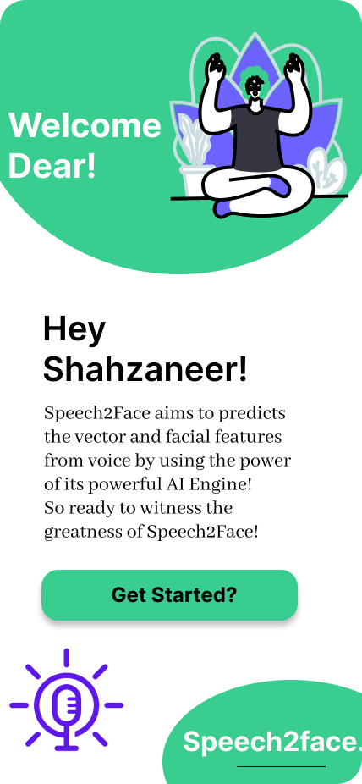

* **Web User Interface**

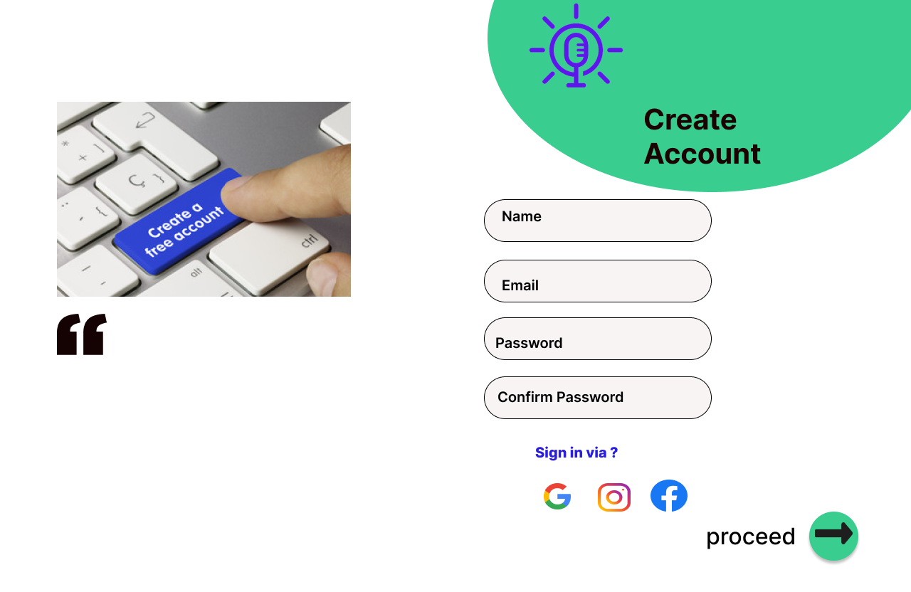

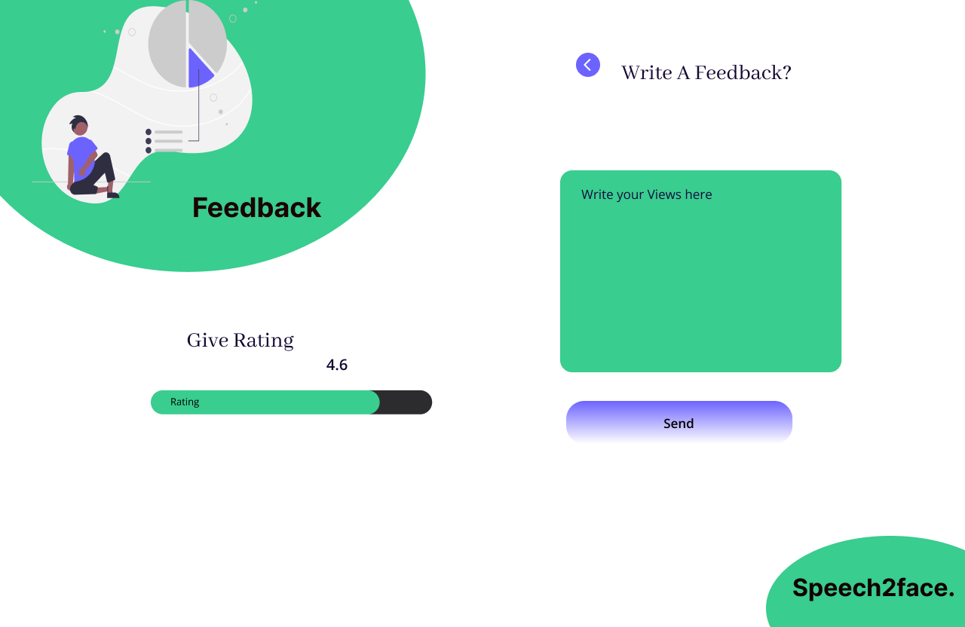

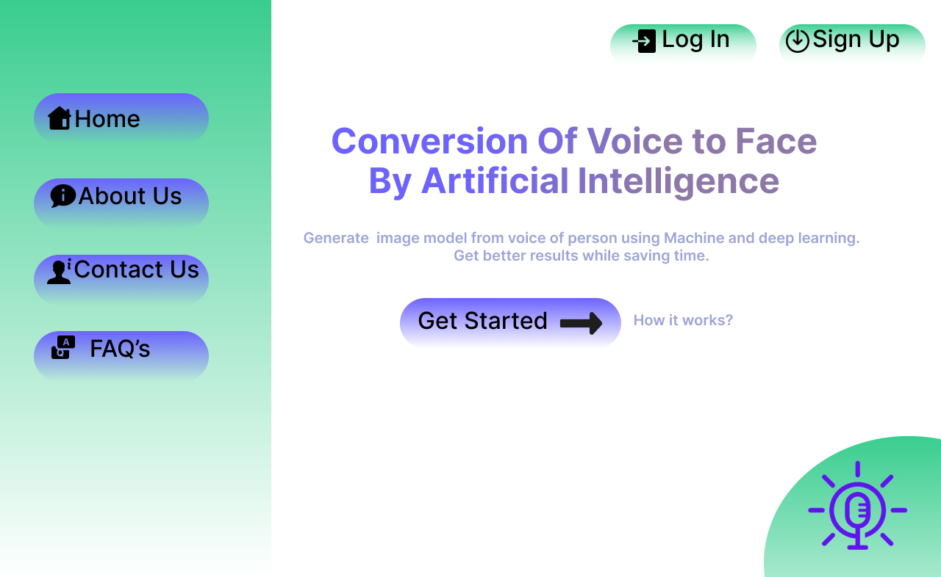

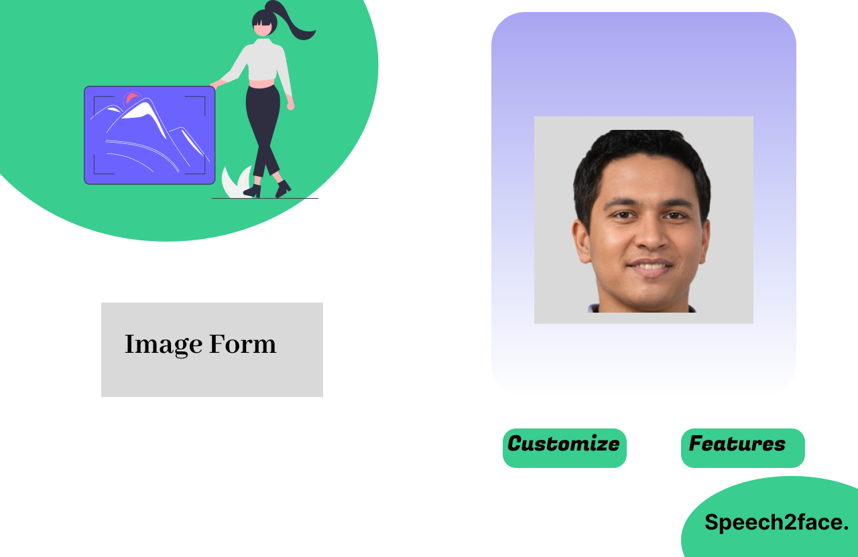

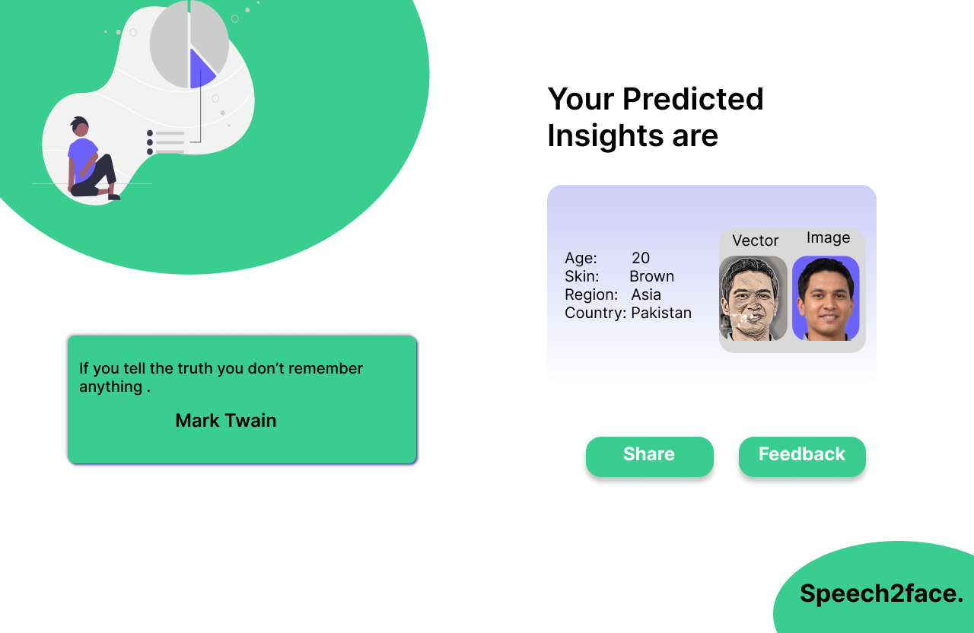

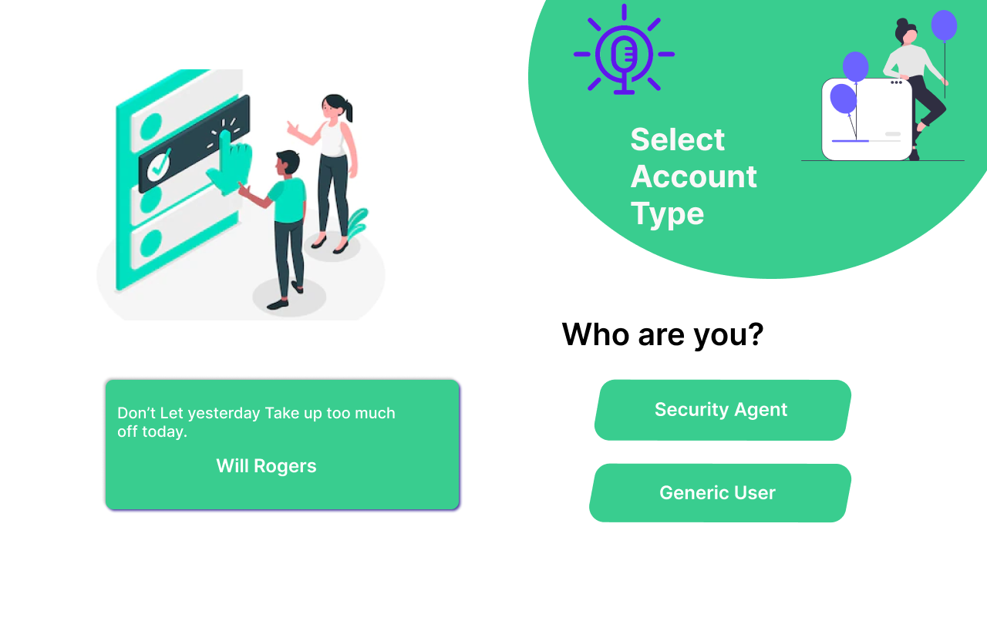

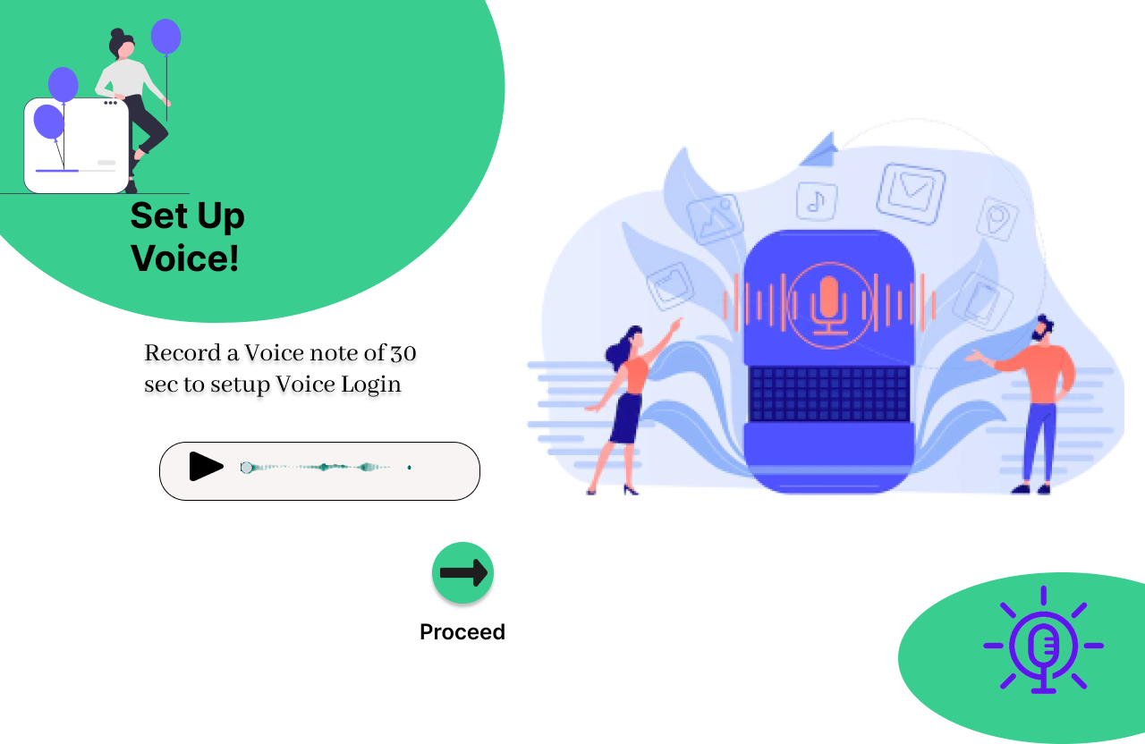

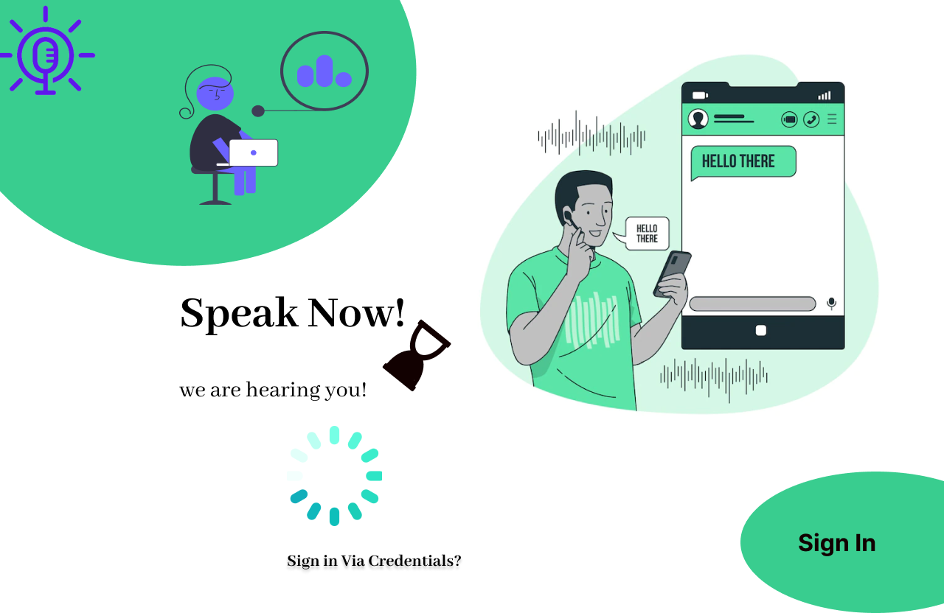

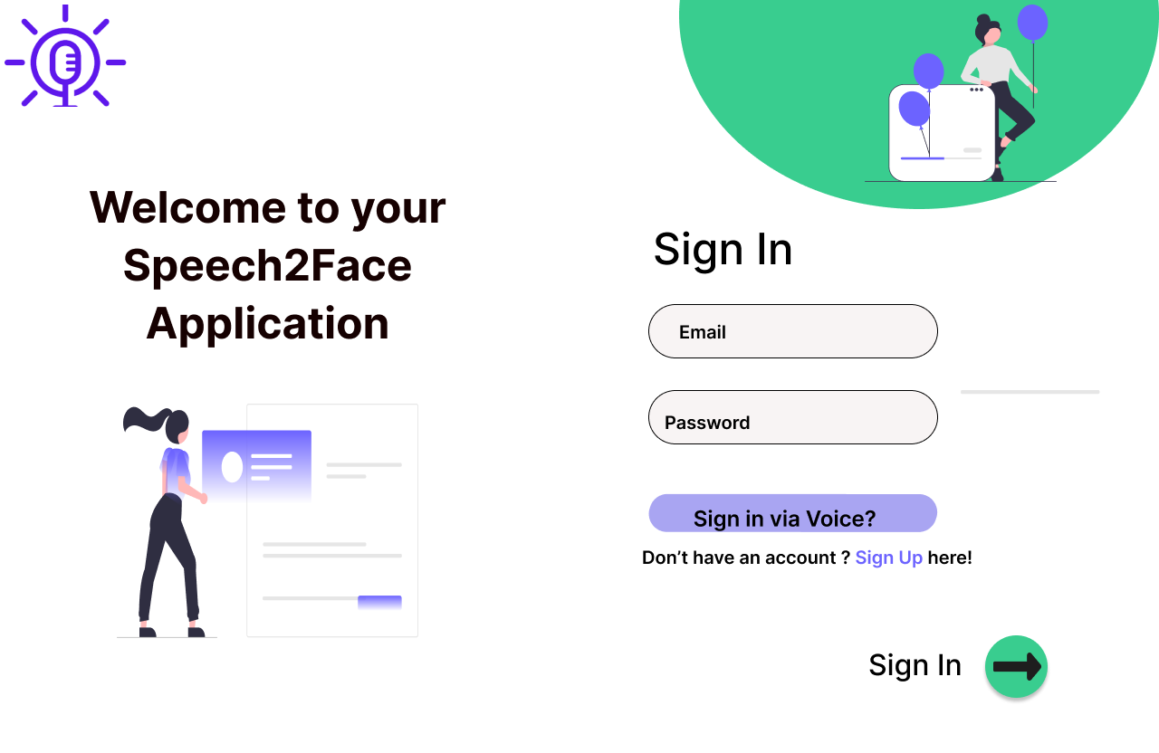

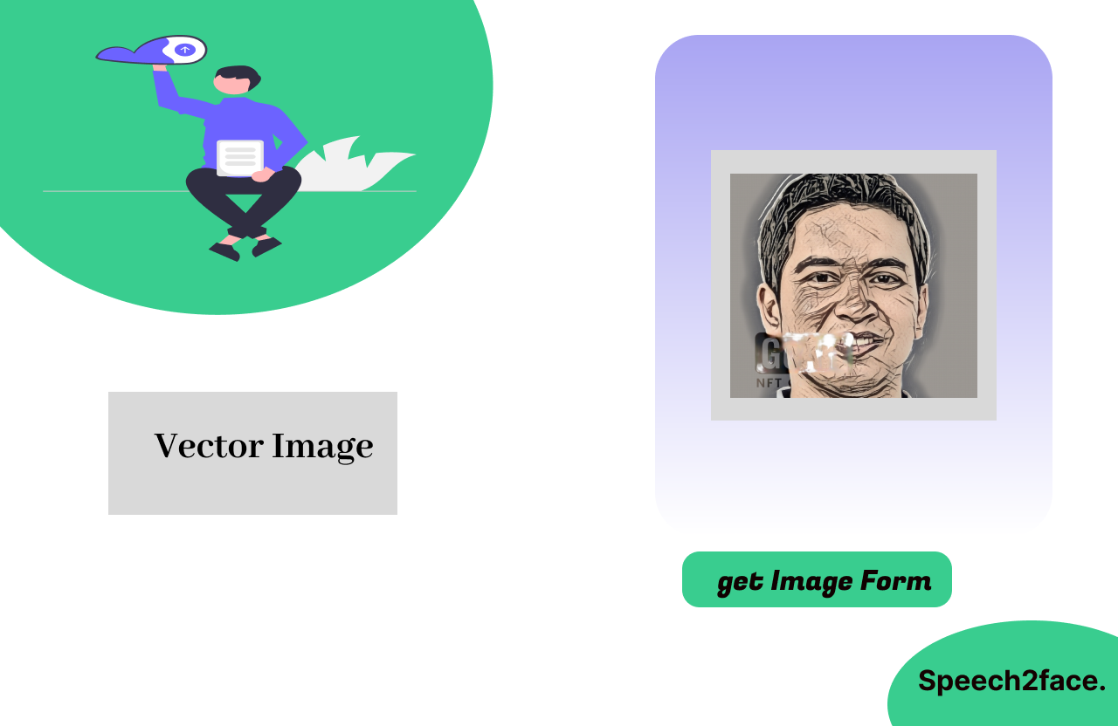

# Testing and Evaluation

This chapter discusses the verification and validation process of the overall working of the implemented system. Using Grey Box testing technique, each project use case is thoroughly tested with carefully curated test cases to ensure the product is producing desired results. These test cases are documented in this section to give an overview of the testing phase along with the contrast between expected and actual results of these test cases. Grey Box testing was opted because of its property of efficient and thorough testing at both internal and external level of product.

* 1. **Verification**

All the processes cycle of the system are tested thoroughly to make sure that the system is bug free as much as possible. All the prepared documents, design and code are tested to check whether they are according to the requirements or not. All the security measures are evaluated in detail. The data from each user needs to be verified because the app has to deal with it.

* 1. **Validation**

The key objective of validation is to make sure that whether the product being built is according to the user requirements or not. So, validation of the system is done make sure that all the built product is in accordance with the user requirements.

* 1. **Usability Testing**

The features and uses of the system are checked whether they are user-friendly or not. The usability will be tested to make sure that the end-user can understand the product easily. As the system will be used by both technical and non-technical users, they should not face any major bugs.

* 1. **Module/Unit Testing**

It is the most basic level of testing. So, each functional requirement is tested individually by the group members. The functional requirements of each module are tested. Most of the bugs can be found in this phase because each basic functional requirement is checked thoroughly.

* 1. **Integration Testing**

Integration level testing is done to make sure that the modules and major components of the system are working properly as an entire entity. Testing is done to detect all kinds of major and minor bugs.

* 1. **System Testing**

In system level testing, the system is tested as a whole after the implementation of each module. Unusual operations are performed to find any bugs or failure of the system. The functionalities of the system are tested to ensure that the system’s result satisfy the user requirements.

* 1. **Acceptance Testing**

The software is deployed to the users or clients, and it will be checked whether the system is accepted by them or not. It is also made sure that the system is fulfilling their requirements.

* 1. **Manual Testing**

The software is used by testers, clients and customers manually without any access to the source code. Each module and functionality is tested thoroughly to check whether it produces the desired results at the end user level.

* 1. **Test Cases**

The testing of our system are discussed in detail below:

* + 1. **Unit Testing**
       - ***Module 1: Profile Management***

*Table 135: Description of List of Use Cases of Module 1*

|  |  |
| --- | --- |
| **UC-ID** | **Use Case Name** |
| **UC-1.1** | Sign up |
| **UC-1.2** | Log in |
| **UC-1.3** | Sign in Via Phone |
| **UC-1.4** | Sign in Via Voice |
| **UC-1.5** | Update Profile |
| **UC-1.6** | Logout |

* **TC-1.1 against UC-1.1**

*Table 136: Test Case 1.1 against UC-1.1*

|  |  |  |  |
| --- | --- | --- | --- |
| **Test Id:** | TC-1.1 | **Test Case Designed by:** | Shahzaneer Ahmed |
| **Test Case Title:** | Sign Up | **Test Case Executed by:** | Shayan Zameer |
| **Module Name:** | Profile Management | **Test Case Execution Date:** | 20-12-2022 |
| **Test Data:** | Email: [Sp21@gmail.com](mailto:Sp21@gmail.com),  Password: sp_123 | **Priority:** | High |
| **Steps /Action** | | **System Response** | |
| 1. Load the web URL or click on mobile application icon. 2. Select Get Started. 3. Create new Account. 4. Enter registered password to login. 5. Press Login Button. 6. Select User or Security Person as your Role | | 1. Main application homepage will open. 2. Sign un screen will open. 3. Email is accepted. 4. Password and confirm password are accepted. 5. Account is logged in. Role Selection Page is displayed. 6. You are directed to the login Screen | |
| **Expected Result:** | | Successfully Signed up. | |
| **Actual Result:** | | Successfully Signed up. | |
| **Status:** | | Pass. | |

* **TC-1.2 against UC-1.2**

***Table 137: Test Case 1.2 against UC-1.2***

|  |  |  |  |
| --- | --- | --- | --- |
| **Test Id:** | TC-1.2 | **Test Case Designed by:** | Shahzaneer Ahmed |
| **Test Case Title:** | Login in | **Test Case Executed by:** | Shayan Zameer |
| **Module Name:** | Profile Management | **Test Case Execution Date:** | 20-12-2022 |
| **Test Data:** | Email: [Sp21@gmail.com](mailto:Sp21@gmail.com),  Password: sp_123 | **Priority:** | High |
| **Steps /Action** | | **System Response** | |
| 1. Load the web URL or click on mobile application icon. 2. Select Get Started. 3. Enter registered email to log in. 4. Enter registered password to login. 5. Press Login Button. 6. Select User or Security Person as your Role | | 1. Main application homepage will open. 2. Log in screen will open. 3. Email is accepted. 4. Password is accepted 5. Account is logged in. Role Selection Page is displayed. 6. Dashboard is opened. | |
| **Expected Result:** | | Successfully Logged in. | |
| **Actual Result:** | | Successfully Logged in. | |
| **Status:** | | Pass. | |

* **TC-1.3 against UC-1.3**

***Table 138: Test Case 1.3 against UC-1.3***

|  |  |  |  |
| --- | --- | --- | --- |
| **Test Id:** | TC-1.3 | **Test Case Designed by:** | Shahzaneer Ahmed |
| **Test Case Title:** | Sign in Via phone | **Test Case Executed by:** | Shayan Zameer |
| **Module Name:** | Profile Management | **Test Case Execution Date:** | 20-12-2022 |
| **Test Data:** | Email: [Sp21@gmail.com](mailto:Sp21@gmail.com),  Password: sp_123  Phone No: 03164606490 | **Priority:** | Medium |
| **Steps /Action** | | **System Response** | |
| 1. Load the web URL or click on mobile application icon. 2. Select Get Started. 3. Enter registered email to log in. 4. Enter login via phone. 5. Enter the phone no. 6. Enter the OTP sent to your number. 7. Select User or Security Person as your Role | | 1. Main application homepage will open. 2. Log in screen will open. 3. Email is accepted. 4. Phone number is accepted. 5. OTP is accepted. 6. Account is logged in. Role Selection Page is displayed. 7. Dashboard is opened. 8. Voice option is displayed and to be recorded successfully. | |
| **Expected Result:** | | Login Successful | |
| **Actual Result:** | | Login Successful | |
| **Status:** | | Pass. | |

* **TC-1.4 against UC-1.4**

***Table 139: Test Case 1.4 against UC-1.4***

|  |  |  |  |
| --- | --- | --- | --- |
| **Test Id:** | TC-1.4 | **Test Case Designed by:** | Shahzaneer Ahmed |
| **Test Case Title:** | Sign in Via Voice | **Test Case Executed by:** | Shayan Zameer |
| **Module Name:** | Profile Management | **Test Case Execution Date:** | 20-12-2022 |
| **Test Data:** | Email: [Sp21@gmail.com](mailto:Sp21@gmail.com),  Password: sp_123  Voice record in MP3 form | **Priority:** | High |
| **Steps /Action** | | **System Response** | |
| 1. Load the web URL or click on mobile application icon. 2. Select Get Started. 3. Enter registered email to log in. 4. Select the login via voice option. 5. Record your voice till 30 sec. 6. The main Dashboard will be shown | | 1. Main application homepage will open. 2. Log in screen will open. 3. Email is accepted. 4. Voice is recorded. 5. Voice is matched 6. Dashboard is opened or error message to record again or go back is shown. | |
| **Expected Result:** | | Login Successfully | |
| **Actual Result:** | | Login Successfully | |
| **Status:** | | Pass. | |

* **TC-1.5 against UC-1.5**

***Table 140: Test Case 1.5 against UC-1.5***

|  |  |  |  |
| --- | --- | --- | --- |
| **Test Id:** | TC-1.5 | **Test Case Designed by:** | Shahzaneer Ahmed |
| **Test Case Title:** | Update Profile | **Test Case Executed by:** | Shayan Zameer |
| **Module Name:** | Profile Management | **Test Case Execution Date:** | 20-12-2022 |
| **Test Data:** | Updated-Email: [Sp21@gmail.com](mailto:Sp21@gmail.com),  Updated Password: sp_1299 | **Priority:** | High |
| **Steps /Action** | | **System Response** | |
| 1. Load the web URL or click on mobile application icon. 2. Select Get Started. 3. Enter registered email to log in. 4. Enter registered password to login. 5. Press Login Button. 6. Select User or Security Person as your Role 7. Select update profile. 8. Enter valid email and password. | | 1. Main application homepage will open. 2. Log in screen will open. 3. Email is accepted. 4. Password is accepted 5. Account is logged in. Role Selection Page is displayed. 6. Update Page will be shown which will prompt the user to add the updated details 7. Updated password and email is accepted | |
| **Expected Result:** | | Profile updated Successfully | |
| **Actual Result:** | | Profile updated Successfully | |
| **Status:** | | Pass. | |

* **TC-1.6 against UC-1.6**

***Table 141: Test Case 1.6 against UC-1.6***

|  |  |  |  |
| --- | --- | --- | --- |
| **Test Id:** | TC-1.6 | **Test Case Designed by:** | Shahzaneer Ahmed |
| **Test Case Title:** | Log Out | **Test Case Executed by:** | Shayan Zameer |
| **Module Name:** | Profile Management | **Test Case Execution Date:** | 20-12-2022 |
| **Test Data:** | Email: [Sp21@gmail.com](mailto:Sp21@gmail.com),  Password: sp_123 | **Priority:** | High |
| **Steps /Action** | | **System Response** | |
| 1. Load the web URL or click on mobile application icon. 2. Select Get Started. 3. Enter registered email to log in. 4. Enter registered password to login. 5. Press Login Button. 6. Select User or Security Person as your Role 7. Click logout button in your profile section. 8. Confirm Logout. | | 1. Main application homepage will open. 2. Log in screen will open. 3. Email is accepted. 4. Password is accepted 5. Account is logged in. Role Selection Page is displayed. 6. Dashboard is opened. 7. You will be asked to confirm if you want to logout. 8. You will be logged out. 9. You will be directed to the sign up/ login screen. | |
| **Expected Result:** | | Logout Successfully. | |
| **Actual Result:** | | Logout Successfully. | |
| **Status:** | | Pass. | |

* + - * ***Module 2: Place a voice record***

***Table 142: Description of list of Use case of Module 2***

|  |  |
| --- | --- |
| **UC-ID** | **Use Case Name** |
| **UC-2.1** | Record Voice |
| **UC-2.2** | Upload Existing Voice |
| **UC-2.3** | Upload Existing Video to fetch Voice |
| **UC-2.4** | Update Voice |
| **UC-2.5** | Update Video |
| **UC-2.6** | Delete Voice |
| **UC-2.7** | Delete Video |

* **TC-2.1 against UC-2.1**

***Table 143: Test Case 2.1 against UC-2.1***

|  |  |  |  |
| --- | --- | --- | --- |
| **Test Id:** | TC-2.1 | **Test Case Designed by:** | SHAYAN ZAMEER |
| **Test Case Title:** | Check Record Voice | **Test Case Executed by:** | Shahzaneer Ahmad |
| **Module Name:** | Place Voice Record | **Test Case Execution Date:** | 20-12-2022 |
| **Test Data:** | Email: [Sp21@gmail.com](mailto:Sp21@gmail.com),  Password: sp_123 | **Priority:** | High |
| **Steps /Action** | | **System Response** | |
| 1. Load the web URL or click on mobile application icon. 2. Select Get Started. 3. Enter registered email to log in. 4. Enter registered password to login. 5. Press Login Button. 6. Select User or Security Person as your Role 7. Select the Record Voice option and record Voice. | | 1. Main application homepage will open. 2. Log in screen will open. 3. Email is accepted. 4. Password is accepted 5. Account is logged in. Role Selection Page is displayed. 6. Dashboard is opened. 7. Voice option is displayed and to be recorded successfully. | |
| **Expected Result:** | | Voice Recorded Successfully. | |
| **Actual Result:** | | Voice Recorded Succesfully. | |
| **Status:** | | Pass. | |

* **TC-2.2 against UC-2.2**

***Table 144: Test Case 2.2 against UC-2.2***

|  |  |  |  |
| --- | --- | --- | --- |
| **Test Id:** | TC-2.2 | **Test Case Designed by:** | SHAYAN ZAMEER |
| **Test Case Title:** | Verify Upload Existing Voice | **Test Case Executed by:** | Shahzaneer Ahmad |
| **Module Name:** | Place Voice Record | **Test Case Execution Date:** | 20-12-2022 |
| **Test Data:** | Email: [Sp21@gmail.com](mailto:Sp21@gmail.com),  Password: sp_123 | **Priority:** | Medium |
| **Steps /Action** | | **System Response** | |
| 1. Load the web URL or click on mobile application icon. 2. Select Get Started. 3. Enter registered email to log in. 4. Enter registered password to login. 5. Press Login Button. 6. Select User or Security Person as your Role. 7. Select the Voice option and then select upload voice option and Upload Existing voice. | | 1. Main application homepage will open. 2. Log in screen will open. 3. Email is accepted. 4. Password is accepted 5. Account is logged in. Role Selection Page is displayed. 6. Dashboard is opened. 7. Response of Uploaded Voice Successfully is displayed. | |
| **Expected Result:** | | Voice Uploaded Successfully. | |
| **Actual Result:** | | Voice was Uploaded. | |
| **Status:** | | Pass | |

* **TC-2.3 against UC-2.3**

***Table 145: Test Case 2.3 against UC-2.3***

|  |  |  |  |
| --- | --- | --- | --- |
| **Test Id:** | TC-2.3 | **Test Case Designed by:** | SHAYAN ZAMEER |
| **Test Case Title:** | Verify Upload Existing Video | **Test Case Executed by:** | Shahzaneer Ahmad |
| **Module Name:** | Place Voice Record | **Test Case Execution Date:** | 20-12-2022 |
| **Test Data:** | Email: [Sp21@gmail.com](mailto:Sp21@gmail.com),  Password: sp_123 | **Priority:** | Medium |
| **Steps /Action** | | **System Response** | |
| * Load the web URL or click on mobile application icon. * Select Get Started. * Enter registered email to log in. * Enter registered password to login. * Press Login Button. * Select User or Security Person as your Role. * Select the Voice option and then select upload Video option and Upload Existing video. | | 1. Main application homepage will open. 2. Log in screen will open. 3. Email is accepted. 4. Password is accepted 5. Account is logged in. Role Selection Page is displayed. 6. Dashboard is opened. 7. Response of Uploaded Voice Successfully is displayed. | |
| **Expected Result:** | | Video Uploaded Successfully. | |
| **Actual Result:** | | Video Was Uploaded. | |
| **Status:** | | Pass. | |

* **TC-2.4 against UC-2.4**

***Table 146: Test Case 2.4 against UC-2.4***

|  |  |  |  |
| --- | --- | --- | --- |
| **Test Id:** | TC-2.4 | **Test Case Designed by:** | SHAYAN ZAMEER |
| **Test Case Title:** | Verify Update Voice | **Test Case Executed by:** | Shahzaneer Ahmad |
| **Module Name:** | Place Voice Record | **Test Case Execution Date:** | 20-12-2022 |
| **Test Data:** | Email: [Sp21@gmail.com](mailto:Sp21@gmail.com),  Password: sp_123 | **Priority:** | Medium |
| **Steps /Action** | | **System Response** | |
| 1. Load the web URL or click on mobile application icon. 2. Select Get Started. 3. Enter registered email to log in. 4. Enter registered password to login. 5. Press Login Button. 6. Select User or Security Person as your Role. 7. Select the Voice option and then select record voice option. 8. User clicks update voice option to update voice. | | 1. Main application homepage will open. 2. Log in screen will open. 3. Email is accepted. 4. Password is accepted 5. Account is logged in. Role Selection Page is displayed. 6. Dashboard is opened. 7. Response of Updated Voice Successfully is displayed. | |
| **Expected Result:** | | Voice Uploaded Successfully. | |
| **Actual Result:** | | Voice was Uploaded Successfully. | |
| **Status:** | | Pass. | |

* **TC-2.5 against UC-2.5**

***Table 147: Test Case 2.5 against UC-2.5***

|  |  |  |  |
| --- | --- | --- | --- |
| **Test Id:** | TC-2.5 | **Test Case Designed by:** | SHAYAN ZAMEER |
| **Test Case Title:** | Verify Update Video | **Test Case Executed by:** | Shahzaneer Ahmad |
| **Module Name:** | Place Voice Record | **Test Case Execution Date:** | 20-12-2022 |
| **Test Data:** | Email: [Sp21@gmail.com](mailto:Sp21@gmail.com),  Password: sp_123 | **Priority:** | Medium |
| **Steps /Action** | | **System Response** | |
| 1. Load the web URL or click on mobile application icon. 2. Select Get Started. 3. Enter registered email to log in. 4. Enter registered password to login. 5. Press Login Button. 6. Select User or Security Person as your Role. 7. Select the Voice option and then select Upload video option. 8. When Video is uploaded, user must click update option to update the video. | | 1. Main application homepage will open. 2. Log in screen will open. 3. Email is accepted. 4. Password is accepted 5. Account is logged in. Role Selection Page is displayed. 6. Dashboard is opened. 7. Response of Updated Video Successfully is displayed. | |
| **Expected Result:** | | Voice Updated Successfully. | |
| **Actual Result:** | | Voice Updated Successfully | |
| **Status:** | | Pass. | |

* **TC-2.6 against UC-2.6**

***Table 148: Test Case 2.6 against UC-2.6***

|  |  |  |  |
| --- | --- | --- | --- |
| **Test Id:** | TC-2.6 | **Test Case Designed by:** | SHAYAN ZAMEER |
| **Test Case Title:** | Verify Delete Voice | **Test Case Executed by:** | Shahzaneer Ahmad |
| **Module Name:** | Place Voice Record | **Test Case Execution Date:** | 20-12-2022 |
| **Test Data:** | Email: [Sp21@gmail.com](mailto:Sp21@gmail.com),  Password: sp_123 | **Priority:** | Medium |
| **Steps /Action** | | **System Response** | |
| 1. Load the web URL or click on mobile application icon. 2. Select Get Started. 3. Enter registered email to log in. 4. Enter registered password to login. 5. Press Login Button. 6. Select User or Security Person as your Role. 7. Select the Voice option and then select saved voice option. 8. User must mark the voices and the click to delete button. | | 1. Main application homepage will open. 2. Log in screen will open. 3. Email is accepted. 4. Password is accepted 5. Account is logged in. Role Selection Page is displayed. 6. Dashboard is opened. 7. Response of Delete Voices Successfully is displayed. | |
| **Expected Result:** | | Voice deleted Successfully. | |
| **Actual Result:** | | Voice was deleted Successfully. | |
| **Status:** | | Pass. | |

* **TC-2.7 against UC-2.7**

***Table 149: Test Case 2.7 against UC-2.7***

|  |  |  |  |
| --- | --- | --- | --- |
| **Test Id:** | TC-2.7 | **Test Case Designed by:** | SHAYAN ZAMEER |
| **Test Case Title:** | Verify Delete Video | **Test Case Executed by:** | Shahzaneer Ahmad |
| **Module Name:** | Place Voice Record | **Test Case Execution Date:** | 20-12-2022 |
| **Test Data:** | Email: [Sp21@gmail.com](mailto:Sp21@gmail.com),  Password: sp_123 | **Priority:** | Medium |
| **Steps /Action** | | **System Response** | |
| 1. Load the web URL or click on mobile application icon. 2. Select Get Started. 3. Enter registered email to log in. 4. Enter registered password to login. 5. Press Login Button. 6. Select User or Security Person as your Role. 7. Select the Voice option and then select saved videos option. 8. User must mark the videos and the click to delete button. | | 1. Main application homepage will open. 2. Log in screen will open. 3. Email is accepted. 4. Password is accepted 5. Account is logged in. Role Selection Page is displayed. 6. Dashboard is opened. 7. Response of Delete Videos Successfully is displayed. | |
| **Expected Result:** | | Videos deleted Successfully. | |
| **Actual Result:** | | Videos deleted Successfully. | |
| **Status:** | | Pass. | |

* + - * ***Module 3: Sound to Face Vector Model***

***Table 150: Description of list of Use cases of Module 3***

|  |  |
| --- | --- |
| **UC-ID** | **Use Case Name** |
| **UC-3.1** | Sound to Vector Modeling Via Deep Learning |
| **UC-3.2** | Generate Vector Model |

* **TC-3.1 against UC-3.1**

***Table 151: Test Case 3.1 against UC-3.1***

|  |  |  |  |
| --- | --- | --- | --- |
| **Test Id:** | TC-3.1 | **Test Case Designed by:** | Shahzaneer Ahmed |
| **Test Case Title:** | Sound to Vector Modelling | **Test Case Executed by:** | Shayan Zameer |
| **Module Name:** | Sound-to-vector | **Test Case Execution Date:** | 20-12-2022 |
| **Test Data:** | Email: [Sp21@gmail.com](mailto:Sp21@gmail.com),  Password: sp_123  Machine Learning Model by Face.net (Google) | **Priority:** | High |
| **Steps /Action** | | **System Response** | |
| 1. Load the web URL or click on mobile application icon. 2. Select Get Started. 3. Enter registered email to log in. 4. Enter registered password to login. 5. Press Login Button. 6. Select User or Security Person as your Role 7. Select the Record Voice option and record Voice and select your voice note. 8. Now select sound to vector conversion. | | 1. Main application homepage will open. 2. Log in screen will open. 3. Email is accepted. 4. Password is accepted 5. Account is logged in. Role Selection Page is displayed. 6. Dashboard is opened. 7. Voice is recorded and selected. 8. Sound to vector conversion is started. | |
| **Expected Result:** | | Sound to Vector Conversion Modeling taking place Successfully. | |
| **Actual Result:** | | Sound to Vector Conversion Modeling taking place Successfully. | |
| **Status:** | | Pass. | |

* **TC-3.2 against UC-3.2**

***Table 152: Test Case 3.2 against UC-3.2***

|  |  |  |  |
| --- | --- | --- | --- |
| **Test Id:** | TC-3.2 | **Test Case Designed by:** | Shahzaneer Ahmed |
| **Test Case Title:** | Generate vector | **Test Case Executed by:** | Shayan Zameer |
| **Module Name:** | Sound-to-vector | **Test Case Execution Date:** | 20-12-2022 |
| **Test Data:** | Email: [Sp21@gmail.com](mailto:Sp21@gmail.com),  Password: sp_123 | **Priority:** | High |
| **Steps /Action** | | **System Response** | |
| 1. Load the web URL or click on mobile application icon. 2. Select Get Started. 3. Enter registered email to log in. 4. Enter registered password to login. 5. Press Login Button. 6. Select User or Security Person as your Role 7. Select the Record Voice option and record Voice. 8. Select the Record Voice option and record Voice and select your voice note. 9. Now select sound to vector conversion. 10. Generate Vector Mode. | | 1. Main application homepage will open. 2. Log in screen will open. 3. Email is accepted. 4. Password is accepted 5. Account is logged in. Role Selection Page is displayed. 6. Dashboard is opened. 7. Voice option is displayed and to be recorded successfully. 8. Voice-Vector modelling is taking place 9. The Vector model is displayed. | |
| **Expected Result:** | | The Vector Model is Displayed | |
| **Actual Result:** | | The Vector Model is Displayed | |
| **Status:** | | Pass. | |

* + - * ***Module 4: Vector to Image Model***

***Table 153: Description of list of Use Case of Module 4***

|  |  |
| --- | --- |
| **UC-ID** | **Use Case Name** |
| **UC-4.1** | Vector to image Modeling |
| **UC-4.2** | Generate Image Model |

* **TC-4.1 against UC-4.1**

***Table 154: Test Case 4.1 against UC-4.1***

|  |  |  |  |
| --- | --- | --- | --- |
| **Test Id:** | TC-4.1 | **Test Case Designed by:** | SHAYAN ZAMEER |
| **Test Case Title:** | Check Vector to Image Model | **Test Case Executed by:** | Not Executed |
| **Module Name:** | Vector to Image Modeling Via Deep Learning | **Test Case Execution Date:** | 20-12-2022 |
| **Test Data:** | Email: [Sp21@gmail.com](mailto:Sp21@gmail.com),  Password: sp_123 | **Priority:** | Medium |
| **Steps /Action** | | **System Response** | |
| 1. Load the web URL or click on mobile application icon. 2. Select Get Started. 3. Enter registered email to log in. 4. Enter registered password to login. 5. Press Login Button. 6. Select User or Security Person as your Role. 7. Select the Voice option and then record voice. 8. By clicking to convert to vector button vector image will be generated. 9. Then by clicking get Image option user will get Image Model. | | 1. Main application homepage will open. 2. Log in screen will open. 3. Email is accepted. 4. Password is accepted 5. Account is logged in. Role Selection Page is displayed. 6. Dashboard is opened. 7. Voice Options are Displayed. 8. Vector Model is Displayed. 9. Image Model is then Displayed. | |
| **Expected Result:** | | Image is Displayed on Screen Successfully. | |
| **Actual Result:** | | Not Executed. | |
| **Status:** | | Not Executed. | |

* **TC-4.2 against UC-4.2**

***Table 155: Test Case 4.2 against UC-4.2***

|  |  |  |  |
| --- | --- | --- | --- |
| **Test Id:** | TC-4.2 | **Test Case Designed by:** | SHAYAN ZAMEER |
| **Test Case Title:** | Check Generate Image Model. | **Test Case Executed by:** | Not Executed |
| **Module Name:** | Vector to Image Modeling Via Deep Learning | **Test Case Execution Date:** | Soon |
| **Test Data:** | Email: [Sp21@gmail.com](mailto:Sp21@gmail.com),  Password: sp_123 | **Priority:** | Medium |
| **Steps /Action** | | **System Response** | |
| 1. Load the web URL or click on mobile application icon. 2. Select Get Started. 3. Enter registered email to log in. 4. Enter registered password to login. 5. Press Login Button. 6. Select User or Security Person as your Role. 7. Select the Voice option and then record voice. 8. By clicking to convert to vector button vector image will be generated. 9. Then by clicking get Image option user will get Image Model and Check Image Generated Successfully or not. | | 1. Main application homepage will open. 2. Log in screen will open. 3. Email is accepted. 4. Password is accepted 5. Account is logged in. Role Selection Page is displayed. 6. Dashboard is opened. 7. Voice Options are Displayed. 8. Vector Model is Displayed. 9. Generation Of image Successfully. | |
| **Expected Result:** | | Image Generated Successfully. | |
| **Actual Result:** | | Image was not generated. | |
| **Status:** | | Fail. | |

* + - * ***Module 5: Image view Customization***

***Table 156: Description of list of Use cases of Module 5***

|  |  |
| --- | --- |
| **UC-ID** | **Use Case Name** |
| **UC-5.1** | Brightness Control |
| **UC-5.2** | Saturation Management |
| **UC-5.3** | Skin Tone Management |
| **UC-5.4** | Filters |
| **UC-5.5** | Avatar Maker |

* **TC-5.1 against UC-5.1**

***Table 157: Test Case 5.1 against UC-5.1***

|  |  |  |  |
| --- | --- | --- | --- |
| **Test Id:** | TC-5.1 | **Test Case Designed by:** | Shahzaneer Ahmed |
| **Test Case Title:** | Brightness Control | **Test Case Executed by:** | Shayan Zameer |
| **Module Name:** | Image-View Customization | **Test Case Execution Date:** | 20-12-2022 |
| **Test Data:** | Email: [Sp21@gmail.com](mailto:Sp21@gmail.com),  Password: sp_123 | **Priority:** | Medium |
| **Steps /Action** | | **System Response** | |
| 1. Load the web URL or click on mobile application icon. 2. Select Get Started. 3. Enter registered email to log in. 4. Enter registered password to login. 5. Press Login Button. 6. Select User or Security Person as your Role 7. Select the Record Voice option and record Voice. 8. Now select the voice and start modeling it into the vector and image form. 9. Now click to the customize Image button 10. Select Brightness. 11. Scroll the slider to change the level of Brightness. 12. Click the tick button above. | | 1. Main application homepage will open. 2. Log in screen will open. 3. Email is accepted. 4. Password is accepted 5. Account is logged in. Role Selection Page is displayed. 6. Dashboard is opened. 7. Voice option is displayed and to be recorded successfully. 8. The Image is converted into vector and image form. 9. The Brightness’ intensity is changing with the slider 10. The brightness is now enhanced with the preferred priority. | |
| **Expected Result:** | | Brightness is enhanced Successfully. | |
| **Actual Result:** | | Brightness is enhanced Successfully. | |
| **Status:** | | Pass. | |

* **TC-5.2 against UC-5.2**

***Table 158: Test Case 5.2 against UC-5.2***

|  |  |  |  |
| --- | --- | --- | --- |
| **Test Id:** | TC-5.2 | **Test Case Designed by:** | Shahzaneer Ahmed |
| **Test Case Title:** | Saturation Management | **Test Case Executed by:** | Shayan Zameer |
| **Module Name:** | Image-View Customization | **Test Case Execution Date:** | 20-12-2022 |
| **Test Data:** | Email: [Sp21@gmail.com](mailto:Sp21@gmail.com),  Password: sp_123 | **Priority:** | Medium |
| **Steps /Action** | | **System Response** | |
| 1. Load the web URL or click on mobile application icon. 2. Select Get Started. 3. Enter registered email to log in. 4. Enter registered password to login. 5. Press Login Button. 6. Select User or Security Person as your Role 7. Select the Record Voice option and record Voice. 8. Now select the voice and start modeling it into the vector and image form. 9. Now click to the customize Image button 10. Select Saturation. 11. Scroll the slider to change the level of Saturation. 12. Click the tick button above. | | 1. Main application homepage will open. 2. Log in screen will open. 3. Email is accepted. 4. Password is accepted 5. Account is logged in. Role Selection Page is displayed. 6. Dashboard is opened. 7. Voice option is displayed and to be recorded successfully. 8. The Image is converted into vector and image form. 9. The Saturation intensity is changing with the slider 10. The saturation is now enhanced with the preferred priority. | |
| **Expected Result:** | | Saturation is enhanced Successfully. | |
| **Actual Result:** | | Saturation is enhanced Successfully. | |
| **Status:** | | Pass. | |

* **TC-5.3 against UC-5.3**

***Table 159: Test Case 5.3 against UC-5.3***

|  |  |  |  |
| --- | --- | --- | --- |
| **Test Id:** | TC-5.3 | **Test Case Designed by:** | Shahzaneer Ahmed |
| **Test Case Title:** | Skin-Tone Management | **Test Case Executed by:** | Shayan Zameer |
| **Module Name:** | Image-View Customization | **Test Case Execution Date:** | 20-12-2022 |
| **Test Data:** | Email: [Sp21@gmail.com](mailto:Sp21@gmail.com),  Password: sp_123 | **Priority:** | Medium |
| **Steps /Action** | | **System Response** | |
| 1. Load the web URL or click on mobile application icon. 2. Select Get Started. 3. Enter registered email to log in. 4. Enter registered password to login. 5. Press Login Button. 6. Select User or Security Person as your Role 7. Select the Record Voice option and record Voice. 8. Now select the voice and start modeling it into the vector and image form. 9. Now click to the customize Image button 10. Select Skin Tone. 11. Scroll the slider to change the level of Skin tone. 12. Click the tick button above. | | 1. Main application homepage will open. 2. Log in screen will open. 3. Email is accepted. 4. Password is accepted 5. Account is logged in. Role Selection Page is displayed. 6. Dashboard is opened. 7. Voice option is displayed and to be recorded successfully. 8. The Image is converted into vector and image form. 9. The Skin Tone’s intensity is changing with the slider 10. The Skin Tone is now enhanced with the preferred priority. | |
| **Expected Result:** | | Skin Tone is enhanced Successfully. | |
| **Actual Result:** | | Skin Tone is enhanced Successfully. | |
| **Status:** | | Pass. | |

* **TC-5.4 against UC-5.4**

***Table 160: Test Case 5.4 against UC-5.4***

|  |  |  |  |
| --- | --- | --- | --- |
| **Test Id:** | TC-5.4 | **Test Case Designed by:** | Shahzaneer Ahmed |
| **Test Case Title:** | Filters | **Test Case Executed by:** | Shayan Zameer |
| **Module Name:** | Image-View Customization | **Test Case Execution Date:** | 20-12-2022 |
| **Test Data:** | Email: [Sp21@gmail.com](mailto:Sp21@gmail.com),  Password: sp_123 | **Priority:** | Low |
| **Steps /Action** | | **System Response** | |
| 1. Load the web URL or click on mobile application icon. 2. Select Get Started. 3. Enter registered email to log in. 4. Enter registered password to login. 5. Press Login Button. 6. Select User or Security Person as your Role 7. Select the Record Voice option and record Voice. 8. Now select the voice and start modeling it into the vector and image form. 9. Now click to the customize Image button 10. Select Filters. 11. Scroll the slider to select the filter of your choice. 12. Click the tick button above. | | 1. Main application homepage will open. 2. Log in screen will open. 3. Email is accepted. 4. Password is accepted 5. Account is logged in. Role Selection Page is displayed. 6. Dashboard is opened. 7. Voice option is displayed and to be recorded successfully. 8. The Image is converted into vector and image form. 9. The filter selected is changing on run time. 10. The Filter is now applied with the preferred priority. | |
| **Expected Result:** | | Filter applied successfully. | |
| **Actual Result:** | | Filter applied successfully. | |
| **Status:** | | Pass. | |

* **TC-5.5 against UC-5.5**

***Table 161: Test Case 5.5 against UC-5.5***

|  |  |  |  |
| --- | --- | --- | --- |
| **Test Id:** | TC-5.5 | **Test Case Designed by:** | Shahzaneer Ahmed |
| **Test Case Title:** | Avatar Maker | **Test Case Executed by:** | Shayan Zameer |
| **Module Name:** | Image-View Customization | **Test Case Execution Date:** | 20-12-2022 |
| **Test Data:** | Email: [Sp21@gmail.com](mailto:Sp21@gmail.com),  Password: sp_123 | **Priority:** | Low |
| **Steps /Action** | | **System Response** | |
| 1. Load the web URL or click on mobile application icon. 2. Select Get Started. 3. Enter registered email to log in. 4. Enter registered password to login. 5. Press Login Button. 6. Select User or Security Person as your Role 7. Select the Record Voice option and record Voice. 8. Now select the voice and start modeling it into the vector and image form. 9. Now click the avatar generator. 10. Click the tick button above. | | 1. Main application homepage will open. 2. Log in screen will open. 3. Email is accepted. 4. Password is accepted 5. Account is logged in. Role Selection Page is displayed. 6. Dashboard is opened. 7. Voice option is displayed and to be recorded successfully. 8. The Image is converted into vector and image form. 9. Your Avatar will be generated. | |
| **Expected Result:** | | Avatar Generated Successfully | |
| **Actual Result:** | | Avatar Generated Successfully | |
| **Status:** | | Pass. | |

* + - * ***Module 6: Features Enhancement***

***Table 162: Description of Use cases of Module 6***

|  |  |
| --- | --- |
| **UC-ID** | **Use Case Name** |
| **UC-6.1** | Face Shape Enhancement |
| **UC-6.2** | Nose Enhancement |
| **UC-6.3** | Eyebrow Enhancement |
| **UC-6.4** | Beard Maker |
| **UC-6.5** | Eye Enhancement |

* **TC-6.1 against UC-6.1**

***Table 163: Test Case 6.1 against UC-6.1***

|  |  |  |  |
| --- | --- | --- | --- |
| **Test Id:** | TC-6.1 | **Test Case Designed by:** | SHAYAN ZAMEER |
| **Test Case Title:** | Check Face Shape Enhancement. | **Test Case Executed by:** | Shahzaneer Ahmad |
| **Module Name:** | Features Enhancer | **Test Case Execution Date:** | 20-12-2022 |
| **Test Data:** | Email: [Sp21@gmail.com](mailto:Sp21@gmail.com),  Password: sp_123 | **Priority:** | Medium |
| **Steps /Action** | | **System Response** | |
| 1. Load the web URL or click on mobile application icon. 2. Select Get Started. 3. Enter registered email to log in. 4. Enter registered password to login. 5. Press Login Button. 6. Select User or Security Person as your Role. 7. Select the Voice option and then record voice. 8. By clicking to convert to vector button vector image will be generated. 9. Then by clicking get Image option Security Person will get Image Model. 10. User will click features enhancer option and select Face Shape enhancement. | | 1. Main application homepage will open. 2. Log in screen will open. 3. Email is accepted. 4. Password is accepted 5. Account is logged in. Role Selection Page is displayed. 6. Dashboard is opened. 7. Voice Options are Displayed. 8. Vector Model is Displayed. 9. Image Model is then Displayed. 10. Feature enhancer option is displayed and Face Shape Enhancement. | |
| **Expected Result:** | | Face Shape Enhancement option working Properly. | |
| **Actual Result:** | | Face Shape Enhancement option working Properly. | |
| **Status:** | | Pass. | |

* **TC-6.2 against UC-6.2**

***Table 164: Test Case 6.2 against UC-6.2***

|  |  |  |  |
| --- | --- | --- | --- |
| **Test Id:** | TC-6.2 | **Test Case Designed by:** | SHAYAN ZAMEER |
| **Test Case Title:** | Check Nose Enhancement. | **Test Case Executed by:** | Shahzaneer Ahmad |
| **Module Name:** | Features Enhancer | **Test Case Execution Date:** | 20-12-2022 |
| **Test Data:** | Email: [Sp21@gmail.com](mailto:Sp21@gmail.com),  Password: sp_123 | **Priority:** | Medium |
| **Steps /Action** | | **System Response** | |
| 1. Load the web URL or click on mobile application icon. 2. Select Get Started. 3. Enter registered email to log in. 4. Enter registered password to login. 5. Press Login Button. 6. Select User or Security Person as your Role. 7. Select the Voice option and then record voice. 8. By clicking to convert to vector button vector image will be generated. 9. Then by clicking get Image option Security Person will get Image Model. 10. User will click features enhancer option and select Nose enhancement option. | | 1. Main application homepage will open. 2. Log in screen will open. 3. Email is accepted. 4. Password is accepted 5. Account is logged in. Role Selection Page is displayed. 6. Dashboard is opened. 7. Voice Options are Displayed. 8. Vector Model is Displayed. 9. Image Model is then Displayed. 10. Feature enhancer option is displayed and Nose Enhancement option. | |
| **Expected Result:** | | Nose Enhancement option working Properly. | |
| **Actual Result:** | | Nose Enhancement option working Properly. | |
| **Status:** | | Pass. | |

* **TC-6.3 against UC-6.3**

***Table 165: Test Case 6.3 against UC-6.3***

|  |  |  |  |
| --- | --- | --- | --- |
| **Test Id:** | TC-6.3 | **Test Case Designed by:** | SHAYAN ZAMEER |
| **Test Case Title:** | Check Eyebrow Enhancement. | **Test Case Executed by:** | Shahzaneer Ahmad |
| **Module Name:** | Features Enhancer | **Test Case Execution Date:** | 20-12-2022 |
| **Test Data:** | Email: [Sp21@gmail.com](mailto:Sp21@gmail.com),  Password: sp_123 | **Priority:** | Medium |
| **Steps /Action** | | **System Response** | |
| 1. Load the web URL or click on mobile application icon. 2. Select Get Started. 3. Enter registered email to log in. 4. Enter registered password to login. 5. Press Login Button. 6. Select User or Security Person as your Role. 7. Select the Voice option and then record voice. 8. By clicking to convert to vector button vector image will be generated. 9. Then by clicking get Image option Security Person will get Image Model. 10. User will click features enhancer option and select Eyebrow enhancement option. | | 1. Main application homepage will open. 2. Log in screen will open. 3. Email is accepted. 4. Password is accepted 5. Account is logged in. Role Selection Page is displayed. 6. Dashboard is opened. 7. Voice Options are Displayed. 8. Vector Model is Displayed. 9. Image Model is then Displayed. 10. Feature enhancer option is displayed and Eyebrow Enhancement option. | |
| **Expected Result:** | | Eyebrow Enhancement option working Properly. | |
| **Actual Result:** | | Eyebrow Enhancement option working Properly. | |
| **Status:** | | Pass | |

* **TC-6.4 against UC-6.4**

***Table 166: Test Case 6.4 against UC-6.4***

|  |  |  |  |
| --- | --- | --- | --- |
| **Test Id:** | TC-6.3 | **Test Case Designed by:** | SHAYAN ZAMEER |
| **Test Case Title:** | Check Beard Maker. | **Test Case Executed by:** | Shahzaneer Ahmad |
| **Module Name:** | Features Enhancer | **Test Case Execution Date:** | 20-12-2022 |
| **Test Data:** | Email: [Sp21@gmail.com](mailto:Sp21@gmail.com),  Password: sp_123 | **Priority:** | Medium |
| **Steps /Action** | | **System Response** | |
| 1. Load the web URL or click on mobile application icon. 2. Select Get Started. 3. Enter registered email to log in. 4. Enter registered password to login. 5. Press Login Button. 6. Select User or Security Person as your Role. 7. Select the Voice option and then record voice. 8. By clicking to convert to vector button vector image will be generated. 9. Then by clicking get Image option Security Person will get Image Model. 10. User will click features enhancer option and select Beard Maker option. | | 1. Main application homepage will open. 2. Log in screen will open. 3. Email is accepted. 4. Password is accepted 5. Account is logged in. Role Selection Page is displayed. 6. Dashboard is opened. 7. Voice Options are Displayed. 8. Vector Model is Displayed. 9. Image Model is then Displayed. 10. Feature enhancer option is displayed and options against Beard maker option. | |
| **Expected Result:** | | Beard Maker option working Properly. | |
| **Actual Result:** | | Beard Maker option working Properly. | |
| **Status:** | | Pass | |

* **TC-6.5 against UC-6.5**

***Table 167: Test Case 6.5 against UC-6.5***

|  |  |  |  |
| --- | --- | --- | --- |
| **Test Id:** | TC-6.5 | **Test Case Designed by:** | SHAYAN ZAMEER |
| **Test Case Title:** | Check Eye Enhancement. | **Test Case Executed by:** | Shahzaneer Ahmad |
| **Module Name:** | Features Enhancer | **Test Case Execution Date:** | 20-12-2022 |
| **Test Data:** | Email: [Sp21@gmail.com](mailto:Sp21@gmail.com),  Password: sp_123 | **Priority:** | Medium |
| **Steps /Action** | | **System Response** | |
| 1. Load the web URL or click on mobile application icon. 2. Select Get Started. 3. Enter registered email to log in. 4. Enter registered password to login. 5. Press Login Button. 6. Select User or Security Person as your Role. 7. Select the Voice option and then record voice. 8. By clicking to convert to vector button vector image will be generated. 9. Then by clicking get Image option Security Person will get Image Model. 10. User will click features enhancer option and select Eye enhancement option. | | 1. Main application homepage will open. 2. Log in screen will open. 3. Email is accepted. 4. Password is accepted 5. Account is logged in. Role Selection Page is displayed. 6. Dashboard is opened. 7. Voice Options are Displayed. 8. Vector Model is Displayed. 9. Image Model is then Displayed. 10. Feature enhancer option is displayed and options against Eye Enhancement option. | |
| **Expected Result:** | | Eye Enhancement option working Properly. | |
| **Actual Result:** | | Eye Enhancement option working Properly. | |
| **Status:** | | Pass. | |

* + - * ***Module 7: Insight Panel***

***Table 168: Description of list of Use cases of Module 7***

|  |  |
| --- | --- |
| **UC-ID** | **Use Case Name** |
| **UC-7.1** | View Report |
| **UC-7.2** | Download Report |
| **UC-7.3** | Share Via Socials |

* **TC-7.1 against UC-7.1**

***Table 169: Test Case 7.1 against UC-7.1***

|  |  |  |  |
| --- | --- | --- | --- |
| **Test Id:** | TC-7.1 | **Test Case Designed by:** | Shahzaneer Ahmed |
| **Test Case Title:** | View Report | **Test Case Executed by:** | Shayan Zameer |
| **Module Name:** | Insights Panel | **Test Case Execution Date:** | 20-12-2022 |
| **Test Data:** | Email: [Sp21@gmail.com](mailto:Sp21@gmail.com),  Password: sp_123 | **Priority:** | High |
| **Steps /Action** | | **System Response** | |
| 1. Load the web URL or click on mobile application icon. 2. Select Get Started. 3. Enter registered email to log in. 4. Enter registered password to login. 5. Press Login Button. 6. Select User or Security Person as your Role 7. Select the Record Voice option and record Voice. 8. Now select the voice and start modeling it into the vector and image form. 9. Now click on insights panel and then on view report. | | 1. Main application homepage will open. 2. Log in screen will open. 3. Email is accepted. 4. Password is accepted 5. Account is logged in. Role Selection Page is displayed. 6. Dashboard is opened. 7. Voice option is displayed and to be recorded successfully. 8. The Image is converted into vector and image form. 9. The generated report will be viewed. | |
| **Expected Result:** | | Viewed Report Successfully | |
| **Actual Result:** | | Viewed Report Successfully. | |
| **Status:** | | Pass. | |

* **TC-7.2 against UC-7.2**

***Table 170: Test Case 7.2 against UC-7.2***

|  |  |  |  |
| --- | --- | --- | --- |
| **Test Id:** | TC-7.2 | **Test Case Designed by:** | Shahzaneer Ahmed |
| **Test Case Title:** | Download Report | **Test Case Executed by:** | Shayan Zameer |
| **Module Name:** | Insights Panel | **Test Case Execution Date:** | 20-12-2022 |
| **Test Data:** | Email: [Sp21@gmail.com](mailto:Sp21@gmail.com),  Password: sp_123 | **Priority:** | High |
| **Steps /Action** | | **System Response** | |
| 1. Load the web URL or click on mobile application icon. 2. Select Get Started. 3. Enter registered email to log in. 4. Enter registered password to login. 5. Press Login Button. 6. Select User or Security Person as your Role 7. Select the Record Voice option and record Voice. 8. Now select the voice and start modeling it into the vector and image form. 9. Now click on insights panel and then on view report. 10. Download it. | | 1. Main application homepage will open. 2. Log in screen will open. 3. Email is accepted. 4. Password is accepted 5. Account is logged in. Role Selection Page is displayed. 6. Dashboard is opened. 7. Voice option is displayed and to be recorded successfully. 8. The Image is converted into vector and image form. 9. The generated report will be viewed 10. The report will be downloaded. | |
| **Expected Result:** | | The report will be downloaded successfully. | |
| **Actual Result:** | | Report is downloaded successfully | |
| **Status:** | | Pass. | |

* **TC-7.3 against UC-7.3**

***Table 171: Test Case 7.3 against UC-7.3***

|  |  |  |  |
| --- | --- | --- | --- |
| **Test Id:** | TC-7.3 | **Test Case Designed by:** | Shahzaneer Ahmed |
| **Test Case Title:** | Share Via Socials | **Test Case Executed by:** | Shayan Zameer |
| **Module Name:** | Insights Panel | **Test Case Execution Date:** | 20-12-2022 |
| **Test Data:** | Email: [Sp21@gmail.com](mailto:Sp21@gmail.com),  Password: sp_123 | **Priority:** | Medium |
| **Steps /Action** | | **System Response** | |
| 1. Load the web URL or click on mobile application icon. 2. Select Get Started. 3. Enter registered email to log in. 4. Enter registered password to login. 5. Press Login Button. 6. Select User or Security Person as your Role 7. Select the Record Voice option and record Voice. 8. Now select the voice and start modeling it into the vector and image form. 9. Now click on insights panel and then on view report. 10. Now select share via socials options 11. Select Social media platform of your own choice and enter select. | | 1. Main application homepage will open. 2. Log in screen will open. 3. Email is accepted. 4. Password is accepted 5. Account is logged in. Role Selection Page is displayed. 6. Dashboard is opened. 7. Voice option is displayed and to be recorded successfully. 8. The Image is converted into vector and image form. 9. The generated report will be viewed 10. The Share via socials options appears in terms of twitter, fb, Instagram and LinkedIn. 11. The selected platform will be opened and the image will be uploaded to it. | |
| **Expected Result:** | | Will be Shared on Social-Media successfully. | |
| **Actual Result:** | | Shared on Social-Media successfully. | |
| **Status:** | | Pass. | |

* + - * ***Module 8: Setting and Configuration***

***Table 172: Description of List of Use cases of Module 8***

|  |  |
| --- | --- |
| **UC-ID** | **Use Case Name** |
| **UC-8.1** | Rate System |
| **UC-8.2** | Sent feedback |
| **UC-8.3** | System Lagging Checks |

* **TC-8.1 against UC-8.1**

***Table 173: Test Case 8.1 against UC-8.1***

|  |  |  |  |
| --- | --- | --- | --- |
| **Test Id:** | TC-8.1 | **Test Case Designed by:** | Shayan Zameer |
| **Test Case Title:** | Check Rate Result | **Test Case Executed by:** | Shahzaneer Ahmad |
| **Module Name:** | Feedback Panel | **Test Case Execution Date:** | 20-12-2022 |
| **Test Data:** | Email: [Sp21@gmail.com](mailto:Sp21@gmail.com),  Password: sp_123,  Rating: “5”,  Rating Stars: “***” | **Priority:** | Medium |
| **Steps /Action** | | **System Response** | |
| 1. Load the web URL or click on mobile application icon. 2. Select Get Started. 3. Enter registered email to log in. 4. Enter registered password to login. 5. Press Login Button. 6. Open Feedback option from webpage header or application’s side-pane menu. 7. Enter Rating 8. Enter Rating with Stars 9. Click Submit button. | | 1. Main application homepage will open. 2. Log in screen will open. 3. Email is accepted. 4. Password is accepted 5. Account is logged in. Role Selection Page is displayed. 6. Feedback page opens. 7. Rating accepted 8. Feedback accepted 9. Feedback submitted successfully | |
| **Expected Result:** | | Successfully result of Rating is submitted. | |
| **Actual Result:** | | Successfully result of Rating is submitted. | |
| **Status:** | | Pass | |

* **TC-8.2 against UC-8.2**

***Table 174: Test Case 8.2 against UC-8.2***

|  |  |  |  |
| --- | --- | --- | --- |
| **Test Id:** | TC-8.2 | **Test Case Designed by:** | Shayan Zameer |
| **Test Case Title:** | Verify Feedback Uploadation | **Test Case Executed by:** | Shahzaneer Ahmad |
| **Module Name:** | Feedback Panel | **Test Case Execution Date:** | 20-12-2022 |
| **Test Data:** | Email: [Sp21@gmail.com](mailto:Sp21@gmail.com),  Password: sp_123,  Rating: “5”,  Feedback: “Check Feedback” | **Priority:** | Medium |
| **Steps /Action** | | **System Response** | |
| 1. Load the web URL or click on mobile application icon. 2. Select Get Started. 3. Enter registered email to log in. 4. Enter registered password to login. 5. Press Login Button. 6. Open Feedback option from webpage header or application’s side-pane menu. 7. Enter Feedback 8. Click Submit button | | 1. Main application homepage will open. 2. Log in screen will open. 3. Email is accepted. 4. Password is accepted 5. Account is logged in. Role Selection Page is displayed. 6. Feedback page opens. 7. Rating accepted 8. Feedback accepted 9. Feedback submitted successfully | |
| **Expected Result:** | | Successfully system feedback is submitted. | |
| **Actual Result:** | | Feedback submission successful | |
| **Status:** | | Pass | |

* **TC-8.3 against UC-8.3**

***Table 175: Test Case 8.3 against UC-8.3***

|  |  |  |  |
| --- | --- | --- | --- |
| **Test Id:** | TC-8.3 | **Test Case Designed by:** | Shayan Zameer |
| **Test Case Title:** | Verify System Lagging Checks | **Test Case Executed by:** | Shahzaneer Ahmad |
| **Module Name:** | Feedback Panel | **Test Case Execution Date:** | 20-12-2022 |
| **Test Data:** | Email: [Sp21@gmail.com](mailto:Sp21@gmail.com),  Password: sp_123 | **Priority:** | Medium |
| **Steps /Action** | | **System Response** | |
| 1. Load the web URL or click on mobile application icon. 2. Select Get Started. 3. Enter registered email to log in. 4. Enter registered password to login. 5. Press Login Button. 6. Open Feedback option from webpage header or application’s side-pane menu. 7. Enter System lagging Checks option. | | 1. Main application homepage will open. 2. Log in screen will open. 3. Email is accepted. 4. Password is accepted 5. Account is logged in. Role Selection Page is displayed. 6. Feedback page opens. 7. System lagging checks Verified Successfully. | |
| **Expected Result:** | | Successfully system lagging checks is verified. | |
| **Actual Result:** | | Successfully system lagging checks is verified | |
| **Status:** | | Pass. | |

* + - * ***Module 9: Help and Support***

***Table 176: description of list of Use Cases of Module 9***

|  |  |
| --- | --- |
| **UC-ID** | **Use Case Name** |
| **UC-9.1** | Chat with AI Bot |
| **UC-9.2** | Contact with Support Team |
| **UC-9.3** | Change Bots’ Language |
| **UC-9.4** | View Bot’s Query History |

* **TC-9.1 against UC-9.1**

***Table 177: Test Case 9.1 against UC-9.1***

|  |  |  |  |
| --- | --- | --- | --- |
| **Test Id:** | TC-9.1 | **Test Case Designed by:** | Shahzaneer Ahmed |
| **Test Case Title:** | Chat with AI Bot | **Test Case Executed by:** | Shayan Zameer |
| **Module Name:** | Helps and Support | **Test Case Execution Date:** | 20-12-2022 |
| **Test Data:** | Email: [Sp21@gmail.com](mailto:Sp21@gmail.com),  Password: sp_123 | **Priority:** | High |
| **Steps /Action** | | **System Response** | |
| 1. Load the web URL or click on mobile application icon. 2. Select Get Started. 3. Enter registered email to log in. 4. Enter registered password to login. 5. Press Login Button. 6. Select User or Security Person as your Role 7. Main Dashboard appears. 8. Now select the Help and support option and then choose the Chat with bot. 9. Send message by typing in the console. 10. Receive message. | | 1. Main application homepage will open. 2. Log in screen will open. 3. Email is accepted. 4. Password is accepted 5. Account is logged in. Role Selection Page is displayed. 6. Dashboard is opened. 7. Voice option is displayed and to be recorded successfully. 8. The Image is converted into vector and image form. 9. The chat bot will be opened 10. The chat bot will reply to the query. | |
| **Expected Result:** | | Chat Bot integrated successfully | |
| **Actual Result:** | | Chat Bot integrated successfully | |
| **Status:** | | Pass. | |

* **TC-9.2 against UC-9.2**

***Table 178: Test Case 9.2 against UC-9.2***

|  |  |  |  |
| --- | --- | --- | --- |
| **Test Id:** | TC-2.1 | **Test Case Designed by:** | Shahzaneer Ahmed |
| **Test Case Title:** | Contact support team | **Test Case Executed by:** | Shayan Zameer |
| **Module Name:** | Helps and Support | **Test Case Execution Date:** | 20-12-2022 |
| **Test Data:** | Email: [Sp21@gmail.com](mailto:Sp21@gmail.com),  Password: sp_123 | **Priority:** | High |
| **Steps /Action** | | **System Response** | |
| 1. Load the web URL or click on mobile application icon. 2. Select Get Started. 3. Enter registered email to log in. 4. Enter registered password to login. 5. Press Login Button. 6. Select User or Security Person as your Role 7. Main Dashboard appears. 8. Now select the Help and support option and then choose the Contact support team. 9. Select the profile you want to chat with. 10. Now through email you can chat. | | 1. Main application homepage will open. 2. Log in screen will open. 3. Email is accepted. 4. Password is accepted 5. Account is logged in. Role Selection Page is displayed. 6. Dashboard is opened. 7. Voice option is displayed and to be recorded successfully. 8. The Image is converted into vector and image form. 9. The Current available support team will be displayed 10. The Email account will be opened. | |
| **Expected Result:** | | Contacted Support team successfully | |
| **Actual Result:** | | Contacted Support team successfully | |
| **Status:** | | Pass. | |

* **TC-9.3 against UC-9.3**

***Table 179: Test Case 9.3 against UC-9.3***

|  |  |  |  |
| --- | --- | --- | --- |
| **Test Id:** | TC-9.3 | **Test Case Designed by:** | Shahzaneer Ahmed |
| **Test Case Title:** | Change-Bot’s Language | **Test Case Executed by:** | Shayan Zameer |
| **Module Name:** | Helps and Support | **Test Case Execution Date:** | 20-12-2022 |
| **Test Data:** | Email: [Sp21@gmail.com](mailto:Sp21@gmail.com),  Password: sp_123 | **Priority:** | Low |
| **Steps /Action** | | **System Response** | |
| 1. Load the web URL or click on mobile application icon. 2. Select Get Started. 3. Enter registered email to log in. 4. Enter registered password to login. 5. Press Login Button. 6. Select User or Security Person as your Role 7. Main Dashboard appears. 8. Now select the Help and support option and then choose the Chat with bot. 9. Select the change language option. 10. Select language Urdu. | | 1. Main application homepage will open. 2. Log in screen will open. 3. Email is accepted. 4. Password is accepted 5. Account is logged in. Role Selection Page is displayed. 6. Dashboard is opened. 7. Voice option is displayed and to be recorded successfully. 8. The Image is converted into vector and image form. 9. The chat bot will be opened 10. The chat bot’s language options are displayed and Urdu is selected. | |
| **Expected Result:** | | Changed The Chatbot’s Language successfully | |
| **Actual Result:** | | Changed the Chatbot’s Language successfully | |
| **Status:** | | Pass. | |

* **TC-9.4 against UC-9.4**

***Table 180: Test Case 9.4 against UC-9.4***

|  |  |  |  |
| --- | --- | --- | --- |
| **Test Id:** | TC-9.4 | **Test Case Designed by:** | Shahzaneer Ahmed |
| **Test Case Title:** | Bot’s query History | **Test Case Executed by:** | Shayan Zameer |
| **Module Name:** | Helps and Support | **Test Case Execution Date:** | 20-12-2022 |
| **Test Data:** | Email: [Sp21@gmail.com](mailto:Sp21@gmail.com),  Password: sp_123 | **Priority:** | Low |
| **Steps /Action** | | **System Response** | |
| 1. Load the web URL or click on mobile application icon. 2. Select Get Started. 3. Enter registered email to log in. 4. Enter registered password to login. 5. Press Login Button. 6. Select User or Security Person as your Role 7. Main Dashboard appears. 8. Now select the Help and support option and then choose the Chat with bot. 9. Select the query history option | | 1. Main application homepage will open. 2. Log in screen will open. 3. Email is accepted. 4. Password is accepted 5. Account is logged in. Role Selection Page is displayed. 6. Dashboard is opened. 7. Voice option is displayed and to be recorded successfully. 8. The Image is converted into vector and image form. 9. The chat bot will be opened and query history will be appeared. | |
| **Expected Result:** | | Query history will be appeared. | |
| **Actual Result:** | | Query history will be appeared. | |
| **Status:** | | Pass. | |

* 1. **Environmental Needs**

Following are the environmental needs for carrying out our test plan:

* Stable internet connection for both mobile and web applications
* Devices with Android 6 and above, or iOS 11 and above.
* Web browsers that support HTML 5.

.

# Conclusion and Future Work

This is the concluding chapter of the document that concludes the purpose of our product. Any improvements or future work that can be done to improve the working of our product are discussed. Alongside, the work contributions of each group member throughout the project have been shared.

# Conclusion

This archive assumes a fundamental part to guarantee the rightness, viability, and dependability of programming items. The framework is completely confirmed and approved to limit item disappointments. This record contains exact data, guaranteeing that partners get precise test reports to appreciate the item's abilities completely.

# Future Work

* Artificial Intelligence can be introduced to login using fingerprint detection, face or voice recognition.
* The application availability can be made global by introducing more language and usability support.
* Using better data structures and coding techniques, we can improve the system performance and reduce the maximum response time from 5 seconds to 2 seconds.
* Through better machine learning techniques, security and fraud detection can be improved and the system can be made more secure.

# Lessons Learnt

* **Shahzaneer Ahmed (SP21-BCS-087)**
* **Technical Aspect**
  1. I learned the difference between the big debate BCS vs BSE as a major.
  2. I learned that I am more interested in Software Engineering as a major with a slight interest in other CS domains.
  3. I learned UI Designing using Figma and developed the UI of my First Application.
  4. Got to know about the SDLC Life Cycle which is going to help me throughout my journey in Software Engineering as a Career.
  5. I learned about Software Testing in detail and the career opportunities besides coding jobs.
  6. I learned about Flutter Application development with MVVM architecture and good coding practices along with design patterns.
  7. I learned how to use Firebase for authentication and database
  8. I learned to use Dialogflow for training my chatbot and its integration in Flutter App.
* **Non-Technical Aspect**
  1. I learned Leadership Skills while leading the project work throughout the semester.
  2. Stress Management while dealing with the tight deadlines and work under pressure.
  3. Improved my decision-making capability while working on different modules.
  4. Enjoyed the trip to Mabali Island and learned we should have separate time for enjoying life too.
  5. I started believing more in myself as I used to a semester ago.
* **Shayan Zameer (SP21-BCS-088)**
  1. My Presentation Documentation preparation skills were enhanced.

* 1. During this project I learnt HTML CSS.
  2. I learnt how to use Figma and create UI of Mobile and web applications.

* 1. Polished my team working skills in handling bigger projects like Speech2Face System.
  2. I learned about Software Testing in detail and the career opportunities.
  3. Stress Management while dealing with the tight deadlines and work under pressure.

# Work Division

* **Scope Document**

|  |  |
| --- | --- |
| **Shahzaneer Ahmed**  **(SP21-BCS-087)** | **Shayan Zameer**  **(SP21-BCS-088)** |
| 1. Abstract 2. Introduction 3. Problem Statement 4. Problem Solution for the proposed system and Objectives 5. Vision Statement 6. Modules 7. System Limitations/Constraints 8. WBS and Gantt Chart 9. Conclusion 10. Final Format Preparation of Scope Document (Word .docx file) | 1. Related System Analysis/Literature Review 2. Advantages/Benefits of Proposed System 3. Project Scope 4. Software Process and Design Methodology 5. Tools and Technologies 6. Project Stakeholders and Roles 7. Work Division 8. Concepts 9. Mockups 10. Presentation (PowerPoint .ppt file) |

* **SRS Document**

|  |  |
| --- | --- |
| **Shahzaneer Ahmed**  **(SP21-BCS-087)** | **Shayan Zameer**  **(SP21-BCS-088)** |
| 1. Overall Description 2. Requirement Identifying Technique (Module 1, 3, 5, 7,9) 3. Functional Requirements   (Module 1, 3, 5, 7,9)   1. External Interface Requirements (Software & Communication interfaces) 2. Final Format Preparation of SRS Document (Word .docx file) | 1. Introduction & Conclusion 2. Requirement Identifying Technique (Module 2, 4, 6, 8) 3. Functional Requirements   (Module 2, 4, 6, 8)   1. External Interface Requirements (User interfaces & Mockups) 2. Presentation (PowerPoint .ppt file) |

* **SDS Document**

|  |  |
| --- | --- |
| **Shahzaneer Ahmed**    **(SP21-BCS-087)** | **Shayan Zameer**    **(SP21-BCS-088)** |
| 1. SDS Document (Word .docx file) 2. Activity-Diagram (Module 1, 3, 5, 7,9) 3. Sequence-Diagram (Module 1, 3, 5, 7,9) 4. Data Dictionary 5. User Interface Design (collaborated) 6. Class Diagram (collaborated) 7. ERD (collaborated) 8. Algorithm and Implementation (4 modules) | 1. SDS Presentation (PowerPoint .ppt file) 2. Activity Diagram (Module 2, 4, 6, 8) 3. Sequence Diagram (Modules 2,4,6,8) 4. JSON Schema 5. User Interface Design (collaborated) 6. Class Diagram (collaborated) 7. ERD (collaborated) 8. Algorithm and Implementation (4 modules) |

* **Project Implementation**

|  |  |
| --- | --- |
| **Shahzaneer Ahmed**  **SP21-BCS-087** | **Shayan Zameer**  **(SP21-BCS-088)** |
|  |  |
| **Mobile App Implementation** | **Web Implementation** |
| 1. **Modules Implemented.** 2. User Profiling 3. AI Chatbot 4. Image view Customization 5. **Technologies Used:** 6. Flutter   ii) Dart  iii) Firebase   1. **Tools Used:**    * 1. Visual Studio Code 2019 | **Modules Implemented.**  **Tools Used:** |

* **STP Document**

|  |  |
| --- | --- |
| **Headings Division** | |
| **Shahzaneer Ahmed**  **(SP21-BCS-087)** | **Shayan Zameer**  **(SP21-BCS-088)** |
| Introduction (Heading 1)  Test Deliverables (Heading 5)  Conclusion (Heading 6) | 1. Executive Summary (Heading 2) 2. Testing and Evaluation (Heading 3) |
| **Test Case Division** | |
| **Shahzaneer Ahmed**  **(SP21-BCS-087)** | **Shayan Zameer**  **(SP21-BCS-088)** |
| Heading 4 : Test Cases  Module (1,3,5,7,9) | Heading 4 : Test Cases  Module (2,4,6,8) |

* **Final Document**

|  |  |
| --- | --- |
| **Shahzaneer Ahmed**  **(SP21-BCS-087)** | **Shayan Zameer**  **(SP21-BCS-088)** |
| 1. Introduction (Heading 1) 2. Implementation (Heading 5) 3. Testing and Evaluation (Heading 6.8-6.11 4. Conclusion (Heading 7) + Lesson Learnt (Heading 7.3) 5. Final Doc formatting | 1. Problem Definition (Heading 2) 2. Requirement Analysis (Heading 3) 3. Architecture & Design (Heading 4) 4. Testing and Evaluation (Heading 6.1-6.7) 5. Lesson Learnt (Heading 7.3) 6. Final ppt. formatting |

# References

## Related System:

### <https://www.github.com/topics/sound-classification>.

### <https://speech2face.github.io/>

### [Google Facenet](https://www.geeksforgeeks.org/facenet-using-facial-recognition-system/%23:~:text=FaceNet%20is%20the%20name%20of,for%20Face%20Recognition%20and%20Clustering.)

## YouTube Resources:

### https://www.youtube.com/watch?v=aKYlSIs3UDY&t=334s

# Appendix

# Figma UI

# <https://www.figma.com/file/2cnbvpco1PohBbW6qkxKSk/Speech2Face?node-id=231%3A832&t=ElN4Nwrc7zcLQNko-0>

# <https://www.figma.com/file/2cnbvpco1PohBbW6qkxKSk/Speech2Face?node-id=304%3A781&t=ElN4Nwrc7zcLQNko-0>

# Figma Prototypes

# <https://www.figma.com/proto/2cnbvpco1PohBbW6qkxKSk/Speech2Face?node-id=295%3A527&scaling=scale-down&page-id=231%3A832&starting-point-node-id=295%3A527>

# <https://www.figma.com/proto/2cnbvpco1PohBbW6qkxKSk/Speech2Face?node-id=104%3A7&scaling=scale-down&page-id=0%3A1&starting-point-node-id=104%3A7>

# Github Repositories

# <https://github.com/ShayanZameer>

# <https://github.com/shahzaneer/Speech2Face>

# YouTube Link

# <https://www.youtube.com/channel/UCNXbD47Sy6nJumfAAME0V9A>

# Guidelines

* **Website Guide:**

1. Download the project files and folders from Github repository.
2. Open “homepage.html” file. You will be directed to the homepage of our website.
3. Firstly, you will have to login in order to access the Speech2Face System. [Credentials are not mandatory to be added]
4. You can either login through **Sign up** button or by clicking on **Get Started.** You will be directed to **Role Selection** page.
5. After logging in, you can choose your role as **User** or **Security person** by clicking on the relevant button.
6. You can use system according to your desire.
7. You can logout or go to the respective homepage whenever you want.

* **Mobile Guide:**

1. Download the project code from GitHub repository.
2. Open the project through Android Studio.
3. Now open the android emulator for the app.
4. Make sure that the mobile emulator is Google Pixel 4 Q Version as it works better on it.
5. Now Run the code, the designed flutter App will open.
6. The first menu will be the **Get Started** Screen.
7. Now click on the **Get Started** button.
8. The login screen will appear.
9. If the user has not created an account then click on Sign Up button to create a new account.
10. The user information will be stored to firebase google.
11. Now Login to the account and choose your role.
12. Now open the side menu and **sign out**.

# Plagiarism Report

N/A